Table of Contents
UNITED STATES SECURITIES AND EXCHANGE COMMISSION
Washington, D.C. 20549
FORM 10-Q
(Mark One)
☒ |  |  | QUARTERLY REPORT PURSUANT TO SECTION 13 OR 15(d) OF THE SECURITIES EXCHANGE ACT OF 1934
For the quarterly period ended March 31, 2026
OR
☐ |  |  | TRANSITION REPORT PURSUANT TO SECTION 13 OR 15(d) OF THE SECURITIES EXCHANGE ACT OF 1934
For the transition period from to
Commission File Number: 001-36383
Five9, Inc.
(Exact Name of Registrant as Specified in Its Charter)
Delaware |  |  |  |  |  | 94-3394123
(State or Other Jurisdiction of  Incorporation or Organization) |  |  |  |  |  | (I.R.S. Employer  Identification No.)
3001 Bishop Drive, Suite 350
San Ramon, CA 94583
(Address of Principal Executive Offices) (Zip Code)
(925) 201-2000
(Registrant’s Telephone Number, Including Area Code)
_______________________________
Securities registered pursuant to Section 12(b) of the Act:
Title of Each Class |  |  | Trading Symbol(s) |  |  | Name of Each Exchange on Which Registered
Common stock, par value $0.001 per share |  |  | FIVN |  |  | The NASDAQ Global Market
Indicate by check mark whether the registrant: (1) has filed all reports required to be filed by Section 13 or 15(d) of the Securities Exchange Act of 1934 during the preceding 12 months (or for such shorter period that the registrant was required to file such reports), and (2) has been subject to such filing requirements for the past 90 days. Yes: ☒ No: ☐
Indicate by check mark whether the registrant has submitted electronically every Interactive Data File required to be submitted pursuant to Rule 405 of Regulation S-T (§232.405 of this chapter) during the preceding 12 months (or for such shorter period that the registrant was required to submit such files). Yes: ☒ No: ☐
Indicate by check mark whether the registrant is a large accelerated filer, an accelerated filer, a non-accelerated filer, a smaller reporting company, or an emerging growth company. See definitions of “large accelerated filer,” “accelerated filer”, “smaller reporting company”, and “emerging growth company” in Rule 12b-2 of the Exchange Act.
Large accelerated filer |  |  | ☒ |  |  |  |  |  |  |  |  | Accelerated filer |  |  | ☐
Non-accelerated filer |  |  | ☐ |  |  |  |  |  |  |  |  | Smaller reporting company |  |  | ☐
 |  |  |  |  |  |  |  |  |  |  |  | Emerging growth company |  |  | ☐
If an emerging growth company, indicate by check mark if the registrant has elected not to use the extended transition period for complying with any new or revised financial accounting standards provided pursuant to Section 13(a) of the Exchange Act. Yes: ☐ No: ☐
Indicate by check mark whether the registrant is a shell company (as defined in Rule 12b-2 of the Exchange Act). Yes: ☐ No: ☒
As of April 27, 2026, there were 76,563,988 shares of the Registrant’s common stock, par value $0.001 per share, outstanding.

Table of Contents
FIVE9, INC.
FORM 10-Q
TABLE OF CONTENTS
SPECIAL NOTE REGARDING FORWARD-LOOKING STATEMENTS |  |  |  |  |  | 2
PART I. FINANCIAL INFORMATION
ITEM 1. Financial Statements |  |  |  |  |  | 4
Condensed Consolidated Balance Sheets (Unaudited) |  |  |  |  |  | 4
Condensed Consolidated Statements of Operations and Comprehensive Income (Loss) (Unaudited) |  |  |  |  |  | 5
Condensed Consolidated Statements of Stockholders’ Equity (Unaudited) |  |  |  |  |  | 6
Condensed Consolidated Statements of Cash Flows (Unaudited) |  |  |  |  |  | 7
Notes to Condensed Consolidated Financial Statements (Unaudited) |  |  |  |  |  | 8
ITEM 2. Management’s Discussion and Analysis of Financial Condition and Results of Operations |  |  |  |  |  | 29
Overview |  |  |  |  |  | 29
Key Operating and Non-GAAP Financial Performance Metrics |  |  |  |  |  | 30
Key Components of Our Results of Operations |  |  |  |  |  | 31
Results of Operations for the Three Months Ended March 31, 2026 and 2025 |  |  |  |  |  | 33
Liquidity and Capital Resources |  |  |  |  |  | 35
Critical Accounting Policies and Estimates |  |  |  |  |  | 37
Recent Accounting Pronouncements |  |  |  |  |  | 37
Contractual and Other Obligations |  |  |  |  |  | 38
ITEM 3. Quantitative and Qualitative Disclosure about Market Risk |  |  |  |  |  | 41
ITEM 4. Controls and Procedures |  |  |  |  |  | 42
PART II. OTHER INFORMATION
ITEM 1. Legal Proceedings |  |  |  |  |  | 43
ITEM 1A. Risk Factors |  |  |  |  |  | 43
ITEM 2. Unregistered Sales of Equity Securities and Use of Proceeds |  |  |  |  |  | 43
ITEM 3. Defaults Upon Senior Securities |  |  |  |  |  | 43
ITEM 4. Mine Safety Disclosures |  |  |  |  |  | 44
ITEM 5. Other Information |  |  |  |  |  | 44
ITEM 6. Exhibits |  |  |  |  |  | 45
SIGNATURES |  |  |  |  |  | 46

1
Table of Contents
SPECIAL NOTE REGARDING FORWARD-LOOKING STATEMENTS

This Quarterly Report on Form 10-Q contains forward-looking statements within the meaning of Section 27A of the Securities Act of 1933 and Section 21E of the Securities Exchange Act of 1934, which involve substantial risks and uncertainties. These statements reflect the current views of our senior management with respect to future events, strategies and financial trends and performance. These forward-looking statements include statements with respect to our business, expenses, strategies, losses, growth plans, product and customer initiatives, market growth projections, and our industry, including those set forth under “Management’s Discussion and Analysis of Financial Condition and Results of Operations” and elsewhere in this Quarterly Report. Statements that include the words “expect,” “intend,” “plan,” “believe,” “project,” “forecast,” “estimate,” “may,” “should,” “anticipate” and similar statements of a future or forward-looking nature identify forward-looking statements for purposes of the federal securities laws or otherwise.

Forward-looking statements address matters that involve risks and uncertainties. Accordingly, there are or will be important factors that could cause our actual results to differ materially from those indicated in these statements. These factors include the information set forth under the caption "Risk Factors" set forth in Part 1, Item 1A, of our Annual Report on Form 10-K for the fiscal year ended December 31, 2025, which we encourage you to carefully read, and include the following:
•adverse economic conditions, including new and continued macroeconomic challenges resulting from the impact of global tariff increases and potential future increases and announcements regarding same, as well as the impact of current and potential global conflicts, continued inflation, uncertainty regarding consumer spending, high interest rates, fluctuations in currency rates, and other factors, may continue to harm our business;
•if we are unable to attract new customers or sell additional services and functionality to our existing customers, our revenue and revenue growth will be harmed;
•if our existing customers terminate their subscriptions or reduce their subscriptions and telecom, or fail to grow subscriptions at the rate they have in the past or that we might expect, our revenues and gross margins will be harmed, and we will be required to spend more money to grow our customer base;
•because a significant percentage of our revenue is derived from existing customers, downturns or upturns in new sales will not be immediately reflected in our operating results and may be difficult to discern;
•if we fail to manage our technical operations infrastructure, our existing customers may experience service outages, our new customers may experience delays in the deployment of our solution and we could be subject to claims for credits or damages, among other things;
•if we are unable to attract and retain highly skilled leaders and other employees, our business and results of operations may be harmed;
•as AI solutions will likely perform an increasing proportion of contact center interactions, if we are unable to replace decreases in subscription revenue from licenses with revenue from the sale of additional AI solutions, our revenue, results of operations and business will be harmed;
•further development of our AI solutions may not be successful, may not achieve market acceptance or compete effectively against our competitors, and may result in reputational harm and our future operating results could be materially harmed;
•the AI technology and features incorporated into our solution include new and evolving technologies that may present both legal and business risks;
•we have established, and are continuing to increase, our network of technology solution distributors and resellers to sell our solution; our failure to effectively develop, grow, manage, and maintain this network could materially harm our revenues;
•our quarterly and annual results may fluctuate significantly, including as a result of the timing and success of new product and feature introductions by us, may not fully reflect the underlying performance of our business and may result in decreases in the price of our common stock;
•our historical growth may not be indicative of our future growth, and even if we grow rapidly, we may fail to manage our growth effectively;
•failure to adequately retain and expand our sales force will impede our growth;
•the use of AI by our workforce may present risks to our business;
2
Table of Contents
•the contact center software solutions market is subject to rapid technological change, and we must develop and sell incremental and new solutions in order to maintain and grow our business;
•our growth depends in part on the success of our strategic relationships with third parties and our failure to successfully maintain, grow and manage these relationships could harm our business;
•the markets in which we participate involve a high number of competitors that is continuing to increase, and if we do not compete effectively, our operating results could be harmed;
•we continue to expand our international operations, which exposes us to significant macroeconomic and other risks;
•security breaches, cybersecurity incidents, and improper access to, use of, or disclosure of our data or our customers’ data, or other cyber-attacks on our systems, could result in litigation and regulatory risk, harm our reputation, our business or financial results;
•we may acquire other companies, or technologies or be the target of strategic transactions, or be impacted by transactions by other companies, which could divert our management’s attention, result in additional dilution to our stockholders or use a significant amount of our cash resources and otherwise disrupt our operations and harm our operating results;
•we sell our solution to larger organizations that require longer sales and implementation cycles and often demand more configuration and integration services or customized features and functions that we may not offer, any of which could delay or prevent these sales and harm our growth rates, business and operating results;
•we rely on third-party telecommunications and internet service providers to provide our customers and their customers with telecommunication services and connectivity to our cloud contact center software and any failure by these service providers to provide reliable services could cause us to lose customers and subject us to claims for credits or damages, among other things;
•prior to 2025, we had a history of losses and we may be unable to sustain profitability;
•our stock price has been volatile, may continue to be volatile and may decline, including due to factors beyond our control;
•we may not be able to secure additional financing on favorable terms, or at all, to meet our future capital needs;
•we may not achieve the anticipated benefits of share repurchase activity;
•failure to comply with laws and regulations could harm our business and our reputation; and
•we may not have sufficient cash to service our convertible senior notes and repay such notes, if required.

The foregoing factors should not be construed as exhaustive and should be read together with the other cautionary statements included in this report. If one or more of these or other risks or uncertainties materialize, or if our underlying assumptions prove to be incorrect, our actual results may differ materially from what we anticipate. You should not place undue reliance on our forward-looking statements. Any forward-looking statements you read in this report reflect our views only as of the date of this report with respect to future events and are subject to these and other risks, uncertainties and assumptions relating to our operations, results of operations, growth strategy and liquidity. We undertake no obligation to update any forward-looking statements made in this report to reflect events or circumstances after the date of this report or to reflect new information or the occurrence of unanticipated events, except as required by law.

3
Table of Contents
PART I. FINANCIAL INFORMATION

ITEM 1. Financial Statements

FIVE9, INC.
CONDENSED CONSOLIDATED BALANCE SHEETS
(In thousands, except per share data)
 |  |  |  |  |  | March 31, 2026 |  |  |  |  |  | December 31, 2025
 |  |  |  |  |  | (Unaudited)
ASSETS
Current assets:
Cash and cash equivalents |  |  |  |  |  | $ | 273,011 |  |  |  |  | $ | 232,084
Marketable investments |  |  |  |  |  | 450,865 |  |  |  |  |  | 464,835
Accounts receivable, net |  |  |  |  |  | 136,541 |  |  |  |  |  | 130,984
Prepaid expenses and other current assets |  |  |  |  |  | 54,699 |  |  |  |  |  | 43,107
Deferred contract acquisition costs, net |  |  |  |  |  | 90,241 |  |  |  |  |  | 88,714
Total current assets |  |  |  |  |  | 1,005,357 |  |  |  |  |  | 959,724
Property and equipment, net |  |  |  |  |  | 167,198 |  |  |  |  |  | 164,635
Operating lease right-of-use assets |  |  |  |  |  | 43,321 |  |  |  |  |  | 46,375
Finance lease right-of-use assets |  |  |  |  |  | 11,939 |  |  |  |  |  | 14,216
Intangible assets, net |  |  |  |  |  | 47,756 |  |  |  |  |  | 51,166
Goodwill |  |  |  |  |  | 366,253 |  |  |  |  |  | 366,253
Other assets |  |  |  |  |  | 46,107 |  |  |  |  |  | 10,725
Deferred contract acquisition costs, net — less current portion |  |  |  |  |  | 177,379 |  |  |  |  |  | 176,976
Total assets |  |  |  |  |  | $ | 1,865,310 |  |  |  |  | $ | 1,790,070
LIABILITIES AND STOCKHOLDERS’ EQUITY
Current liabilities:
Accounts payable |  |  |  |  |  | $ | 30,586 |  |  |  |  | $ | 29,973
Accrued and other current liabilities |  |  |  |  |  | 87,961 |  |  |  |  |  | 84,120
Operating lease liabilities |  |  |  |  |  | 12,806 |  |  |  |  |  | 12,922
Finance lease liabilities |  |  |  |  |  | 8,117 |  |  |  |  |  | 8,480
Deferred revenue |  |  |  |  |  | 83,334 |  |  |  |  |  | 77,515
Total current liabilities |  |  |  |  |  | 222,804 |  |  |  |  |  | 213,010
Convertible senior notes - less current portion |  |  |  |  |  | 736,370 |  |  |  |  |  | 735,490
Operating lease liabilities — less current portion |  |  |  |  |  | 38,859 |  |  |  |  |  | 42,116
Finance lease liabilities — less current portion |  |  |  |  |  | 4,159 |  |  |  |  |  | 6,090
Other long-term liabilities |  |  |  |  |  | 33,487 |  |  |  |  |  | 7,547
Total liabilities |  |  |  |  |  | 1,035,679 |  |  |  |  |  | 1,004,253
Commitments and contingencies (Note 10)
Stockholders’ equity:
Common stock |  |  |  |  |  | 77 |  |  |  |  |  | 77
Additional paid-in capital |  |  |  |  |  | 1,188,499 |  |  |  |  |  | 1,163,072
Accumulated other comprehensive income |  |  |  |  |  | 872 |  |  |  |  |  | 897
Accumulated deficit |  |  |  |  |  | (359,817) |  |  |  |  |  | (378,229)
Total stockholders’ equity |  |  |  |  |  | 829,631 |  |  |  |  |  | 785,817
Total liabilities and stockholders’ equity |  |  |  |  |  | $ | 1,865,310 |  |  |  |  | $ | 1,790,070
See accompanying notes to the unaudited condensed consolidated financial statements.

4
Table of Contents
FIVE9, INC.
CONDENSED CONSOLIDATED STATEMENTS OF OPERATIONS
AND COMPREHENSIVE INCOME (LOSS)
(Unaudited, in thousands, except per share data)
 |  |  |  |  |  | Three Months Ended
 |  |  |  |  |  | March 31, 2026 |  |  |  |  |  | March 31, 2025
Revenue |  |  |  |  |  | $ | 305,319 |  |  |  |  | $ | 279,705
Cost of revenue |  |  |  |  |  | 134,792 |  |  |  |  |  | 125,973
Gross profit |  |  |  |  |  | 170,527 |  |  |  |  |  | 153,732
Operating expenses:
Research and development |  |  |  |  |  | 39,676 |  |  |  |  |  | 41,100
Sales and marketing |  |  |  |  |  | 79,489 |  |  |  |  |  | 82,855
General and administrative |  |  |  |  |  | 32,869 |  |  |  |  |  | 35,205
Total operating expenses |  |  |  |  |  | 152,034 |  |  |  |  |  | 159,160
Income (loss) from operations |  |  |  |  |  | 18,493 |  |  |  |  |  | (5,428)
Other income (expense), net:
Interest expense |  |  |  |  |  | (3,142) |  |  |  |  |  | (4,115)
Interest income and other |  |  |  |  |  | 5,212 |  |  |  |  |  | 10,303
Total other income (expense), net |  |  |  |  |  | 2,070 |  |  |  |  |  | 6,188
Income before income taxes |  |  |  |  |  | 20,563 |  |  |  |  |  | 760
Provision for income taxes |  |  |  |  |  | 2,151 |  |  |  |  |  | 184
Net income |  |  |  |  |  | $ | 18,412 |  |  |  |  | $ | 576
Net income per share:
Basic |  |  |  |  |  | $ | 0.24 |  |  |  |  | $ | 0.01
Diluted |  |  |  |  |  | $ | 0.21 |  |  |  |  | $ | 0.01
Shares used in computing net income per share:
Basic |  |  |  |  |  | 76,823 |  |  |  |  |  | 75,949
Diluted |  |  |  |  |  | 86,298 |  |  |  |  |  | 89,275
Comprehensive Income (Loss):
Net income |  |  |  |  |  | $ | 18,412 |  |  |  |  | $ | 576
Other comprehensive loss |  |  |  |  |  | (25) |  |  |  |  |  | (139)
Comprehensive income |  |  |  |  |  | $ | 18,387 |  |  |  |  | $ | 437
See accompanying notes to the unaudited condensed consolidated financial statements.

5
Table of Contents

FIVE9, INC.
CONDENSED CONSOLIDATED STATEMENTS OF STOCKHOLDERS’ EQUITY
(Unaudited, in thousands)

 |  |  |  |  |  |  |  | Common Stock |  |  |  |  |  |  |  | Additional Paid-In Capital |  |  |  |  |  |  |  |  |  |  |  | Accumulated  Other Comprehensive Income (Loss) |  | Accumulated  Deficit |  | Total Stockholders’ Equity
 |  |  |  |  |  |  |  |  |  | Shares |  |  |  |  |  |  |  |  |  |  |  |  |  |  | Amount
Balance as of December 31, 2024 |  |  |  |  |  |  |  |  |  | 75,808 |  |  |  |  |  | $ | 76 |  |  |  |  | $ | 1,039,125 |  |  |  |  |  |  |  |  | $ | 636 |  |  |  |  | $ | (417,645) |  |  |  |  | $ | 622,192
Issuance of common stock upon exercise of stock options |  |  |  |  |  |  |  |  |  | — |  |  |  |  |  | — |  |  |  |  |  | 3 |  |  |  |  |  |  |  |  |  | — |  |  |  |  |  | — |  |  |  |  |  | 3
Issuance of common stock upon vesting of restricted stock units |  |  |  |  |  |  |  |  |  | 435 |  |  |  |  |  | — |  |  |  |  |  | — |  |  |  |  |  |  |  |  |  | — |  |  |  |  |  | — |  |  |  |  |  | —
Stock-based compensation |  |  |  |  |  |  |  |  |  | — |  |  |  |  |  | — |  |  |  |  |  | 41,654 |  |  |  |  |  |  |  |  |  | — |  |  |  |  |  | — |  |  |  |  |  | 41,654
Other comprehensive loss |  |  |  |  |  |  |  |  |  | — |  |  |  |  |  | — |  |  |  |  |  | — |  |  |  |  |  |  |  |  |  | (139) |  |  |  |  |  | — |  |  |  |  |  | (139)
Net income |  |  |  |  |  |  |  |  |  | — |  |  |  |  |  | — |  |  |  |  |  | — |  |  |  |  |  |  |  |  |  | — |  |  |  |  |  | 576 |  |  |  |  |  | 576
Balance as of March 31, 2025 |  |  |  |  |  |  |  |  |  | 76,243 |  |  |  |  |  | $ | 76 |  |  |  |  | $ | 1,080,782 |  |  |  |  |  |  |  |  | $ | 497 |  |  |  |  | $ | (417,069) |  |  |  |  | $ | 664,286
Balance as of December 31, 2025 |  |  |  |  |  |  |  |  |  | 77,194 |  |  |  |  |  | $ | 77 |  |  |  |  | $ | 1,163,072 |  |  |  |  |  |  |  |  | $ | 897 |  |  |  |  | $ | (378,229) |  |  |  |  | $ | 785,817
Share repurchases |  |  |  |  |  |  |  |  |  | (1,280) |  |  |  |  |  | (1) |  |  |  |  |  | (10,011) |  |  |  |  |  |  |  |  |  | — |  |  |  |  |  | — |  |  |  |  |  | (10,012)
Issuance of common stock upon exercise of stock options |  |  |  |  |  |  |  |  |  | 55 |  |  |  |  |  | — |  |  |  |  |  | 445 |  |  |  |  |  |  |  |  |  | — |  |  |  |  |  | — |  |  |  |  |  | 445
Issuance of common stock upon vesting of restricted stock units |  |  |  |  |  |  |  |  |  | 595 |  |  |  |  |  | 1 |  |  |  |  |  | (1) |  |  |  |  |  |  |  |  |  | — |  |  |  |  |  | — |  |  |  |  |  | —
Stock-based compensation |  |  |  |  |  |  |  |  |  | — |  |  |  |  |  | — |  |  |  |  |  | 34,994 |  |  |  |  |  |  |  |  |  | — |  |  |  |  |  | — |  |  |  |  |  | 34,994
Other comprehensive loss |  |  |  |  |  |  |  |  |  | — |  |  |  |  |  | — |  |  |  |  |  | — |  |  |  |  |  |  |  |  |  | (25) |  |  |  |  |  | — |  |  |  |  |  | (25)
Net income |  |  |  |  |  |  |  |  |  | — |  |  |  |  |  | — |  |  |  |  |  | — |  |  |  |  |  |  |  |  |  | — |  |  |  |  |  | 18,412 |  |  |  |  |  | 18,412
Balance as of March 31, 2026 |  |  |  |  |  |  |  |  |  | 76,564 |  |  |  |  |  | $ | 77 |  |  |  |  | $ | 1,188,499 |  |  |  |  |  |  |  |  | $ | 872 |  |  |  |  | $ | (359,817) |  |  |  |  | $ | 829,631

See accompanying notes to the unaudited condensed consolidated financial statements.

6
Table of Contents
FIVE9, INC.
CONDENSED CONSOLIDATED STATEMENTS OF CASH FLOWS
(Unaudited, in thousands)
 |  |  |  |  |  | Three Months Ended
 |  |  |  |  |  | March 31, 2026 |  |  |  |  |  | March 31, 2025
Cash flows from operating activities:
Net income |  |  |  |  |  | $ | 18,412 |  |  |  |  | $ | 576
Adjustments to reconcile net income to net cash provided by operating activities:
Depreciation and amortization |  |  |  |  |  | 17,842 |  |  |  |  |  | 14,490
Reduction in the carrying amount of right-of-use assets |  |  |  |  |  | 5,311 |  |  |  |  |  | 5,084
Amortization of deferred contract acquisition costs |  |  |  |  |  | 23,888 |  |  |  |  |  | 20,362
Accretion of discount on marketable investments |  |  |  |  |  | (1,233) |  |  |  |  |  | (3,313)
Provision for credit losses |  |  |  |  |  | 365 |  |  |  |  |  | 423
Stock-based compensation |  |  |  |  |  | 32,664 |  |  |  |  |  | 39,245
Amortization of discount and issuance costs on convertible senior notes |  |  |  |  |  | 879 |  |  |  |  |  | 1,407
Impairment charge of long-lived assets |  |  |  |  |  | 136 |  |  |  |  |  | 322
Interest on finance lease obligations |  |  |  |  |  | 187 |  |  |  |  |  | 266
Deferred taxes - excluding tax benefit from acquisition |  |  |  |  |  | 15 |  |  |  |  |  | 192
Other |  |  |  |  |  | 851 |  |  |  |  |  | (163)
Changes in operating assets and liabilities:
Accounts receivable |  |  |  |  |  | (5,923) |  |  |  |  |  | (3,866)
Prepaid expenses and other current assets |  |  |  |  |  | (1,935) |  |  |  |  |  | 3,008
Deferred contract acquisition costs |  |  |  |  |  | (25,818) |  |  |  |  |  | (25,429)
Other assets |  |  |  |  |  | 3,239 |  |  |  |  |  | 843
Accounts payable |  |  |  |  |  | 1,159 |  |  |  |  |  | 2,731
Accrued and other current liabilities |  |  |  |  |  | (10,990) |  |  |  |  |  | (3,208)
Deferred revenue |  |  |  |  |  | 5,607 |  |  |  |  |  | (4,561)
Other liabilities (including non-current portions of operating and finance lease liabilities) |  |  |  |  |  | (740) |  |  |  |  |  | (25)
Net cash provided by operating activities |  |  |  |  |  | 63,916 |  |  |  |  |  | 48,384
Cash flows from investing activities:
Purchases of marketable investments |  |  |  |  |  | (114,064) |  |  |  |  |  | (275,939)
Proceeds from sales of marketable investments |  |  |  |  |  | 58,372 |  |  |  |  |  | —
Proceeds from maturities of marketable investments |  |  |  |  |  | 70,021 |  |  |  |  |  | 251,292
Purchases of property and equipment |  |  |  |  |  | (5,265) |  |  |  |  |  | (4,724)
Capitalization of internal-use software development costs |  |  |  |  |  | (9,210) |  |  |  |  |  | (8,732)
Net cash used in investing activities |  |  |  |  |  | (146) |  |  |  |  |  | (38,103)
Cash flows from financing activities:
Proceeds from exercise of common stock options |  |  |  |  |  | 445 |  |  |  |  |  | 3
Cash paid for repurchase of the Company's common stock |  |  |  |  |  | (10,012) |  |  |  |  |  | —
Principal repayment on financing liability |  |  |  |  |  | (10,779) |  |  |  |  |  | —
Payment of finance lease liabilities |  |  |  |  |  | (2,482) |  |  |  |  |  | (2,166)
Net cash used in financing activities |  |  |  |  |  | (22,828) |  |  |  |  |  | (2,163)
Net increase in cash, cash equivalents and restricted cash |  |  |  |  |  | 40,942 |  |  |  |  |  | 8,118
Cash, cash equivalents and restricted cash:
Beginning of period |  |  |  |  |  | 234,131 |  |  |  |  |  | 364,185
End of period |  |  |  |  |  | $ | 275,073 |  |  |  |  | $ | 372,303
Supplemental disclosures of cash flow data:
Cash paid for interest |  |  |  |  |  | $ | 4,131 |  |  |  |  | $ | 4,026
Cash paid for income taxes |  |  |  |  |  | $ | 17 |  |  |  |  | $ | —
Non-cash investing and financing activities:
Maintenance services purchased through financing |  |  |  |  |  | $ | 48,276 |  |  |  |  | $ | —
Equipment purchased and unpaid at period-end |  |  |  |  |  | $ | 6,754 |  |  |  |  | $ | 9,330
Stock-based compensation included in capitalized software development costs |  |  |  |  |  | $ | 2,330 |  |  |  |  | $ | 2,409
Reconciliation of Cash, Cash Equivalents and Restricted Cash to the Condensed Consolidated Balance Sheets - Beginning of Period:
Cash and cash equivalents |  |  |  |  |  | $ | 232,084 |  |  |  |  | $ | 362,546
Restricted cash in other assets |  |  |  |  |  | 2,047 |  |  |  |  |  | 1,639
Total cash, cash equivalents and restricted cash |  |  |  |  |  | $ | 234,131 |  |  |  |  | $ | 364,185
Reconciliation of Cash, Cash Equivalents and Restricted Cash to the Condensed Consolidated Balance Sheets - End of Period:
Cash and cash equivalents |  |  |  |  |  | $ | 273,011 |  |  |  |  | $ | 370,344
Restricted cash in other assets |  |  |  |  |  | 2,062 |  |  |  |  |  | 1,959
Total cash, cash equivalents and restricted cash |  |  |  |  |  | $ | 275,073 |  |  |  |  | $ | 372,303
See accompanying notes to the unaudited condensed consolidated financial statements.

7
Table of Contents
FIVE9, INC.
Notes to Condensed Consolidated Financial Statements (Unaudited)

1. Description of Business and Summary of Significant Accounting Policies
Five9, Inc. and its wholly-owned subsidiaries (the “Company”) is a provider of cloud software for contact centers. The Company was incorporated in Delaware in 2001 and is headquartered in San Ramon, California. In addition to the United States, the Company has offices in Europe, Asia and Australia, which primarily provide research, development, sales, marketing, and customer support services.
Basis of Presentation
The accompanying condensed consolidated financial statements have been prepared in accordance with generally accepted accounting principles in the United States (“GAAP”) and applicable rules and regulations of the Securities and Exchange Commission (“SEC”) regarding interim financial reporting. Certain information and note disclosures normally included in financial statements prepared in accordance with GAAP have been condensed or omitted pursuant to such rules and regulations. Therefore, these condensed consolidated financial statements should be read in conjunction with the consolidated financial statements and notes included in the Company’s Annual Report on Form 10-K for the year ended December 31, 2025. In the opinion of management, the condensed consolidated financial statements reflect all adjustments, which are normal and recurring in nature, necessary for fair financial statement presentation. All intercompany transactions and balances have been eliminated in consolidation.
Use of Estimates
The preparation of condensed consolidated financial statements in accordance with GAAP requires management to make estimates and assumptions that affect the reported amounts of assets and liabilities and disclosure of contingent assets and liabilities at the date of the condensed consolidated financial statements, including accompanying notes, and the reported amounts of revenue and expenses during the reporting period. The significant estimates made by management affect revenue and related reserves, as well as the fair value of assets acquired and liabilities assumed through business combinations and the fair value of the performance-based restricted stock units ("PRSUs"). Management periodically evaluates such estimates and they are adjusted prospectively based upon such periodic evaluation. Actual results could differ from those estimates.
Significant Accounting Policies
There have been no material changes from the significant accounting policies previously disclosed in Part II, Item 8, of the Company's Annual Report on Form 10-K for the fiscal year ended December 31, 2025 as filed with the SEC on February 20, 2026.
Recently Adopted Accounting Pronouncements
In July 2025, the FASB issued ASU 2025-05, Financial Instruments - Credit Losses (Topic 326): Measurement of Credit Losses for Accounts Receivable and Contract Assets. The ASU provides a practical expedient to assume that conditions as of the balance sheet date remain unchanged over the life of the asset when estimating expected credit losses for current accounts receivable and current contract assets arising from transactions accounted for under Topic 606. This guidance is effective for reporting periods beginning after December 15, 2025, with early adoption permitted. The Company's adoption of ASU 2025-05 electing the practical expedient method did not have a material impact on its financial position and results of operations.
In November 2024, the FASB issued ASU 2024-04, Debt with Conversion and Other Options (Subtopic 470-20), which clarifies the requirements for determining whether certain settlements of convertible debt instruments should be accounted for as an induced conversion. The ASU is effective for annual and interim reporting periods beginning after December 15, 2025. Early adoption is permitted for entities that have implemented ASU 2020-06, with the option to apply the guidance prospectively or retrospectively. The Company's adoption of ASU 2024-04 on a prospective basis did not have an impact on its financial position and results of operations.
Recent Accounting Pronouncements Not Yet Effective
In November 2024, the FASB issued ASU 2024-03, Income Statement - Reporting Comprehensive Income - Expense Disaggregation Disclosures (Subtopic 220-40), and in January 2025, the FASB issued ASU 2025-01, Income Statement - Reporting Comprehensive Income - Expense Disaggregation Disclosures (Subtopic 220-40): Clarifying the Effective Date, which clarified the effective date of ASU 2024-03. This ASU is intended to improve
8
Table of Contents
the decision-usefulness of expense information on public companies’ income statements through disaggregation of relevant expense captions in the notes to the financial statements. The guidance, as clarified by ASU 2025-01, is effective for annual reporting periods beginning after December 15, 2026, and interim periods within annual reporting periods beginning after December 15, 2027, with early adoption permitted. The Company is currently assessing the impact of this ASU on its consolidated financial statements and related disclosures.
In September 2025, the FASB issued ASU 2025-06, Intangibles - Goodwill and Other-Internal-Use Software (Subtopic 350-40): Targeted Improvements to the Accounting for Internal-Use Software. The amendments are intended to modernize the recognition and capitalization framework to reflect current software development practices, including iterative and agile methodologies, by removing references to development project stages. It requires that an entity capitalize software costs when both of the following occur: (1) management has authorized and committed to funding the software project and (2) it is probable that the project will be completed and the software will be used to perform the function intended. The amendments in ASU 2025-06 are effective for annual reporting periods beginning after December 15, 2027, and interim reporting periods within those annual reporting periods. Early adoption is permitted as of the beginning of an annual reporting period. The Company is currently assessing the impact of this ASU on its consolidated financial statements and related disclosures.
In December 2025, the FASB issued ASU 2025-11, Interim Reporting (Topic 270) Narrow Scope Improvements, which is intended to clarify the guidance in ASC 270. Under the amendments, an entity is subject to ASC 270 if it provides interim financial statements and notes in accordance with GAAP. ASU 2025-11 also addresses the form and content of such financial statements, adds lists to ASC 270 of the interim disclosures required by all other codification topics, and establishes a principle under which an entity must disclose events since the end of the last annual reporting period that have a material impact on the entity. ASU 2025-11 is effective for interim reporting periods within annual reporting periods beginning after December 15, 2027. Early adoption is permitted. The Company is currently assessing the impact of this ASU on its consolidated financial statements and related disclosures.

2. Revenue
Contract Balances
The following table provides information about accounts receivable, net, deferred contract acquisition costs, net, contract assets and contract liabilities from contracts with customers (in thousands):
 |  |  |  |  |  | March 31, 2026 |  |  |  |  |  | December 31, 2025
Accounts receivable, net |  |  |  |  |  | $ | 136,541 |  |  |  |  | $ | 130,984
Deferred contract acquisition costs, net:
Current |  |  |  |  |  | $ | 90,241 |  |  |  |  | $ | 88,714
Non-current |  |  |  |  |  | 177,379 |  |  |  |  |  | 176,976
Total deferred contract acquisition costs, net |  |  |  |  |  | $ | 267,620 |  |  |  |  | $ | 265,690
Contract assets and contract liabilities:
Contract assets (included in prepaid expenses and other current assets) |  |  |  |  |  | $ | 5,806 |  |  |  |  | $ | 4,101
Contract liabilities (deferred revenue) |  |  |  |  |  | (83,334) |  |  |  |  |  | (77,515)
Noncurrent contract liabilities (deferred revenue) (included in other long-term liabilities) |  |  |  |  |  | (1,333) |  |  |  |  |  | (1,545)
Net contract liabilities |  |  |  |  |  | $ | (78,861) |  |  |  |  | $ | (74,959)
The Company receives payments from customers based upon billing cycles. Invoice payment terms are usually 30 days or less. Accounts receivable are recorded when the right to consideration becomes unconditional.
Deferred contract acquisition costs are recorded when incurred and are amortized over an estimated customer benefit period of five years.
The Company’s contract assets consist of unbilled amounts typically resulting from professional services where revenue is recognized in excess of total amounts billed to the customer. The Company’s contract liabilities consist of advance payments and billings in excess of revenue recognized.
9
Table of Contents
In the three months ended March 31, 2026, the Company recognized revenue of $45.5 million related to its contract liabilities at December 31, 2025.
Remaining Performance Obligations
As of March 31, 2026, the aggregate amount of the total transaction price allocated in contracts with original duration of greater than one year to the remaining performance obligations was $1,198 million. The Company expects to recognize revenue on approximately four-fifths of the remaining performance obligations over the next 24 months, with the balance recognized thereafter. The Company excludes amounts for remaining performance obligations that are part of contracts with an original expected duration of one year or less. Such remaining performance obligations represent unsatisfied or partially unsatisfied performance obligations.

3. Investments and Fair Value Measurements
Marketable Investments
The Company’s marketable investments have been classified and accounted for as available-for-sale. The Company’s intent is that all marketable investments are available for use in its current operations, including marketable investments with maturity dates greater than one year from March 31, 2026. The Company’s marketable investments as of March 31, 2026 and December 31, 2025 were as follows (in thousands):
 |  |  |  |  |  | March 31, 2026
Marketable Investments |  |  |  |  |  | Cost |  |  |  |  |  | Gross Unrealized Gains |  |  |  |  |  | Gross Unrealized Losses |  |  |  |  |  | Fair Value
Certificates of deposit |  |  |  |  |  | $ | 1,978 |  |  |  |  | $ | — |  |  |  |  | $ | (1) |  |  |  |  | $ | 1,977
U.S. treasury securities |  |  |  |  |  | 313,973 |  |  |  |  |  | 106 |  |  |  |  |  | (154) |  |  |  |  |  | 313,925
U.S. agency and government-sponsored securities |  |  |  |  |  | 105,106 |  |  |  |  |  | 7 |  |  |  |  |  | (181) |  |  |  |  |  | 104,932
Commercial paper |  |  |  |  |  | 7,476 |  |  |  |  |  | — |  |  |  |  |  | (7) |  |  |  |  |  | 7,469
Municipal bonds |  |  |  |  |  | 227 |  |  |  |  |  | — |  |  |  |  |  | — |  |  |  |  |  | 227
Corporate bonds |  |  |  |  |  | 22,424 |  |  |  |  |  | — |  |  |  |  |  | (89) |  |  |  |  |  | 22,335
Total |  |  |  |  |  | $ | 451,184 |  |  |  |  | $ | 113 |  |  |  |  | $ | (432) |  |  |  |  | $ | 450,865
 |  |  |  |  |  | December 31, 2025
Marketable Investments |  |  |  |  |  | Cost |  |  |  |  |  | Gross Unrealized Gains |  |  |  |  |  | Gross Unrealized Losses |  |  |  |  |  | Fair Value
Certificates of deposit |  |  |  |  |  | $ | 1,066 |  |  |  |  | $ | 1 |  |  |  |  | $ | — |  |  |  |  | $ | 1,067
U.S. treasury securities |  |  |  |  |  | 266,671 |  |  |  |  |  | 459 |  |  |  |  |  | — |  |  |  |  |  | 267,130
U.S. agency and government-sponsored securities |  |  |  |  |  | 166,170 |  |  |  |  |  | 81 |  |  |  |  |  | (14) |  |  |  |  |  | 166,237
Commercial paper |  |  |  |  |  | 7,867 |  |  |  |  |  | 6 |  |  |  |  |  | — |  |  |  |  |  | 7,873
Corporate bonds |  |  |  |  |  | 22,511 |  |  |  |  |  | 17 |  |  |  |  |  | — |  |  |  |  |  | 22,528
Total |  |  |  |  |  | $ | 464,285 |  |  |  |  | $ | 564 |  |  |  |  | $ | (14) |  |  |  |  | $ | 464,835
10
Table of Contents
The following table presents the gross unrealized losses and the fair value for those marketable investments that were in an unrealized loss position for less than 12 months as of March 31, 2026 and December 31, 2025 (in thousands):
 |  |  |  |  |  | March 31, 2026 |  |  |  |  |  |  |  |  |  |  |  | December 31, 2025
 |  |  |  |  |  | Gross Unrealized Losses |  |  |  |  |  | Fair Value |  |  |  |  |  | Gross Unrealized Losses |  |  |  |  |  | Fair Value
Certificates of deposit |  |  |  |  |  | $ | (1) |  |  |  |  | $ | 667 |  |  |  |  | $ | — |  |  |  |  | $ | —
U.S. treasury securities |  |  |  |  |  | (154) |  |  |  |  |  | 160,598 |  |  |  |  |  | — |  |  |  |  |  | —
U.S. agency and government-sponsored securities |  |  |  |  |  | (181) |  |  |  |  |  | 93,912 |  |  |  |  |  | (14) |  |  |  |  |  | 33,935
Commercial paper |  |  |  |  |  | (7) |  |  |  |  |  | 7,469 |  |  |  |  |  | — |  |  |  |  |  | —
Corporate bonds |  |  |  |  |  | (89) |  |  |  |  |  | 22,335 |  |  |  |  |  | — |  |  |  |  |  | —
Total |  |  |  |  |  | $ | (432) |  |  |  |  | $ | 284,981 |  |  |  |  | $ | (14) |  |  |  |  | $ | 33,935
Although the Company had certain available-for-sale debt securities in an unrealized loss position as of March 31, 2026, no impairment loss was recorded since it did not intend to sell them, did not anticipate a need to sell them, and the decline in fair value was not due to any credit-related factors.
The amortized cost and fair value of the Company’s marketable investments by contractual maturity as of March 31, 2026 were as follows (in thousands):
 |  |  |  |  |  | Cost |  |  |  |  |  | Fair Value
Due within one year |  |  |  |  |  | $ | 316,374 |  |  |  |  | $ | 316,370
Due after one year through two years |  |  |  |  |  | 134,810 |  |  |  |  |  | 134,495
Total |  |  |  |  |  | $ | 451,184 |  |  |  |  | $ | 450,865

Fair Value Measurements
The Company carries cash equivalents and marketable investments at fair value. Fair value is based on the price that would be received from selling an asset or paid to transfer a liability in an orderly transaction between market participants at the measurement date. Fair value is estimated by applying the following hierarchy, which prioritizes the inputs used to measure fair value into three levels and bases the categorization within the hierarchy upon the lowest level of input that is available and significant to the fair value measurement:
Level 1 — Observable inputs, which include unadjusted quoted prices in active markets for identical assets or liabilities.
Level 2 — Observable inputs other than Level 1 inputs, such as quoted prices in markets that are not active, or other inputs that are observable or can be corroborated by observable market data for substantially the full term of the assets or liabilities.
Level 3 — Unobservable inputs that are supported by little or no market activity and that are based on management’s assumptions, including fair value measurements determined by using pricing models, discounted cash flow methodologies or similar techniques.
The Company determined the fair value of its Level 1 financial instruments, which are traded in active markets, using quoted market prices for identical instruments.
Marketable investments classified within Level 2 of the fair value hierarchy are valued based on other observable inputs, including broker or dealer quotations or alternative pricing sources. When quoted prices in active markets for identical assets or liabilities are not available, the Company relies on non-binding quotes from its investment managers, which are based on proprietary valuation models of independent pricing services. These models generally use inputs such as observable market data, quoted market prices for similar instruments, historical pricing trends of a security as relative to its peers. To validate the fair value determination provided by its investment managers, the Company reviews the pricing movement in the context of overall market trends and trading information from its investment managers. The Company performs routine procedures such as comparing prices obtained from independent sources to ensure that appropriate fair values are recorded.
11
Table of Contents
The following tables set forth the Company’s assets measured at fair value by level within the fair value hierarchy (in thousands):
 |  |  |  |  |  | March 31, 2026
 |  |  |  |  |  | Level 1 |  |  |  |  |  | Level 2 |  |  |  |  |  | Level 3 |  |  |  |  |  | Total
Assets
Cash equivalents
Money market funds |  |  |  |  |  | $ | 14,106 |  |  |  |  | $ | — |  |  |  |  | $ | — |  |  |  |  | $ | 14,106
Certificates of deposit |  |  |  |  |  | — |  |  |  |  |  | 2,081 |  |  |  |  |  | — |  |  |  |  |  | 2,081
U.S. treasury securities |  |  |  |  |  | 52,507 |  |  |  |  |  | — |  |  |  |  |  | — |  |  |  |  |  | 52,507
Total cash equivalents |  |  |  |  |  | $ | 66,613 |  |  |  |  | $ | 2,081 |  |  |  |  | $ | — |  |  |  |  | $ | 68,694
Marketable investments
Certificates of deposit |  |  |  |  |  | $ | — |  |  |  |  | $ | 1,977 |  |  |  |  | $ | — |  |  |  |  | $ | 1,977
U.S. treasury securities |  |  |  |  |  | 313,925 |  |  |  |  |  | — |  |  |  |  |  | — |  |  |  |  |  | 313,925
U.S. agency and government sponsored securities |  |  |  |  |  | — |  |  |  |  |  | 104,932 |  |  |  |  |  | — |  |  |  |  |  | 104,932
Commercial paper |  |  |  |  |  | — |  |  |  |  |  | 7,469 |  |  |  |  |  | — |  |  |  |  |  | 7,469
Municipal bonds |  |  |  |  |  | — |  |  |  |  |  | 227 |  |  |  |  |  | — |  |  |  |  |  | 227
Corporate bonds |  |  |  |  |  | — |  |  |  |  |  | 22,335 |  |  |  |  |  | — |  |  |  |  |  | 22,335
Total marketable investments |  |  |  |  |  | $ | 313,925 |  |  |  |  | $ | 136,940 |  |  |  |  | $ | — |  |  |  |  | $ | 450,865
 |  |  |  |  |  | December 31, 2025
 |  |  |  |  |  | Level 1 |  |  |  |  |  | Level 2 |  |  |  |  |  | Level 3 |  |  |  |  |  | Total
Assets
Cash equivalents
Money market funds |  |  |  |  |  | $ | 103,637 |  |  |  |  | $ | — |  |  |  |  | $ | — |  |  |  |  | $ | 103,637
Certificates of deposit |  |  |  |  |  | — |  |  |  |  |  | 747 |  |  |  |  |  | — |  |  |  |  |  | 747
Total cash equivalents |  |  |  |  |  | $ | 103,637 |  |  |  |  | $ | 747 |  |  |  |  | $ | — |  |  |  |  | $ | 104,384
Marketable investments
Certificates of deposit |  |  |  |  |  | $ | — |  |  |  |  | $ | 1,067 |  |  |  |  | $ | — |  |  |  |  | $ | 1,067
U.S. treasury securities |  |  |  |  |  | 267,130 |  |  |  |  |  | — |  |  |  |  |  | — |  |  |  |  |  | 267,130
U.S. agency and government-sponsored securities |  |  |  |  |  | — |  |  |  |  |  | 166,237 |  |  |  |  |  | — |  |  |  |  |  | 166,237
Commercial paper |  |  |  |  |  | — |  |  |  |  |  | 7,873 |  |  |  |  |  | — |  |  |  |  |  | 7,873
Corporate bonds |  |  |  |  |  | — |  |  |  |  |  | 22,528 |  |  |  |  |  | — |  |  |  |  |  | 22,528
Total marketable investments |  |  |  |  |  | $ | 267,130 |  |  |  |  | $ | 197,705 |  |  |  |  | $ | — |  |  |  |  | $ | 464,835
In March 2024, the Company issued $747.5 million aggregate principal amount of 1.00% convertible senior notes due 2029 (the "2029 convertible senior notes") in a private offering. In connection with the issuance of the 2029 convertible senior notes, the Company used part of the net proceeds from the issuance to repurchase approximately $313.1 million aggregate principal amount of its 0.50% convertible senior notes due 2025 (the "2025 convertible senior notes"). The 2025 convertible senior notes matured on June 1, 2025, and the Company settled its obligations with respect to the 2025 convertible senior notes in cash in connection therewith. As of March 31, 2026 and December 31, 2025, the estimated fair value of the outstanding 2029 convertible senior notes was $650.3 million and $674.1 million, respectively. The fair values were determined based on the quoted price of the convertible senior notes in an inactive market on the last trading day of the reporting period and have been classified as Level 2 in the fair value hierarchy. See Note 6 for further information on the Company’s convertible senior notes.
In February 2022, the Company made a $2.0 million equity investment in a privately-held company that the Company does not have the ability to exercise significant influence over. The Company elected to utilize the measurement alternative for an equity security without a readily determinable fair value. Accordingly, this investment is accounted for at its cost minus impairment, if any, and is classified within Level 3. If the Company
12
Table of Contents
identifies observable price changes in orderly transactions for such investment or a similar investment, it will measure the investment at fair value as of the date that the observable transactions or events occurred. During 2024, the Company noted an indicator of impairment of this investment and recorded a $1.3 million impairment charge. The Company concluded that there was no further indicator of impairment of this investment as of March 31, 2026.
Except for the equity investment described above, there were no assets or liabilities measured at fair value on a non-recurring basis as of March 31, 2026 and December 31, 2025.
The fair value of the Company’s other financial instruments, including accounts receivable, accounts payable and other current liabilities, approximate their carrying value due to the relatively short maturity of those instruments. The carrying amounts of the Company’s operating and finance leases approximate their fair value, which is the present value of expected future cash payments based on assumptions about current interest rates and the creditworthiness of the Company.

4. Financial Statement Components
Cash and cash equivalents consisted of the following (in thousands):
 |  |  |  |  |  | March 31, 2026 |  |  |  |  |  | December 31, 2025
Cash |  |  |  |  |  | $ | 204,317 |  |  |  |  | $ | 127,700
Money market funds |  |  |  |  |  | 14,106 |  |  |  |  |  | 103,637
Certificates of deposit |  |  |  |  |  | 2,081 |  |  |  |  |  | 747
U.S. treasury securities |  |  |  |  |  | 52,507 |  |  |  |  |  | —
Total cash and cash equivalents |  |  |  |  |  | $ | 273,011 |  |  |  |  | $ | 232,084
Accounts receivable, net consisted of the following (in thousands):
 |  |  |  |  |  | March 31, 2026 |  |  |  |  |  | December 31, 2025
Trade accounts receivable |  |  |  |  |  | $ | 119,049 |  |  |  |  | $ | 112,918
Unbilled trade accounts receivable, net of advance customer deposits |  |  |  |  |  | 17,934 |  |  |  |  |  | 18,501
Provision for credit losses |  |  |  |  |  | (442) |  |  |  |  |  | (435)
Accounts receivable, net |  |  |  |  |  | $ | 136,541 |  |  |  |  | $ | 130,984
There was one customer that represented 18% of accounts receivable and no single customer accounted for more than 10% of the Company's total revenue as of March 31, 2026.
Prepaid expenses and other current assets consisted of the following (in thousands):
 |  |  |  |  |  | March 31, 2026 |  |  |  |  |  | December 31, 2025
Prepaid expenses |  |  |  |  |  | $ | 36,089 |  |  |  |  | $ | 24,209
Other current assets |  |  |  |  |  | 12,804 |  |  |  |  |  | 14,797
Contract assets |  |  |  |  |  | 5,806 |  |  |  |  |  | 4,101
Prepaid expenses and other current assets |  |  |  |  |  | $ | 54,699 |  |  |  |  | $ | 43,107
13
Table of Contents
Property and equipment, net consisted of the following (in thousands):
 |  |  |  |  |  | March 31, 2026 |  |  |  |  |  | December 31, 2025
Computer and network equipment |  |  |  |  |  | $ | 182,030 |  |  |  |  | $ | 178,485
Computer software |  |  |  |  |  | 63,669 |  |  |  |  |  | 63,547
Internal-use software development costs |  |  |  |  |  | 109,893 |  |  |  |  |  | 98,542
Furniture and fixtures |  |  |  |  |  | 4,620 |  |  |  |  |  | 4,561
Leasehold improvements |  |  |  |  |  | 7,652 |  |  |  |  |  | 6,757
Property and equipment |  |  |  |  |  | 367,864 |  |  |  |  |  | 351,892
Accumulated depreciation and amortization |  |  |  |  |  | (200,666) |  |  |  |  |  | (187,257)
Property and equipment, net |  |  |  |  |  | $ | 167,198 |  |  |  |  | $ | 164,635
Depreciation and amortization expense associated with property and equipment was $14.4 million and $10.4 million for the three months ended March 31, 2026 and 2025, respectively. During the three months ended March 31, 2026 and 2025, the Company recorded impairment charges of property and equipment in the amount of $0.1 million and $0.3 million, respectively.
Other assets consisted of the following (in thousands):
 |  |  |  |  |  | March 31, 2026 |  |  |  |  |  | December 31, 2025
Other assets |  |  |  |  |  | $ | 42,397 |  |  |  |  | $ | 7,136
Equity investment in a privately-held company |  |  |  |  |  | 750 |  |  |  |  |  | 750
Deferred tax assets |  |  |  |  |  | 2,960 |  |  |  |  |  | 2,839
Other assets |  |  |  |  |  | $ | 46,107 |  |  |  |  | $ | 10,725
Accrued and other current liabilities consisted of the following (in thousands):
 |  |  |  |  |  | March 31, 2026 |  |  |  |  |  | December 31, 2025
Accrued expenses |  |  |  |  |  | $ | 22,977 |  |  |  |  | $ | 24,550
Accrued compensation and benefits |  |  |  |  |  | 47,981 |  |  |  |  |  | 52,387
Financing liability |  |  |  |  |  | 10,779 |  |  |  |  |  | —
Accrued federal fees |  |  |  |  |  | 3,822 |  |  |  |  |  | 3,911
Sales and other tax liabilities |  |  |  |  |  | 2,402 |  |  |  |  |  | 3,272
Accrued and other current liabilities |  |  |  |  |  | $ | 87,961 |  |  |  |  | $ | 84,120
During the first quarter of 2026, the Company entered into a $53.9 million five-year agreement for data center support and maintenance services, which was financed through a non-interest bearing financing arrangement. In accordance with ASC 835-30, the financing arrangement was recorded as a liability at its present value of $48.3 million using an imputed interest rate. The current and long-term portions of this obligation were $10.8 million and $26.9 million, respectively, as of March 31, 2026.
Other long-term liabilities consisted of the following (in thousands):
 |  |  | March 31, 2026 |  |  |  |  |  | December 31, 2025
Deferred revenue |  |  | $ | 1,333 |  |  |  |  | $ | 1,545
Deferred tax liabilities |  |  | 53 |  |  |  |  |  | 56
Sales and other tax liabilities |  |  | 1,467 |  |  |  |  |  | 1,357
Financing liability |  |  | 26,904 |  |  |  |  |  | —
Other long-term liabilities |  |  | 3,730 |  |  |  |  |  | 4,589
Other long-term liabilities |  |  | $ | 33,487 |  |  |  |  | $ | 7,547

14
Table of Contents
5. Goodwill and Intangible Assets
The following table summarizes the activity in the Company's goodwill and intangible asset balances during the three months ended March 31, 2026 (in thousands):
 |  |  |  |  |  | Goodwill |  |  |  |  |  | Intangible Assets
Beginning of the period, December 31, 2025 |  |  |  |  |  | $ | 366,253 |  |  |  |  | $ | 51,166
Amortization |  |  |  |  |  | — |  |  |  |  |  | (3,410)
End of the period, March 31, 2026 |  |  |  |  |  | $ | 366,253 |  |  |  |  | $ | 47,756
The components of intangible assets were as follows (in thousands):
 |  |  |  |  |  | March 31, 2026 |  |  |  |  |  |  |  |  |  |  |  |  |  |  |  |  |  |  |  |  |  |  |  | December 31, 2025
 |  |  |  |  |  | Gross Carrying Amount |  |  |  |  |  | Accumulated Amortization |  |  |  |  |  | Net Carrying Amount |  |  |  |  |  | Weighted Average Remaining Amortization period (Years) |  |  |  |  |  | Gross Carrying Amount |  |  |  |  |  | Accumulated Amortization |  |  |  |  |  | Net Carrying Amount |  |  |  |  |  | Weighted Average Remaining Amortization period (Years)
Developed technology |  |  |  |  |  | $ | 105,714 |  |  |  |  | $ | (65,532) |  |  |  |  | $ | 40,182 |  |  |  |  | 5.7 |  |  |  |  |  | $ | 105,714 |  |  |  |  | $ | (62,794) |  |  |  |  | $ | 42,920 |  |  |  |  | 5.8
Acquired workforce |  |  |  |  |  | 470 |  |  |  |  |  | (470) |  |  |  |  |  | — |  |  |  |  |  | 0.0 |  |  |  |  |  | 470 |  |  |  |  |  | (470) |  |  |  |  |  | — |  |  |  |  |  | 0.0
Customer relationships |  |  |  |  |  | 12,850 |  |  |  |  |  | (5,713) |  |  |  |  |  | 7,137 |  |  |  |  |  | 3.2 |  |  |  |  |  | 12,850 |  |  |  |  |  | (5,150) |  |  |  |  |  | 7,700 |  |  |  |  |  | 3.5
Trademarks |  |  |  |  |  | 1,300 |  |  |  |  |  | (863) |  |  |  |  |  | 437 |  |  |  |  |  | 1.3 |  |  |  |  |  | 1,300 |  |  |  |  |  | (754) |  |  |  |  |  | 546 |  |  |  |  |  | 1.5
Total |  |  |  |  |  | $ | 120,334 |  |  |  |  | $ | (72,578) |  |  |  |  | $ | 47,756 |  |  |  |  | 5.2 |  |  |  |  |  | $ | 120,334 |  |  |  |  | $ | (69,168) |  |  |  |  | $ | 51,166 |  |  |  |  | 5.4
Amortization expense related to intangible assets was $3.4 million and $4.1 million for the three months ended March 31, 2026 and 2025, respectively.
As of March 31, 2026, the expected future amortization expense for intangible assets was as follows (in thousands):
Period |  |  |  |  |  | Expected Future Amortization Expense
Remaining 2026 |  |  |  |  |  | $ | 9,599
2027 |  |  |  |  |  | 8,612
2028 |  |  |  |  |  | 8,246
2029 |  |  |  |  |  | 7,328
2030 |  |  |  |  |  | 6,188
Thereafter |  |  |  |  |  | 7,783
Total |  |  |  |  |  | $ | 47,756

6. Debt
2029 Convertible Senior Notes and Related Capped Call Transactions
In March 2024, the Company issued $747.5 million aggregate principal amount of 2029 convertible senior notes in a private offering, which aggregate principal amount included the exercise in full of the initial purchasers’ option to purchase up to an additional $97.5 million principal amount of the 2029 convertible senior notes. The 2029 convertible senior notes mature on March 15, 2029 and bear interest at a fixed rate of 1.00% per annum, payable semiannually in arrears on March 15 and September 15 of each year, beginning on September 15, 2024. The total net proceeds from the issuance of the 2029 convertible senior notes, after deducting initial purchasers' discounts and commissions and estimated debt issuance costs, were approximately $728.8 million.
Each $1,000 principal amount of the 2029 convertible senior notes is initially convertible into 12.5918 shares of the Company’s common stock (the “2029 Conversion Option”), which is equivalent to an initial conversion price
15
Table of Contents
of approximately $79.42 per share of common stock, subject to adjustment upon the occurrence of specified events. The initial conversion price represents a premium of approximately 30% to the $61.09 per share closing price of the Company’s common stock on The Nasdaq Global Market on February 27, 2024. There have been no changes to the initial conversion price of the 2029 convertible senior notes since issuance. The 2029 convertible senior notes are convertible, in multiples of $1,000 principal amount, at the option of the holders prior to the close of business on the business day immediately preceding December 15, 2028, only under the following circumstances: (1) during any calendar quarter commencing after the calendar quarter ending on June 30, 2024 (and only during such calendar quarter), if the last reported sale price of the Company’s common stock for at least 20 trading days (whether or not consecutive) during a period of 30 consecutive trading days ending on, and including, the last trading day of the immediately preceding calendar quarter is greater than or equal to 130% of the conversion price on each applicable trading day; (2) during the five business day period after any five consecutive trading day period (the “2029 Measurement Period”) in which the trading price (as defined in the 2029 Indenture governing the 2029 convertible senior notes) per $1,000 principal amount of the 2029 convertible senior notes for each trading day of the 2029 Measurement Period was less than 98% of the product of the last reported sale price of the Company’s common stock and the conversion rate in effect on each such trading day; (3) if the Company calls any or all of the 2029 convertible senior notes for redemption, at any time prior to the close of business on the second scheduled trading day immediately preceding the redemption date; or (4) upon the occurrence of specified corporate events. On or after December 15, 2028 until the close of business on the second scheduled trading day immediately preceding the maturity date, holders may convert all or any portion of their 2029 convertible senior notes, in multiples of $1,000 principal amount, at the option of the holder regardless of the foregoing circumstances.
Upon conversion, the Company will pay or deliver, as the case may be, cash, shares of the Company’s common stock or a combination of cash and shares of the Company’s common stock, at the Company’s election. If the Company undergoes a fundamental change (as defined in the indenture governing the 2029 convertible senior notes), subject to certain conditions, holders may require the Company to repurchase for cash all or any portion of their 2029 convertible senior notes, in principal amounts of $1,000 or a multiple thereof, at a fundamental change repurchase price equal to 100% of the principal amount of the 2029 convertible senior notes to be repurchased, plus accrued and unpaid interest, if any, to, but excluding, the fundamental change repurchase date. In addition, following certain corporate events or if the Company issues a notice of redemption, it will, under certain circumstances, increase the conversion rate for holders who elect to convert their notes in connection with such corporate event or during the relevant redemption period.
The closing market price of the Company's common stock of $15.17 per share on March 31, 2026, the last trading day during the three months ended March 31, 2026, was below $103.24 per share, which represents 130% of the initial conversion price of $79.42 per share. Additionally, the last reported sale price of the Company’s common stock for at least 20 trading days (whether or not consecutive) during a period of 30 consecutive trading days ending on, and including, the last trading day, March 31, 2026, was not greater than or equal to 130% of the initial conversion price. As such, during the three months ended March 31, 2026, the conditions allowing holders of the 2029 convertible senior notes to convert were not met. The 2029 convertible senior notes are therefore not convertible during the three months ending June 30, 2026.
The Company may not redeem the 2029 convertible senior notes prior to March 22, 2027. The Company may redeem for cash all or any portion of the 2029 convertible senior notes, at its option, on or after March 22, 2027 and prior to December 15, 2028, if the last reported sale price of its common stock has been at least 130% of the conversion price then in effect for at least 20 trading days (whether or not consecutive) during any 30 consecutive trading day period (including the last trading day of such period) ending on, and including, the trading day immediately preceding the date on which the Company provides notice of redemption at a redemption price equal to 100% of the principal amount of the 2029 convertible senior notes to be redeemed, plus accrued and unpaid interest, if any, to, but excluding, the redemption date. However, the Company may not redeem less than all of the outstanding 2029 convertible senior notes unless at least $100.0 million aggregate principal amount of 2029 convertible senior notes are outstanding and not called for redemption at the time the redemption notice is sent. No sinking fund is provided for the 2029 convertible senior notes.
The 2029 convertible senior notes are the Company’s senior unsecured obligations and rank senior in right of payment to any of the Company’s indebtedness that is expressly subordinated in right of payment to the 2029 convertible senior notes; equal in right of payment to any of the Company’s unsecured indebtedness that is not so subordinated (including the 2025 convertible senior notes); effectively junior in right of payment to any of the Company’s secured indebtedness to the extent of the value of the assets securing such indebtedness; and structurally junior to all indebtedness and other liabilities.
The net carrying amount of the 2029 convertible senior notes as of March 31, 2026 and December 31, 2025 was as follows (in thousands):
16
Table of Contents
 |  |  |  |  |  | March 31, 2026 |  |  |  |  |  | December 31, 2025
Principal |  |  |  |  |  | $ | 747,500 |  |  |  |  | $ | 747,500
Unamortized issuance costs |  |  |  |  |  | (11,130) |  |  |  |  |  | (12,010)
Net carrying amount |  |  |  |  |  | $ | 736,370 |  |  |  |  | $ | 735,490
Interest expense related to the 2029 convertible senior notes was as follows (in thousands):
 |  |  |  |  |  | Three Months Ended
 |  |  |  |  |  | March 31, 2026 |  |  |  |  |  | March 31, 2025
Contractual interest expense |  |  |  |  |  | $ | 1,869 |  |  |  |  | $ | 1,869
Amortization of issuance costs |  |  |  |  |  | 879 |  |  |  |  |  | 866
Total interest expense |  |  |  |  |  | $ | 2,748 |  |  |  |  | $ | 2,735
The debt issuance costs are amortized into interest expense over the term of the 2029 convertible senior notes at an effective interest rate of 1.49%.
In connection with the issuance of the 2029 convertible senior notes, the Company entered into privately negotiated capped call transactions (each a “2029 Capped Call,” and collectively the "2029 Capped Calls") with certain financial institutions. The 2029 Capped Call has an initial strike price of approximately $79.42, subject to certain adjustments, which corresponds to the initial conversion price of the 2029 convertible senior notes. The 2029 Capped Calls have an initial cap price of $122.18 per share, subject to certain adjustments. The 2029 Capped Calls are expected to partially offset the potential dilution to the Company’s common stock upon any conversion of the 2029 convertible senior notes, with such offset subject to a cap based on the cap price. Each 2029 Capped Call covers, subject to anti-dilution adjustments, approximately 9.4 million shares of the Company’s common stock. The 2029 Capped Call is subject to adjustment upon the occurrence of specified extraordinary events affecting the Company, including merger events, tender offers, and announcement events. In addition, each 2029 Capped Call is subject to certain specified additional disruption events that may give rise to a termination of the 2029 Capped Calls, including nationalization, insolvency or delisting, changes in law, failures to deliver, insolvency filings, and hedging disruptions. For accounting purposes, each 2029 Capped Call is treated as a separate transaction from, and not part of the terms of the 2029 convertible senior notes. As these transactions meet certain accounting criteria, the 2029 Capped Calls are recorded in stockholders' equity and are not accounted for as derivatives. The 2029 Capped Calls will not be remeasured as long as they continue to meet the conditions for equity classification.
2025 Convertible Senior Notes and Related Capped Call Transactions
In May and June 2020, the Company issued $747.5 million aggregate principal amount of 2025 convertible senior notes in a private offering, which aggregate principal amount included the exercise in full of the initial purchasers’ option to purchase up to an additional $97.5 million principal amount of the 2025 convertible senior notes. The total net proceeds from the issuance of the 2025 convertible senior notes, after deducting initial purchasers' discounts and commissions and estimated debt issuance costs, were approximately $728.8 million.
In March 2024, the Company used part of the net proceeds from the issuance of the 2029 convertible senior notes to repurchase $313.1 million aggregate principal amount of the 2025 convertible senior notes in privately-negotiated transactions.

The 2025 convertible senior notes matured on June 1, 2025, and the Company settled its obligations with respect to the 2025 convertible senior notes in cash in connection therewith. Prior to maturity, the 2025 convertible senior notes bore interest at a fixed rate of 0.500% per annum, payable semiannually in arrears on June 1 and December 1 of each year.
Interest expense related to the 2025 convertible senior notes was as follows (in thousands):
 |  |  |  |  |  | Three Months Ended
 |  |  |  |  |  | March 31, 2026 |  |  |  |  |  | March 31, 2025
Contractual interest expense |  |  |  |  |  | $ | — |  |  |  |  | $ | 543
Amortization of issuance costs |  |  |  |  |  | — |  |  |  |  |  | 541
Total interest expense |  |  |  |  |  | $ | — |  |  |  |  | $ | 1,084

17
Table of Contents
In connection with the issuance of the 2025 convertible senior notes, the Company entered into privately negotiated capped call transactions (each a “2025 Capped Call,” and collectively the "2025 Capped Calls") with certain financial institutions. The 2025 Capped Calls each had an initial strike price of approximately $134.34, which corresponded to the initial conversion price of the 2025 convertible senior notes. In connection with the Repurchase Transaction, the Company unwound a portion of the 2025 Capped Calls. Refer to the Repurchase Transaction section above for further information. The remaining 2025 Capped Calls covered, subject to anti-dilution adjustments, approximately 3.2 million shares of the Company’s common stock. For accounting purposes, each 2025 Capped Call was a separate transaction from, and not part of the terms of the 2025 convertible senior notes. As these transactions met certain accounting criteria, the 2025 Capped Calls were recorded in stockholders' equity and were not accounted for as derivatives. Upon maturity, the outstanding 2025 Capped Calls associated with the 2025 convertible senior notes were settled with no consideration received since their strike prices were in excess of the Company's stock price at that time.

7. Stockholders’ Equity
Capital Structure
Common Stock
The Company is authorized to issue 450,000,000 shares of common stock with a par value of $0.001 per share. As of March 31, 2026 and December 31, 2025, the Company had 76,563,988 and 77,194,499 shares of common stock issued and outstanding, respectively.
Preferred Stock
The Company is authorized to designate and issue up to 5,000,000 shares of preferred stock with a par value of $0.001 per share in one or more series without stockholder approval and to fix the rights, preferences, privileges and restrictions thereof. As of March 31, 2026 and December 31, 2025, there were no shares of preferred stock issued and outstanding.
2025 Repurchase Program
In October 2025, the Company’s Board of Directors approved the 2025 Repurchase Program, which authorized the repurchase of up to $150.0 million of the Company’s common stock through December 31, 2027. The shares may be repurchased at management’s discretion, either on the open market or in privately negotiated block transactions. Management’s decision to repurchase shares will depend on price, blackout periods and other corporate developments. Purchases may occur from time to time and no maximum purchase price has been set.
As part of the 2025 Repurchase Program, on November 11, 2025, the Company entered into the ASR program with JPMorgan Chase Bank, National Association ("JPM"). Under the terms of the ASR program, on November 12, 2025, the Company made an aggregate payment of $50 million and received an initial delivery of 1,926,782 shares of the Company’s common stock at an initial price of $20.76 per share, representing approximately 80% of the total number of shares of the Company’s common stock expected to be purchased under the ASR program. The shares received were immediately retired and recorded as a reduction to additional paid-in-capital within stockholders’ equity. Given the Company’s ability to settle in shares, as described below, the remaining prepaid forward contract amount was classified as a reduction to additional-paid-in-capital upon issuance and as of December 31, 2025.
Under the ASR program, upon settlement, the Company was permitted to either receive additional shares of common stock from JPM or was required to deliver additional shares of common stock or cash to JPM, at the Company’s election. The final number of shares the Company repurchased was based on the average of the daily volume-weighted average prices of the Company’s common stock during the term of the ASR program, less a discount and subject to adjustments pursuant to the terms and conditions of the ASR program. Cash settlement was not mandatory pursuant to the terms of the ASR program. The ASR program was completed on February 2, 2026, which resulted in delivery of 701,517 additional shares to the Company. The final share settlement was based on the average daily volume-weighted average price of the Company's shares, netted against the initial delivery.
In March 2026, the Company repurchased 578,742 shares under the 2025 Repurchase Program at an average share price of $17.28 for an aggregate payment of $10.0 million.
As of March 31, 2026, approximately $90.0 million remained available under the 2025 Repurchase Program.
18
Table of Contents
Common Stock Reserved for Future Issuance
Shares of common stock reserved for future issuance related to outstanding equity awards and employee equity incentive plans as of March 31, 2026 were as follows (in thousands):
 |  |  |  |  |  | March 31, 2026
Stock options outstanding |  |  |  |  |  | 333
RSUs (including PRSUs) outstanding |  |  |  |  |  | 9,515
Shares available for future grant under 2014 Plan |  |  |  |  |  | 8,983
Shares available for future issuance under ESPP |  |  |  |  |  | 3,697
Total shares of common stock reserved |  |  |  |  |  | 22,528
Stock Options
A summary of the Company’s stock option activity during the three months ended March 31, 2026 is as follows (in thousands, except years and per share data):
 |  |  |  |  |  | Number of  Shares |  |  |  |  |  | Weighted  Average  Exercise  Price |  |  |  |  |  | Weighted  Average  Remaining  Contractual  Life  (Years) |  |  |  |  |  | Aggregate  Intrinsic  Value
Outstanding as of December 31, 2025 |  |  |  |  |  | 390 |  |  |  |  |  | $ | 51.62
Options granted |  |  |  |  |  | — |  |  |  |  |  | —
Options exercised |  |  |  |  |  | (55) |  |  |  |  |  | 8.15
Options forfeited or expired |  |  |  |  |  | (2) |  |  |  |  |  | 117.31
Outstanding as of March 31, 2026 |  |  |  |  |  | 333 |  |  |  |  |  | 58.17 |  |  |  |  |  | 2.0 |  |  |  |  |  | $ | 1.757
Vested and expected to vest as of March 31, 2026 |  |  |  |  |  | 333 |  |  |  |  |  | 58.17 |  |  |  |  |  | 2.0 |  |  |  |  |  | 1.757
Exercisable as of March 31, 2026 |  |  |  |  |  | 333 |  |  |  |  |  | 58.16 |  |  |  |  |  | 2.0 |  |  |  |  |  | 1.757
The aggregate intrinsic value amounts are computed based on the difference between the exercise price of the stock options and the fair market value of the Company’s common stock of $15.17 per share as of March 31, 2026 for all in-the-money stock options outstanding.
Restricted Stock Units (including PRSUs)
A summary of the Company’s restricted stock unit ("RSU") activity, including PRSUs, during the three months ended March 31, 2026 is as follows (in thousands, except per share data):
 |  |  |  |  |  | Number of Shares |  |  |  |  |  | Weighted Average Grant Date Fair Value Per Share
Outstanding as of December 31, 2025 |  |  |  |  |  | 6,029 |  |  |  |  |  | $ | 43.50
RSUs granted(1) |  |  |  |  |  | 4,466 |  |  |  |  |  | 19.68
RSUs vested and released |  |  |  |  |  | (595) |  |  |  |  |  | 49.05
RSUs forfeited or cancelled |  |  |  |  |  | (385) |  |  |  |  |  | 66.07
Outstanding as of March 31, 2026 |  |  |  |  |  | 9,515 |  |  |  |  |  | 31.06
(1) Includes 1,100,055 PRSUs granted during the three months ended March 31, 2026.
PRSUs. During the three months ended March 31, 2026, the Company granted a total of 1,100,055 PRSUs with a grant date fair value of $27.9 million as part of its annual grant of equity incentive awards to certain executives and in connection with the appointment of Amit Mathradas as its new Chief Executive Officer.
For the 802,752 market-based PRSUs with a grant date fair value of $21.8 million granted to Mr. Mathradas, the amount that may be earned pursuant to the market-based PRSUs ranges from 0% to 200% of the target number based on the Company’s relative total shareholder return (“RTSR”) performance as compared to the companies in the S&P Software and Services Select Index during the performance period. The 2026-2028 performance period contains two overlapping measurement periods— a two-year period and a three-year period. 60% of the total market-based PRSUs may be earned and settled in shares following the end of the two-year measurement period and
19
Table of Contents
40% of the total market-based PRSUs may be earned and settled in shares following the end of the three-year measurement period, in each case based on RTSR performance and subject to continued employment through the payment date; provided that upon a qualifying termination of employment that occurs between January 1, 2027 and December 31, 2027, up to 33% of the maximum number of PRSUs may be earned and settled in shares following such qualifying termination, based on RTSR performance during the period consisting of January 1, 2026 through December 31, 2026. If the Company’s absolute total shareholder return for any measurement period is negative, then no more than 100% of the target amount of market-based PRSUs for such period may be earned. If an executive's employment with the Company terminates before the end of the final measurement period due to death or disability, 100% (if due to death) or 50% (if due to disability) of the unvested market-based PRSUs may be earned subject to ultimate RTSR performance in each remaining measurement period. Upon a qualifying termination of employment in connection with a change in control of the Company, the unvested market-based PRSUs subject to the 2026-2028 performance period will vest on a double-trigger basis (i) at the target level for the uncompleted portions of the measurement periods and (ii) at the actual level of performance measured through the date of the change in control of the Company, based on the price per share paid in such change in control.
For the 297,303 PRSUs with a grant date fair value of $6.1 million granted as part of the Company’s annual grant of equity incentive awards to certain executives, the amount that may be earned pursuant to the PRSUs ranges from 0% to 200% of the target number based on the achievement of the following performance metrics (the “Performance Metrics”) during the performance period: (i) the Company’s Subscription Revenue Growth Rate (“CAGR”), which is weighted 70%, and (ii) the Company’s RTSR performance as compared to the companies in the S&P Software and Services Select Index, which is weighted 30%. The 2026-2028 performance period contains two overlapping measurement periods—a two-year period and a three-year period. 60% of the total PRSUs may be earned and settled in shares following the end of the two-year measurement period and 40% of the total PRSUs may be earned and settled in shares following the end of the three-year measurement period, in each case based on the achievement of the Performance Metrics and subject to continued employment through the payment date. If the Company’s absolute total shareholder return for any measurement period is negative, then no more than 100% of the target amount of market-based PRSUs that vest based on the Company’s RTSR for such period may be earned. If an executive's employment with the Company terminates before the end of the final measurement period due to death or disability, 100% (if due to death) or 50% (if due to disability) of the unvested PRSUs may be earned subject to actual achievement of the Performance Metrics in each remaining measurement period. Upon a qualifying termination of employment in connection with a change in control of the Company, the unvested PRSUs subject to the 2026-2028 performance period will vest on a double-trigger basis (i) at the target level for the uncompleted portions of the measurement periods and (ii) for the completed portions of the measurement periods, (A) at the actual level of performance for the RTSR metric measured through the date of the change in control of the Company, based on the price per share paid in such change in control, and (B) at the greater of target or actual level of performance, if measurable, for the CAGR metric measured through the date of the change in control.
The fair value of PRSUs subject to performance conditions, is equal to the fair value of the Company’s common stock on the date of grant. The fair value of PRSUs subject to market conditions are determined using a Monte Carlo Simulation model. Compensation expense is recognized net of actual forfeitures over the service period, which is generally the vesting period.
During the first quarter of 2026, the Company certified the performance results for the final measurement period for the market-based PRSUs subject to the 2023-2025 performance period. The Company determined that its actual total shareholder return for such measurement period was (51.28)%, and that its relative total shareholder return ranking was in the 10.0 percentile relative to companies in the S&P Software & Services Select Index as of January 1, 2023, which resulted in a payout percentage of 0.0% of target. During the first quarter of 2026, the Company also certified the performance results for the second measurement period for the market-based PRSUs subject to the 2024-2026 performance period. The Company determined that its actual total shareholder return for such measurement period was (78.31)%, and that its relative total shareholder return ranking was in the 1.0 percentile relative to companies in the S&P Software & Services Select Index as of January 1, 2024, which resulted in a payout percentage of 0.0% of target. During the first quarter of 2026, the Company also certified the performance results for the first measurement period for the market-based PRSUs subject to the 2025-2027 performance period. The Company determined that its actual total shareholder return for such measurement period was (51.28)%, and that its relative total shareholder return ranking was in the 9.0 percentile relative to companies in
20
Table of Contents
the S&P Software & Services Select Index as of January 1, 2025, which resulted in a payout percentage of 0.0% of target.
Stock-Based Compensation
Stock-based compensation expense was as follows (in thousands):
 |  |  |  |  |  | Three Months Ended
 |  |  |  |  |  | March 31, 2026 |  |  |  |  |  | March 31, 2025
Cost of revenue |  |  |  |  |  | $ | 6,307 |  |  |  |  | $ | 7,184
Research and development |  |  |  |  |  | 7,515 |  |  |  |  |  | 8,690
Sales and marketing |  |  |  |  |  | 8,564 |  |  |  |  |  | 11,574
General and administrative |  |  |  |  |  | 10,278 |  |  |  |  |  | 11,797
Total stock-based compensation expense |  |  |  |  |  | $ | 32,664 |  |  |  |  | $ | 39,245
As of March 31, 2026, unrecognized stock-based compensation expense by award type and expected weighted-average recognition periods are summarized in the following table (in thousands, except years).
 |  |  |  |  |  | Stock Option |  |  |  |  |  | RSU  (excluding PRSUs) |  |  |  |  |  | PRSU |  |  |  |  |  | ESPP
Unrecognized stock-based compensation expense |  |  |  |  |  | $ | 2 |  |  |  |  | $ | 240,389 |  |  |  |  | $ | 33,570 |  |  |  |  | $ | 669
Weighted-average amortization period |  |  |  |  |  | 0.1 years |  |  |  |  |  | 2.4 years |  |  |  |  |  | 2.1 years |  |  |  |  |  | 0.1 years
The weighted-average assumptions used to value PRSUs with market conditions granted during the periods presented were as follows:
PRSUs (Market Conditions) |  |  |  |  |  | Three Months Ended
 |  |  |  |  |  | March 31, 2026 |  |  |  |  |  | March 31, 2025
Expected term (years) |  |  |  |  |  | 2.9 |  |  |  |  |  | 2.8
Volatility |  |  |  |  |  | 59.9 |  | % |  |  |  | 56.0 |  | %
Risk-free interest rate |  |  |  |  |  | 3.4 |  | % |  |  |  | 4.0 |  | %
Dividend yield (1) |  |  |  |  |  | — |  |  |  |  |  | —
(1)The Company has not paid, and does not anticipate paying, cash dividends on its shares of common stock. Accordingly, the expected dividend yield is zero.

8. Net Income Per Share
Basic net income per share is calculated by dividing net income by the weighted average number of shares of common stock outstanding during the period, and excludes any dilutive effects of employee stock-based awards and potential shares upon conversion of the convertible senior notes. Diluted net income per share is computed giving effect to all potentially dilutive shares of common stock, including common stock issuable upon exercise of stock options, vesting of RSUs and PRSUs, and shares of common stock issuable upon conversion of convertible senior notes.
21
Table of Contents
The following table presents the calculation of basic and diluted net income per share (in thousands, except per share data):
 |  |  |  |  |  | Three Months Ended
 |  |  |  |  |  | March 31, 2026 |  |  |  |  |  | March 31, 2025
Net income |  |  |  |  |  | $ | 18,412 |  |  |  |  | $ | 576
Weighted-average shares used in computing basic and diluted net income per share:
Basic |  |  |  |  |  | 76,823 |  |  |  |  |  | 75,949
Diluted |  |  |  |  |  | 86,298 |  |  |  |  |  | 89,275
Basic and diluted net income per share:
Basic |  |  |  |  |  | $ | 0.24 |  |  |  |  | $ | 0.01
Diluted |  |  |  |  |  | $ | 0.21 |  |  |  |  | $ | 0.01
The Company used the if-converted method for calculating any potential dilutive effect of its convertible senior notes for the three months ended March 31, 2026 and 2025. Under this method, the Company calculates diluted earnings per share under both the cash and share settlement assumptions to determine which is more dilutive. If share settlement is more dilutive, the Company calculates diluted earnings per share assuming that all of the convertible senior notes were converted solely into shares of common stock at the beginning of the reporting period. The potential impact upon the conversion of the convertible senior notes was included in the calculation of diluted net income per share for the three months ended March 31, 2026 and 2025.

9. Income Taxes
The provision for income taxes for the three months ended March 31, 2026 and 2025 was approximately $2.2 million and $0.2 million, respectively.

The provision for income taxes for the three months ended March 31, 2026 consisted primarily of U.S. state tax expense incurred as a result of increased federal taxable income flowing to the states due to an increase in projected profit before tax, state tax attribute utilization limitations, and exhaustion of tax attributes in certain state jurisdictions. The provision for income taxes for the three months ended March 31, 2025 consisted primarily of year-to-date withholding taxes incurred as a result of the Company's activity in foreign jurisdictions.
For the three months ended March 31, 2026, the provision for income taxes differed from the statutory amount primarily due to non-deductible stock based compensation, accelerated capitalized R&D deductions, state and foreign income taxes, net operating loss and research and development credit utilization, and the Company maintaining a full valuation allowance against its U.S. net deferred tax assets. For the three months ended March 31, 2025, the provision for income taxes differed from the statutory amount primarily due to non-deductible stock based compensation, IRC Section 174 research and experimental capitalization requirements, state and foreign income taxes, research and development credits and the Company maintaining a full valuation allowance against its U.S. net deferred tax assets.
The realization of tax benefits from deferred tax assets is dependent upon future levels of taxable income, of an appropriate character, to be recognized in the periods the items are expected to be deductible or taxable. Based on the weight of the available objective evidence, the Company does not believe it is more likely than not that the U.S. net deferred tax assets will be realizable. Accordingly, the Company has provided a full valuation allowance against such net deferred tax assets as of March 31, 2026 and December 31, 2025. The Company intends to maintain the valuation allowance until sufficient positive evidence exists to support a reversal of, or decrease in, the valuation allowance. During the three months ended March 31, 2026, there were no material changes to the total amount of unrecognized tax benefits.

10. Commitments and Contingencies
Commitments
The Company’s principal commitments consist of future payment obligations under its convertible senior notes, finance leases to finance data centers and other computer and networking equipment, operating leases for office facilities, cloud services and software and maintenance agreements, and agreements with third parties to provide co-location hosting and telecommunication services. These commitments as of December 31, 2025 are
22
Table of Contents
disclosed in the Company’s Annual Report on Form 10-K for the year ended December 31, 2025, and material updates to these commitments during the three months ended March 31, 2026 are disclosed herein, including in this Note 10 and in Note 12.
As of March 31, 2026, the Company’s commitments under various co-location hosting and telecommunication usage service agreements totaled $13.1 million for terms ranging up to approximately five years. These agreements require the Company to make payments over the service term in exchange for certain network services.
As of March 31, 2026, the Company had outstanding cloud services and software and maintenance agreement commitments totaling $149.0 million, of which $37.1 million is expected to be purchased in 2026, $56.2 million is expected to be purchased in 2027, $52.3 million is expected to be purchased in 2028, and the remaining $3.4 million is expected to be purchased in 2029.
During the first quarter of 2026, the Company executed a reseller agreement with a total commitment of $9.0 million, a term from March 31, 2026 to March 31, 2027, and total remaining commitment of $8.7 million as of March 31, 2026.
During the first quarter of 2026, the Company entered into a $53.9 million five-year agreement for data center support and maintenance services, which was financed through a non-interest bearing financing arrangement. In accordance with ASC 835-30, the financing arrangement was recorded as a liability at its present value of $48.3 million using an imputed interest. The Company is obligated to pay five installment payments of $10.8 million annually, with the first payment made upon execution of the agreement in March 2026, and the remaining four annual payments due from March 2027 through March 2030. The current and long-term portions of this obligation were $10.8 million and $26.9 million, respectively, as of March 31, 2026.
As of March 31, 2026, (i) no 2025 convertible senior notes were outstanding since they matured on June 1, 2025 and the Company settled its obligations with respect to the 2025 convertible senior notes in cash in connection therewith, and (ii) $747.5 million of aggregate principal of the 2029 convertible senior notes was outstanding, which 2029 convertible senior notes have a maturity date of March 15, 2029. See Note 6 for more information concerning the convertible senior notes.
Legal Matters
The Company is involved in various legal and regulatory matters arising in the normal course of business. In management’s opinion, resolution of these matters is not expected to have a material impact on the Company’s consolidated results of operations, cash flows, or its financial position. However, due to the uncertain nature of legal matters, an unfavorable resolution of a matter could materially affect the Company’s future consolidated results of operations, cash flows or financial position in a particular period. The Company expenses legal fees as incurred. The Company is currently party to the following actions:
On December 4, 2024, a purported holder of the Company’s securities filed a putative class action complaint against the Company, its then-current Chief Executive Officer, and its then-current Chief Financial Officer in the United States District Court for the Northern District of California alleging violations of Section 10(b) and 20(a) of the Securities Exchange Act of 1934 and Rule 10b-5, promulgated thereunder, based on alleged false and/or misleading statements or omissions regarding the Company and its business and seeking unspecified damages on behalf of all persons and entities (subject to specified exceptions) that purchased or otherwise acquired the Company’s securities, including call options, from June 4, 2024, through the close of trading on August 8, 2024. On February 3, 2025, Lucid Alternative Fund, LP moved to be appointed lead plaintiff of this action pursuant to the Private Securities Litigation Reform Act of 1995. On March 18, 2025, the court appointed Lucid Alternative Fund, LP as lead plaintiff and approved lead plaintiff’s selection of lead counsel. Per the court’s subsequent order on March 27, 2025, Lucid Alternative Fund, LP filed an amended complaint on May 30, 2025. The Company moved to dismiss the amended complaint on July 29, 2025, and the court took the motion under submission after oral argument on December 18, 2025. On February 23, 2026, the court granted in part and denied in part Defendants’ motion to dismiss. The Company cannot predict the duration or outcome of this lawsuit at this time. As a result, the Company is unable to estimate the reasonably possible loss or range of reasonably possible losses arising from this lawsuit. The Company intends to vigorously defend this lawsuit.
On March 18, 2025, a related shareholder derivative action was filed in the United States District Court for the Northern District of California on behalf of nominal defendant Five9, Inc. and against its directors and certain of its officers seeking to assert claims for breach of fiduciary duty, unjust enrichment, abuse of control, gross mismanagement, and waste of corporate assets, and for contribution under Sections 10(b) and 21D of the Securities
23
Table of Contents
Exchange Act of 1934. The Company was served with the complaint on March 20, 2025. The action was stayed pending the resolution of the motion to dismiss in the securities action. On February 27, 2026, a separate and related shareholder derivative action was filed again in the United States District Court for the Northern District of California on behalf of nominal defendant Five9, Inc. and against its directors and certain of its officers seeking to assert claims for breach of fiduciary duty, unjust enrichment, abuse of control, gross mismanagement, and waste of corporate assets, and for contribution under Sections 10(b) and 21D of the Securities Exchange Act of 1934. On March 9, 2026, all parties filed a stipulation with the court to consolidate the two derivative actions, which the court so-ordered on March 17, 2026.
On March 24, 2026, a related shareholder derivative action was filed in the United States District Court of Delaware on behalf of nominal defendant Five9, Inc. and against its directors and certain of its officers seeking to assert claims for breaches of fiduciary duties, gross mismanagement, waste of corporate assets, unjust enrichment, and violation of Section 14(a) of the Securities Exchange Act of 1934. On April 15, 2026, the parties to this derivative action jointly filed a stipulation with the court to stay the derivative action.
Indemnification Agreements
In the ordinary course of business, the Company enters into agreements of varying scope and terms pursuant to which it agrees to indemnify customers, vendors, lessors, business partners and other parties with respect to certain matters, including losses arising out of breach of such agreements, including breach of security, services to be provided by the Company or from intellectual property infringement claims made by third parties. The Company has received indemnification demands, and will likely continue to receive demands, from customers regarding its intellectual property indemnification obligations under these contracts. In addition, the Company has entered into indemnification agreements with its directors, officers and certain employees that requires it, among other things, to indemnify them against certain liabilities that may arise by reason of their status or service as directors, officers or employees. There are no claims that the Company is aware of that could have a material effect on the consolidated balance sheets, consolidated statements of operations and comprehensive income (loss), or consolidated statements of cash flows.

11. Segment and Geographical Information
The Company has a single operating and reportable segment and manages its business activities on a consolidated basis. The Company’s single segment provides its solution through a SaaS business model. The Company generates subscription revenue from its Intelligent CX Platform, and also generates usage-based telephony revenue. The Company charges its customers monthly subscription fees for access to its solution, primarily based on the number of licenses. The Company’s AI solutions are sold to its customers on a consumption basis. The Company’s reliable, secure, and scalable Intelligent CX Platform, powered by Five9 Genius AI, delivers a comprehensive suite of easy-to-use applications that enable the breadth of customer service, sales, and marketing related functions. The Company’s chief operating decision maker (“CODM”) is its chief executive officer. The Company’s CODM reviews financial information presented on a consolidated basis for purposes of assessing financial performance and making operating decisions on how to allocate resources based on net income that is also
24
Table of Contents
reported on its consolidated statements of operations and comprehensive income (loss) as consolidated net income (loss). The measure of segment assets is reported on its consolidated balance sheets as total consolidated assets.
Revenue by Geographic Areas
The following table summarizes revenues by geographic region based on customer billing address (in thousands):
 |  |  |  |  |  | Three Months Ended
 |  |  |  |  |  | March 31, 2026 |  |  |  |  |  | March 31, 2025
United States |  |  |  |  |  | $ | 269,577 |  |  |  |  | $ | 247,057
International |  |  |  |  |  | 35,742 |  |  |  |  |  | 32,648
Total revenue |  |  |  |  |  | $ | 305,319 |  |  |  |  | $ | 279,705
Long-Lived Assets, Net by Geographic Areas
The following table summarizes total property and equipment, net in the respective locations (in thousands):
 |  |  |  |  |  | March 31, 2026 |  |  |  |  |  | December 31, 2025
United States |  |  |  |  |  | $ | 157,138 |  |  |  |  | $ | 154,855
International |  |  |  |  |  | 10,060 |  |  |  |  |  | 9,780
Property and equipment, net |  |  |  |  |  | $ | 167,198 |  |  |  |  | $ | 164,635
Total purchases of property and equipment for the three months ended March 31, 2026 and 2025 are disclosed in the Company’s Consolidated Statements of Cash Flows.
Segment Information - Consolidated Statements of Operations
 |  |  |  |  |  | Three Months Ended,
 |  |  |  |  |  | 2026 |  |  |  |  |  | 2025
Revenue |  |  |  |  |  | $ | 305,319 |  |  |  |  | $ | 279,705
Adjusted cost of revenue(1) |  |  |  |  |  | (111,007) |  |  |  |  |  | (105,089)
Adjusted research and development(2) |  |  |  |  |  | (29,645) |  |  |  |  |  | (31,072)
Adjusted sales and marketing(3) |  |  |  |  |  | (70,920) |  |  |  |  |  | (71,245)
Adjusted general and administrative(4) |  |  |  |  |  | (19,265) |  |  |  |  |  | (19,596)
Other segment items(5) |  |  |  |  |  | (38,147) |  |  |  |  |  | (43,641)
Depreciation and amortization |  |  |  |  |  | (17,842) |  |  |  |  |  | (14,490)
Interest expense |  |  |  |  |  | (3,142) |  |  |  |  |  | (4,115)
Interest income and other |  |  |  |  |  | 5,212 |  |  |  |  |  | 10,303
Provision for income taxes(6) |  |  |  |  |  | (2,151) |  |  |  |  |  | (184)
Net income |  |  |  |  |  | $ | 18,412 |  |  |  |  | $ | 576
___________________
(1) Adjusted cost of revenue includes cost of revenue in accordance with GAAP, adjusted for depreciation and amortization, stock-based compensation, acquisition and related transaction costs and one-time integration costs, and lease amortization for finance leases.
(2) Adjusted research and development includes research and development in accordance with GAAP, adjusted for depreciation and amortization, stock-based compensation, acquisition and related transaction costs and one-time integration costs, and lease amortization for finance leases.
(3) Adjusted sales and marketing includes sales and marketing expense in accordance with GAAP, adjusted for depreciation and amortization, and stock-based compensation.
(4) Adjusted general and administrative included general and administrative expense in accordance with GAAP, adjusted for depreciation and amortization, stock-based compensation, acquisition and related transaction costs and one-time integration costs, one-time expenses related to strategic consulting services for operational review, other cost-reduction and productivity initiatives, one-time expenses related to advisory services for long-term strategy and growth, and legal fees related to the securities class action.
(5) Other segment items included in segment net income include stock-based compensation, acquisition and related transaction costs and one-time integration costs, lease amortization for finance leases, one-time expenses related to strategic consulting services for operational review, other cost-reduction and productivity initiatives, one-time expenses related to advisory services for long-term strategy and growth, and legal fees related to the securities class action.
25
Table of Contents
(6) Non-GAAP adjustments do not have a material impact on our worldwide income tax provision due to the tax treatment of the non-GAAP adjustments reported, and our domestic valuation allowance position.

12. Leases
The Company has leases for offices, data centers and computer and networking equipment that expire at various dates through 2031. The Company’s leases have remaining terms of one to seven years, some of the leases include a Company option to extend the leases for up to one to five years, and some of the leases include the option to terminate the leases upon 30-days' notice. The Company does not separate lease and non-lease components for real estate operating leases.
As the Company’s leases do not provide an implicit rate, the net present value of future minimum lease payments is determined using the Company’s incremental borrowing rate. Operating leases with a duration of 12 months or less are excluded from right-of-use assets and operating lease liabilities, and related lease payments are generally recognized on a straight-line basis over the lease term and variable lease payments are recognized as incurred.
The components of lease expenses were as follows (in thousands):
 |  |  |  |  |  | Three Months Ended
 |  |  |  |  |  | March 31, 2026 |  |  |  |  |  | March 31, 2025
Operating lease cost |  |  |  |  |  | $ | 3,627 |  |  |  |  | $ | 3,171
Finance lease cost:
Amortization of right-of-use assets |  |  |  |  |  | $ | 2,282 |  |  |  |  | $ | 2,008
Interest on finance lease liabilities |  |  |  |  |  | 187 |  |  |  |  |  | 261
Total finance lease cost |  |  |  |  |  | $ | 2,469 |  |  |  |  | $ | 2,269
Supplemental cash flow information related to leases was as follows (in thousands):
 |  |  |  |  |  | Three Months Ended
 |  |  |  |  |  | March 31, 2026 |  |  |  |  |  | March 31, 2025
Cash paid for amounts included in the measurement of lease liabilities:
Operating cash used in operating leases |  |  |  |  |  | $ | (3,253) |  |  |  |  | $ | (2,942)
Financing cash used in finance leases |  |  |  |  |  | (2,482) |  |  |  |  |  | (2,166)
Right of use assets obtained in exchange for lease obligations:
Operating leases |  |  |  |  |  | — |  |  |  |  |  | 803
Finance leases |  |  |  |  |  | — |  |  |  |  |  | 3,853
26
Table of Contents
Supplemental balance sheet information related to leases was as follows (in thousands):
 |  |  |  |  |  | March 31, 2026 |  |  |  |  |  | December 31, 2025
Operating leases
Operating lease right-of-use assets |  |  |  |  |  | $ | 43,321 |  |  |  |  | $ | 46,375
Operating lease liabilities |  |  |  |  |  | $ | 12,806 |  |  |  |  | $ | 12,922
Operating lease liabilities — less current portion |  |  |  |  |  | 38,859 |  |  |  |  |  | 42,116
Total operating lease liabilities |  |  |  |  |  | $ | 51,665 |  |  |  |  | $ | 55,038
Finance leases
Finance lease right-of-use assets |  |  |  |  |  | $ | 11,939 |  |  |  |  | $ | 14,216
Property and equipment, gross |  |  |  |  |  | $ | 14,354 |  |  |  |  | $ | 14,354
Less: accumulated depreciation and amortization |  |  |  |  |  | (14,354) |  |  |  |  |  | (14,354)
Property and equipment, net |  |  |  |  |  | $ | — |  |  |  |  | $ | —
Finance lease liabilities |  |  |  |  |  | $ | 8,117 |  |  |  |  | $ | 8,480
Finance lease liabilities — less current portion |  |  |  |  |  | 4,159 |  |  |  |  |  | 6,090
Total finance lease liabilities |  |  |  |  |  | $ | 12,276 |  |  |  |  | $ | 14,570
Weighted average remaining terms were as follows (in years):
 |  |  |  |  |  | March 31, 2026 |  |  |  |  |  | December 31, 2025
Weighted average remaining lease term
Operating leases |  |  |  |  |  | 4.4 |  |  |  |  |  | 4.6
Finance leases |  |  |  |  |  | 1.5 |  |  |  |  |  | 1.7
Weighted average discount rates were as follows:
 |  |  |  |  |  | March 31, 2026 |  |  |  |  |  | December 31, 2025
Weighted average discount rate
Operating leases |  |  |  |  |  | 4.6 |  | % |  |  |  | 4.7 |  | %
Finance leases |  |  |  |  |  | 5.8 |  | % |  |  |  | 5.8 |  | %
Maturities of lease liabilities were as follows (in thousands):
Year Ending December 31, |  |  |  |  |  | Operating Leases |  |  |  |  |  | Finance Leases
Remaining 2026 |  |  |  |  |  | $ | 11,228 |  |  |  |  | $ | 6,568
2027 |  |  |  |  |  | 12,489 |  |  |  |  |  | 5,906
2028 |  |  |  |  |  | 10,817 |  |  |  |  |  | 319
2029 |  |  |  |  |  | 10,574 |  |  |  |  |  | —
2030 |  |  |  |  |  | 10,233 |  |  |  |  |  | —
Thereafter |  |  |  |  |  | 1,665 |  |  |  |  |  | —
Total future minimum lease payments |  |  |  |  |  | 57,006 |  |  |  |  |  | 12,793
Less: imputed interest |  |  |  |  |  | (5,341) |  |  |  |  |  | (517)
Total |  |  |  |  |  | $ | 51,665 |  |  |  |  | $ | 12,276
As of March 31, 2026, the Company had entered into an additional operating lease to commence in May 2026, representing a total commitment over its term of approximately $7.2 million.

27
Table of Contents
13. Restructuring
On March 31, 2025, the Board of Directors of the Company approved a reduction in force plan (the “2025 Plan”) as part of its broader efforts to prioritize investments in key strategic areas, including artificial intelligence, as well as to drive profitable growth and support its positive, long-term outlook and increasing stockholder value. On April 3, 2025, the Company commenced execution of the 2025 Plan, which resulted in the reduction of the Company’s global full-time employees by approximately 4%. During the year ended December 31, 2025, the Company incurred a total of $7.9 million in cash restructuring costs under the 2025 Plan, primarily consisting of notice period payments, severance payments, employee benefits and related costs, all of which are cash expenditures, of which $1.6 million was recorded in cost of revenue, $1.9 million was recorded in research and development expenses, $3.4 million was recorded in sales and marketing expenses, and $1.0 million was recorded in general and administrative expenses on the consolidated statements of operations and comprehensive income (loss). As of December 31, 2025, $7.9 million in total restructuring costs under the 2025 Plan had been paid. During the year ended December 31, 2025, the Company also incurred an additional $2.1 million in stock-based compensation costs related to the 2025 Plan due to additional vesting of share-based awards, of which $0.3 million was recorded in cost of revenue, $0.5 million was recorded in research and development expenses, $1.1 million was recorded in sales and marketing expenses, and $0.2 million was recorded in general and administrative expenses on the consolidated statements of operations and comprehensive income (loss). The Company does not expect to incur any additional costs under the 2025 Plan.

14. Subsequent Events
2025 Repurchase Program
On April 30, 2026, the Company announced its intent to enter into an ASR program (the “2026 ASR Program”) of $90 million with JPM to repurchase the remaining authorized amount under the 2025 Repurchase Program. The Company intends to enter into the new 2026 ASR Program in May 2026 with a completion date by September 30, 2026.
2026 Repurchase Program
On April 30, 2026, the Company also announced that its Board of Directors approved of a new share repurchase program (the “2026 Repurchase Program”), which authorized the repurchase of up to an additional $200.0 million of the Company’s common stock and has no expiration date.
Repurchases under the 2026 Share Repurchase Program will be made pursuant to open market purchases, solicited or unsolicited privately negotiated transactions, accelerated share repurchase transactions, including pursuant to 10b5-1 plans, and in compliance with applicable securities laws and other requirements. The 2026 Share Repurchase Program will be funded using the Company's cash on hand and future cash flow generation.
The timing, manner, price, and amount of repurchases under the 2026 Share Repurchase Program is subject to the discretion of the Company’s management. The Company is not obligated to acquire a specified number of shares under the 2026 Share Repurchase Program, which may be suspended, modified, or terminated at any time, without prior notice. The shares received will be immediately retired and recorded as a reduction to additional paid-in-capital within stockholders’ equity.
Corporate Headquarter Consolidation
On April 27, 2026, management initiated a plan to consolidate its corporate headquarters in San Ramon, California by reducing the facility space it occupies from two floors to a single floor by May 2026 (the "Plan"). The Plan will result in excess facility space that the Company intends to sublease. Consequently, the Company expects to record an impairment loss on its operating lease right-of-use assets and related leasehold improvements of between $8.0 to $9.0 million in the second quarter of 2026. The impairment loss that it expects to incur in connection with the Plan will be estimated based on a review and analysis of real estate market conditions, its projected sublease income and sublease commencement assumptions. The impairment loss will be reflected in the Company’s operating expenses in its condensed consolidated statements of income. See Item 5. Other Information for further information.

28
Table of Contents
ITEM 2. Management’s Discussion and Analysis of Financial Condition and Results of Operations
You should read the following discussion in conjunction with the condensed consolidated financial statements and notes thereto included elsewhere in this Quarterly Report on Form 10-Q and our Annual Report on Form 10-K for the year ended December 31, 2025.

Overview
Five9 is a leading provider of the Intelligent CX Platform for enterprise contact centers. With a foundation in our cloud-native solution, Five9 is now evolving into an AI-native CX platform, empowering enterprises to scale seamlessly, innovate faster, and deliver enhanced customer experiences as our market opportunity continues to expand. Our reliable, secure, and scalable Intelligent CX Platform, powered by our Five9 Genius AI suite, delivers a comprehensive suite of easy-to-use applications that enable the breadth of customer service, sales, and marketing functions. We have become an established leader in the AI-powered CX market with more than 3,000 customers.
Our Genius AI suite is a comprehensive portfolio of AI solutions that uses Generative AI to power agentic CX. The contact center is the system of record for interactions with full conversation history, and our platform serves as a real-time orchestration engine for every customer interaction across all channels, whether it is with a human or AI agent. As a result, our platform is designed to deliver a seamless collaboration between human agents and AI agents, where each interaction strengthens the next. This continuous learning loop compounds over time, creating a powerful data flywheel that drives higher performance, accuracy, and personalization for every customer engagement. We believe this is the structural advantage of our end-to-end AI-powered CX platform.
We provide our solution through a software-as-a-service, or SaaS, business model. We generate subscription revenue from our Intelligent CX Platform, and also generate usage-based telephony revenue. We charge our customers monthly subscription fees for access to our Intelligent CX Platform, primarily based on the number of licenses, as well as on a consumption basis for our AI solutions. Our customers generally purchase both subscriptions and related telephony usage from us. However, a growing number of our customers subscribe to our platform but purchase telephony usage directly from wholesale telecommunications service providers. We offer monthly, annual and multiple-year contracts to our customers, generally with 30 days’ notice required for limited reductions in the number of licenses or the level of consumption. Increases in the number of licenses or the level of consumption can be provisioned almost immediately. Subscription fees are generally billed monthly in advance, while telecom fees are billed in arrears. For each of the three months ended March 31, 2026 and 2025, subscription and telecom fees accounted for 94% and 93% of our revenue, respectively. The remainder was comprised of professional services revenue from the implementation and optimization of our solution.
Macroeconomic Factors
We are subject to risks and exposures, including new and continued macroeconomic challenges resulting from the impact of global tariff increases and potential future increases and announcements regarding same, as well as the impact of current and potential global conflicts. While the implications of macroeconomic challenges on our business, results of operations and overall financial position remain uncertain over the long term, we believe such macroeconomic challenges could have an adverse impact on our revenue in future periods.
Reduction in Force Plan
On March 31, 2025, our Board of Directors approved a reduction in force plan, or the 2025 Plan, as part of our broader efforts to prioritize investments in key strategic areas, including artificial intelligence, as well as to drive profitable growth and support our positive, long-term outlook and increasing stockholder value. On April 3, 2025, we commenced execution of the 2025 Plan, which resulted in the reduction of our global full-time employees by approximately 4%. During the year ended December 31, 2025, we incurred a total of $7.9 million in cash restructuring costs under the 2025 Plan, primarily consisting of notice period payments, severance payments, employee benefits and related costs, all of which are cash expenditures, of which $1.6 million was recorded in cost of revenue, $1.9 million was recorded in research and development expenses, $3.4 million was recorded in sales and marketing expenses, and $1.0 million was recorded in general and administrative expenses on the consolidated statements of operations and comprehensive income (loss). During the year ended December 31, 2025, we also incurred an additional $2.1 million in stock-based compensation costs related to the 2025 Plan due to additional vesting of share-based awards, of which $0.3 million was recorded in cost of revenue, $0.5 million was recorded in research and development expenses, $1.1 million was recorded in sales and marketing expenses, and $0.2 million was recorded in general and administrative expenses on the consolidated statements of operations and comprehensive income (loss). We do not expect to incur any additional costs under the 2025 Plan.
29
Table of Contents
Key GAAP Operating Results
Our revenue increased to $305.3 million for the three months ended March 31, 2026 from $279.7 million for the three months ended March 31, 2025. Revenue growth was primarily attributable to our larger customers, driven by an increase in our sales and marketing activities and our improved brand awareness. For each of the three months ended March 31, 2026 and 2025, no single customer accounted for more than 10% of our total revenue. As of March 31, 2026, we had over 3,000 customers across multiple industries with a wide range of license sizes. We had net income of $18.4 million in the three months ended March 31, 2026, compared to net income of $0.6 million in the three months ended March 31, 2025.
We have continued to make significant expenditures and investments, including in sales and marketing, research and development, infrastructure and investments in complementary businesses, technologies and intellectual property rights. We primarily evaluate the success of our business based on revenue growth and the efficiency and effectiveness of our investments. The growth of our business and our future success depend on many factors, including our ability to continue to expand our base of larger customers, grow revenue from our existing customers, innovate and expand internationally. While these areas represent significant opportunities for us, they also pose risks and challenges that we must successfully address, including new and continued macroeconomic challenges resulting from the impact of global tariff increases and potential future increases and announcements regarding same, as well as the impact of current and potential global conflicts, in order to successfully grow our business and improve our operating results.

Key Operating and Non-GAAP Financial Performance Metrics
In addition to measures of financial performance presented in our condensed consolidated financial statements, we monitor the key metrics set forth below to help us evaluate growth trends, establish budgets, measure the effectiveness of our sales and marketing efforts and assess operational efficiencies.
Annual Dollar-Based Retention Rate
We believe that our Annual Dollar-Based Retention Rate provides insight into our ability to retain and grow revenue from our customers, and is a measure of the long-term value of our customer relationships. Our Annual Dollar-Based Retention Rate is calculated by dividing our Retained Net Revenue by our Retention Base Net Revenue on a monthly basis, which we then average using the rates for the trailing twelve months for the period presented. We define Retention Base Net Revenue in two ways. First is subscription plus telecom revenue from all customers in the comparable prior year period. Second is subscription revenue from all customers in the comparable prior year period. Similarly, we define Retained Net Revenue as either subscription plus telecom revenue or subscription revenue from that same group of customers in the current period. We consider both subscription and telecom to be recurring revenue.
The following table shows our Annual Dollar-Based Retention Rate based on subscription plus telecom revenue as well as subscription revenue for the periods presented:
 |  |  |  |  |  | Twelve Months Ended
 |  |  |  |  |  | March 31, 2026 |  |  |  |  |  | March 31, 2025
Annual Dollar-Based Retention Rate (Subscription plus Telecom Revenue) |  |  |  |  |  | 105% |  |  |  |  |  | 107%
Annual Dollar-Based Retention Rate (Subscription Revenue) |  |  |  |  |  | 107% |  |  |  |  |  | 109%
The year-over-year decrease for annual dollar-based retention rate for both subscription plus telecom revenue as well as subscription revenue reflects year-over-year challenges related to a single large new customer ramping significantly throughout 2024 and seasonal increases being stronger in the second half of 2024, offset in part by ongoing momentum in AI and expansion of larger existing customers throughout 2025 and the first quarter of 2026.
Adjusted EBITDA
We monitor adjusted EBITDA, a non-GAAP financial measure, to analyze our financial results and believe that it is useful to investors, as a supplement to U.S. GAAP measures, in evaluating our ongoing operational performance and enhancing an overall understanding of our past financial performance. We believe that adjusted EBITDA helps illustrate underlying trends in our business that could otherwise be masked by the effect of the income or expenses that we exclude from adjusted EBITDA. Furthermore, we use this measure to establish budgets and operational goals for managing our business and evaluating our performance. We also believe that adjusted
30
Table of Contents
EBITDA provides an additional tool for investors to use in comparing our recurring core business operating results over multiple periods with other companies in our industry.

Adjusted EBITDA should not be considered in isolation from, or as a substitute for, financial information prepared in accordance with U.S. GAAP, and our calculation of adjusted EBITDA may differ from that of other companies in our industry. We compensate for the inherent limitations associated with using adjusted EBITDA through disclosure of these limitations, presentation of our financial statements in accordance with U.S. GAAP and reconciliation of adjusted EBITDA to the most directly comparable U.S. GAAP measure, net income. We calculate adjusted EBITDA as net income before (1) depreciation and amortization, (2) stock-based compensation, (3) interest expense, (4) interest income and other, (5) acquisition and related transaction costs and one-time integration costs, (6) lease amortization for finance leases, (7) one-time expenses related to strategic consulting services for operational review, (8) other cost-reduction and productivity initiatives, (9) one-time expenses related to advisory services for long-term strategy and growth, (10) legal fees related to the securities class action, (11) provision for income taxes, and (12) other items that do not directly affect what we consider to be our core operating performance.
The following table shows a reconciliation of net income to adjusted EBITDA for the periods presented (in thousands):
 |  |  |  |  |  | Three Months Ended
 |  |  |  |  |  | March 31, 2026 |  |  |  |  |  | March 31, 2025
Net income |  |  |  |  |  | $ | 18,412 |  |  |  |  | $ | 576
Non-GAAP adjustments:
Depreciation and amortization (1) |  |  |  |  |  | 17,842 |  |  |  |  |  | 14,490
Stock-based compensation (2) |  |  |  |  |  | 32,664 |  |  |  |  |  | 39,245
Interest expense |  |  |  |  |  | 3,142 |  |  |  |  |  | 4,115
Interest income and other |  |  |  |  |  | (5,212) |  |  |  |  |  | (10,303)
Acquisition and related transaction costs and one-time integration costs |  |  |  |  |  | 1,683 |  |  |  |  |  | 982
Lease amortization for finance leases |  |  |  |  |  | 2,282 |  |  |  |  |  | 2,008
One-time expenses related to strategic consulting services for operational review |  |  |  |  |  | — |  |  |  |  |  | 1,265
Other cost-reduction and productivity initiatives |  |  |  |  |  | (3) |  |  |  |  |  | —
One-time expenses related to advisory services for long-term strategy and growth |  |  |  |  |  | 1,175 |  |  |  |  |  | —
Legal fees related to the securities class action |  |  |  |  |  | 347 |  |  |  |  |  | 141
Provision for income taxes |  |  |  |  |  | 2,151 |  |  |  |  |  | 184
Adjusted EBITDA |  |  |  |  |  | $ | 74,483 |  |  |  |  | $ | 52,703
(1)Depreciation and amortization expenses included in our results of operations for the periods presented are as follows (in thousands):
 |  |  |  |  |  | Three Months Ended
 |  |  |  |  |  | March 31, 2026 |  |  |  |  |  | March 31, 2025
Cost of revenue |  |  |  |  |  | $ | 15,374 |  |  |  |  | $ | 11,883
Research and development |  |  |  |  |  | 838 |  |  |  |  |  | 680
Sales and marketing |  |  |  |  |  | 5 |  |  |  |  |  | 36
General and administrative |  |  |  |  |  | 1,625 |  |  |  |  |  | 1,891
Total depreciation and amortization |  |  |  |  |  | $ | 17,842 |  |  |  |  | $ | 14,490
(2)See Note 7 to the condensed consolidated financial statements for stock-based compensation expense included in our results of operations for the periods presented.
(3)Non-GAAP adjustments do not have a material impact on our worldwide income tax provision due to the tax treatment of the non-GAAP adjustments reported, and our domestic valuation allowance position.

Key Components of Our Results of Operations
Revenue
Our revenue consists of subscription and telecom as well as professional services. We consider our subscription and telecom to be recurring revenue. We charge our customers monthly subscription fees for access to our Intelligent CX Platform, primarily based on the number of licenses, as well as on a consumption basis for our AI solutions. We offer monthly, annual and multiple-year contracts to our customers, generally with 30 days’ notice required for limited reductions in the number of licenses or the level of consumption. Increases in the number of
31
Table of Contents
licenses or the level of consumption can be provisioned almost immediately. Subscription fees are generally billed monthly in advance, while usage fees are billed in arrears. Subscription fees are recognized on a straight-line basis over the applicable term, which is predominantly the monthly contractual billing period. Support activities include technical assistance for our solution and upgrades and enhancements on a when and if available basis, which are not billed separately. Usage fees are billed in arrears based on customer-specific per minute rate plans and are recognized as actual usage occurs.
In addition, we generate professional services revenue from assisting customers in implementing our solution and optimizing its use. These services include application configuration, system integration and education and training services. Professional services are primarily billed on a fixed-fee basis and are typically performed by us directly. However, our customers can choose to perform these services themselves, use one of our certified professional service providers, or engage their own third-party service providers to perform such services. Professional services are recognized as the services are performed using the proportional performance method, with performance measured based on labor hours, provided all other criteria for revenue recognition are met.
We expect that new and continued macroeconomic challenges resulting from the impact of global tariff increases and potential future increases and announcements regarding same, as well as the impact of current and potential global conflicts, continued inflation, uncertainty regarding consumer spending, high interest rates, fluctuations in currency rates, and other factors, may continue to harm our business.
Cost of Revenue
Our cost of revenue consists primarily of personnel costs, including stock-based compensation, fees that we pay to telecommunications providers for usage, Universal Service Fund, or USF, contributions and other regulatory costs, depreciation and related expenses of our servers and equipment, costs to build out and maintain co-location data centers, costs of public cloud-based data centers, cost of third party software that we resell, allocated office and facility costs, amortization of acquired technology, amortization of internal-use software development costs and lease amortization for finance leases. Cost of revenue can fluctuate based on a number of factors, including the fees we pay to telecommunications providers, which vary depending on our customers’ usage of our Intelligent CX Platform, the timing of capital expenditures and related depreciation charges and changes in headcount. We expect to continue investing in professional services, public cloud, cloud operations, customer support and network infrastructure to maintain high quality and availability of services, which we believe will result in absolute dollar increases in cost of revenue but we expect the percentage of revenue to fluctuate in the near term, and to decline as a percentage of revenue in the long-term through economies of scale.
Operating Expenses
We classify our operating expenses as research and development, sales and marketing, and general and administrative expenses.
Research and Development. Our research and development expenses consist primarily of salary and related expenses, including stock-based compensation, for personnel related to the development of new products, improvements and expanded features for our services, as well as quality assurance, testing, product management and allocated overhead. We expense research and development expenses as they are incurred except for internal use software development costs that qualify for capitalization. We believe that continued investment in our solution is important for our future growth, and we expect our research and development expenses to increase in absolute dollars and fluctuate as a percentage of revenue in the near and longer term.
Sales and Marketing. Sales and marketing expenses consist primarily of salaries and related expenses, including stock-based compensation, for personnel in sales and marketing, amortization of deferred contract acquisition costs, as well as advertising, marketing, corporate communications, travel costs and allocated overhead. We believe it is important to continue investing in sales and marketing to continue to generate revenue growth, and we expect sales and marketing expenses to increase in absolute dollars and fluctuate as a percentage of revenue in the near and longer term as we continue to support our growth initiatives.
General and Administrative. General and administrative expenses consist primarily of salary and related expenses, including stock-based compensation, for management, finance and accounting, legal, information systems and human resources personnel, professional fees, compliance costs, other corporate expenses and allocated overhead. We expect that general and administrative expenses will fluctuate in absolute dollars and as a percentage of revenue in the near term, but to increase in absolute dollars and decline as a percentage of revenue in the longer term.

32
Table of Contents
Results of Operations for the Three Months Ended March 31, 2026 and 2025
Based on the condensed consolidated statements of operations and comprehensive income (loss) set forth in this Quarterly Report on Form 10-Q, the following table sets forth our operating results as a percentage of revenue for the periods indicated:
 |  |  |  |  |  | Three Months Ended
 |  |  |  |  |  | March 31, 2026 |  |  |  |  |  | March 31, 2025
Revenue |  |  |  |  |  | 100 |  | % |  |  |  | 100 |  | %
Cost of revenue |  |  |  |  |  | 44 |  | % |  |  |  | 45 |  | %
Gross profit |  |  |  |  |  | 56 |  | % |  |  |  | 55 |  | %
Operating expenses:
Research and development |  |  |  |  |  | 13 |  | % |  |  |  | 15 |  | %
Sales and marketing |  |  |  |  |  | 26 |  | % |  |  |  | 30 |  | %
General and administrative |  |  |  |  |  | 11 |  | % |  |  |  | 12 |  | %
Total operating expenses |  |  |  |  |  | 50 |  | % |  |  |  | 57 |  | %
Income (loss) from operations |  |  |  |  |  | 6 |  | % |  |  |  | (2) |  | %
Other income (expense), net:
Interest expense |  |  |  |  |  | (1) |  | % |  |  |  | (2) |  | %
Interest income and other |  |  |  |  |  | 2 |  | % |  |  |  | 4 |  | %
Total other income (expense), net |  |  |  |  |  | 1 |  | % |  |  |  | 2 |  | %
Income before income taxes |  |  |  |  |  | 7 |  | % |  |  |  | — |  | %
Provision for income taxes |  |  |  |  |  | 1 |  | % |  |  |  | — |  | %
Net income |  |  |  |  |  | 6 |  | % |  |  |  | — |  | %
Revenue
 |  |  |  |  |  | Three Months Ended
 |  |  |  |  |  | March 31, 2026 |  |  |  |  |  | March 31, 2025 |  |  |  |  |  | $  Change |  |  |  |  |  | %  Change
 |  |  |  |  |  | (in thousands, except percentages)
Revenue |  |  |  |  |  | $ | 305,319 |  |  |  |  | $ | 279,705 |  |  |  |  | $ | 25,614 |  |  |  |  | 9 |  | %
The increase in revenue for the three months ended March 31, 2026 compared to the same period of 2025 was primarily attributable to our larger customers, driven by our sales and marketing activities and our improved brand awareness.
Cost of Revenue
 |  |  |  |  |  | Three Months Ended
 |  |  |  |  |  | March 31, 2026 |  |  |  |  |  | March 31, 2025 |  |  |  |  |  | $  Change |  |  |  |  |  | %  Change
 |  |  |  |  |  | (in thousands, except percentages)
Cost of revenue |  |  |  |  |  | $ | 134,792 |  |  |  |  | $ | 125,973 |  |  |  |  | $ | 8,819 |  |  |  |  | 7 |  | %
% of Revenue |  |  |  |  |  | 44 |  | % |  |  |  | 45 |  | %
The increase in cost of revenue for the three months ended March 31, 2026 compared to the same period of 2025 was primarily due to a $6.9 million increase in third-party costs driven by increased customer activities, a $3.4 million increase in amortization of capitalized internal-use software development costs, and a $0.7 million increase in consulting costs for global expansion, offset in part by a $1.2 million decrease in personnel-related costs primarily driven by a decrease in stock-based compensation costs, and by a $0.7 million decrease in amortization of acquired intangible assets.

33
Table of Contents
Gross Profit
 |  |  |  |  |  | Three Months Ended
 |  |  |  |  |  | March 31, 2026 |  |  |  |  |  | March 31, 2025 |  |  |  |  |  | $  Change |  |  |  |  |  | %  Change
 |  |  |  |  |  | (in thousands, except percentages)
Gross profit |  |  |  |  |  | $ | 170,527 |  |  |  |  | $ | 153,732 |  |  |  |  | $ | 16,795 |  |  |  |  | 11 |  | %
% of Revenue |  |  |  |  |  | 56 |  | % |  |  |  | 55 |  | %
The increase in gross profit for the three months ended March 31, 2026 compared to the same period of 2025 was primarily due to increases in subscription and related revenues. We expect gross margin to increase in the long-term with long-term revenue growth outpacing continued investments in professional services, public cloud, cloud operations, customer support and network infrastructure.
Operating Expenses
Research and Development
 |  |  |  |  |  | Three Months Ended
 |  |  |  |  |  | March 31, 2026 |  |  |  |  |  | March 31, 2025 |  |  |  |  |  | $  Change |  |  |  |  |  | %  Change
 |  |  |  |  |  | (in thousands, except percentages)
Research and development |  |  |  |  |  | $ | 39,676 |  |  |  |  | $ | 41,100 |  |  |  |  | $ | (1,424) |  |  |  |  | (3) |  | %
% of Revenue |  |  |  |  |  | 13% |  |  |  |  |  | 15 |  | %
The decrease in research and development expenses for the three months ended March 31, 2026 compared to the same period of 2025 was primarily due to a $1.3 million decrease in personnel-related costs primarily due to a decrease in stock-based compensation costs and an $0.8 million increase in research and development costs (excluding stock-based compensation costs) that qualified for capitalization, which resulted in a corresponding decrease in research and development costs, offset in part by a $0.5 million increase in staff augmentation costs and by a $0.2 million increase in public cloud development costs.
Sales and Marketing
 |  |  |  |  |  | Three Months Ended
 |  |  |  |  |  | March 31, 2026 |  |  |  |  |  | March 31, 2025 |  |  |  |  |  | $  Change |  |  |  |  |  | %  Change
 |  |  |  |  |  | (in thousands, except percentages)
Sales and marketing |  |  |  |  |  | $ | 79,489 |  |  |  |  | $ | 82,855 |  |  |  |  | $ | (3,366) |  |  |  |  | (4) |  | %
% of Revenue |  |  |  |  |  | 26 |  | % |  |  |  | 30 |  | %
The decrease in sales and marketing expenses for the three months ended March 31, 2026 compared to the same period of 2025 was primarily due to a $5.4 million decrease in personnel-related costs mainly due to decreased sales and marketing headcount as a result of the 2025 Plan and a prior reduction-in-force plan executed in August 2024, and a decrease in stock-based compensation costs, and a $0.4 million decrease in travel costs as a result of reduced business travel, offset in part by a $3.8 million increase in amortization of deferred contract acquisition costs driven by the growth in sales and bookings of our solution. The remaining decrease was due to a reduction in overall marketing spend during the period.
General and Administrative
 |  |  |  |  |  | Three Months Ended
 |  |  |  |  |  | March 31, 2026 |  |  |  |  |  | March 31, 2025 |  |  |  |  |  | $  Change |  |  |  |  |  | %  Change
 |  |  |  |  |  | (in thousands, except percentages)
General and administrative |  |  |  |  |  | $ | 32,869 |  |  |  |  | $ | 35,205 |  |  |  |  | $ | (2,336) |  |  |  |  | (7) |  | %
% of Revenue |  |  |  |  |  | 11 |  | % |  |  |  | 12 |  | %
34
Table of Contents
The decrease in general and administrative expenses for the three months ended March 31, 2026 compared to the same period of 2025 was primarily due to a $1.5 million decrease in personnel-related costs primarily due to a decrease in stock-based compensation costs. The remaining decrease was primarily due to a reduction in overall general and administrative spend during this period as a result of our ongoing cost-reduction and productivity initiatives.
Other Income (Expense), Net
 |  |  |  |  |  | Three Months Ended
 |  |  |  |  |  | March 31, 2026 |  |  |  |  |  | March 31, 2025 |  |  |  |  |  | $  Change |  |  |  |  |  | %  Change
 |  |  |  |  |  | (in thousands, except percentages)
Interest expense |  |  |  |  |  | $ | (3,142) |  |  |  |  | $ | (4,115) |  |  |  |  | $ | 973 |  |  |  |  | (24) |  | %
Interest income and other |  |  |  |  |  | 5,212 |  |  |  |  |  | 10,303 |  |  |  |  |  | (5,091) |  |  |  |  |  | (49) |  | %
Total other income (expense), net |  |  |  |  |  | $ | 2,070 |  |  |  |  | $ | 6,188 |  |  |  |  | $ | (4,118) |  |  |  |  | (67) |  | %
% of Revenue |  |  |  |  |  | 1 |  | % |  |  |  | 2 |  | %
The decrease in interest expense for the three months ended March 31, 2026 compared to the same period of 2025 was primarily due to the maturity of the 2025 convertible senior notes on June 1, 2025.
The decrease in interest income and other for the three months ended March 31, 2026 compared to the same period of 2025 was due to lower investable balances primarily resulting from cash paid in connection with the maturity of the 2025 convertible senior notes and the repurchases of our common stock.

Liquidity and Capital Resources
To date, we have financed our operations primarily through sales of our solution, net proceeds from our equity and debt financings, including the issuance of convertible senior notes in March 2024, May and June 2020 and May 2018, and lease facilities. As of March 31, 2026, we had $782.6 million in working capital, which included $273.0 million in cash and cash equivalents and $450.9 million in marketable investments. Our 2025 convertible senior notes matured on June 1, 2025, and we settled our obligations with respect to the 2025 convertible senior notes through a cash payment of $434.4 million in connection therewith. Our intent is that all marketable investments are available for use in our current operations, including marketable investments with maturity dates greater than one year from March 31, 2026.
In March 2024, we issued $747.5 million aggregate principal amount of our 2029 convertible senior notes in a private offering. The 2029 convertible senior notes mature on March 15, 2029 and are our senior unsecured obligations. The 2029 convertible senior notes bear interest at a fixed rate of 1.00% per annum, payable semiannually in arrears on March 15 and September 15 of each year, beginning on September 15, 2024. The total net proceeds from the issuance of the 2029 convertible senior notes, after deducting initial purchasers' discounts and commissions and estimated debt issuance costs, were approximately $728.8 million. In connection with the issuance of the 2029 convertible senior notes, we used part of the net proceeds from the issuance to repurchase approximately $313.1 million aggregate principal amount of our then outstanding 2025 convertible senior notes in privately-negotiated transactions for aggregate cash consideration of approximately $304.9 million. In connection with the issuance of the 2029 convertible senior notes, we also entered into privately negotiated capped call transactions with certain financial institutions. We believe our existing cash and cash equivalents will be sufficient to meet our working capital and capital expenditure needs for at least the next 12 months.
We plan to continue to finance our operations in the future primarily through sales of our solution, net proceeds from equity and debt financings, and lease facilities. Our future capital requirements will depend on many factors including our growth rate, continuing market acceptance of our solution, the strength of the global economy, customer retention, growth within our installed base, our ability to gain new customers, the timing and extent of spending to support research and development efforts, the outcome of any pending or future litigation or other claims by third parties or governmental entities, the expansion of sales and marketing activities and personnel, the introduction of new and enhanced offerings, expenses incurred in expanding our operations internationally, and the effect of the length and severity of the continued macroeconomic challenges resulting from the impact of global tariff increases and potential future increases and announcements regarding same, as well as the impact of current and potential global conflicts, on these or other factors. We may also acquire or invest in complementary businesses, technologies and intellectual property rights, such as our acquisitions of Aceyus in August 2023 and Acqueon in August 2024, which may increase our use of cash and future capital requirements, both to pay acquisition costs and
35
Table of Contents
to support our combined operations. We may raise additional capital through equity or debt financings at any time to fund these or other requirements. However, we may not be able to raise additional capital through equity or debt financings when needed on terms acceptable to us or at all, depending on our financial performance and condition, economic and market conditions, the trading price of our common stock, and other factors, including the length and severity of the current challenging macroeconomic environment and fluctuations in the financial markets resulting from the impact of global tariff increases and potential future increases and announcements regarding same, as well as the impact of current and potential global conflicts. If we are unable to raise additional capital as needed, our business, operating results and financial condition could be harmed. In addition, if our operating performance during the next twelve months is below our expectations, our liquidity and ability to operate our business also could be harmed.
If we raise additional funds by issuing equity or equity-linked securities, the ownership of our existing stockholders would be diluted. If we raise additional funds through the incurrence of additional indebtedness, we will be subject to increased debt service obligations and could also be subject to restrictive covenants and other operating restrictions that could negatively impact our ability to operate our business.
2025 Repurchase Program
In October 2025, our Board of Directors approved the 2025 Repurchase Program, which authorized the repurchase of up to $150.0 million of our common stock through December 31, 2027. The shares may be repurchased at management’s discretion, either on the open market or in privately negotiated block transactions. Management’s decision to repurchase shares will depend on price, blackout periods and other corporate developments. Purchases may occur from time to time and no maximum purchase price has been set.
As part of our 2025 Repurchase Program, on November 11, 2025, we entered into the ASR program with JPM. Under the terms of the ASR program, on November 12, 2025, we made an aggregate payment of $50 million and received an initial delivery of 1,926,782 shares of our common stock, representing approximately 80% of the total number of shares of our common stock expected to be purchased under the ASR program. The shares received were immediately retired and recorded as a reduction to additional paid-in-capital within stockholders’ equity. Given our ability to settle in shares, as described below, the remaining prepaid forward contract amount was classified as a reduction to additional-paid-in-capital upon issuance and as of December 31, 2025.
Under the ASR program, upon settlement, we were permitted to either receive additional shares of common stock from JPM or were required to deliver additional shares of common stock or cash to JPM, at our election. The final number of shares repurchased was based on the average of the daily volume-weighted average prices of our common stock during the term of the ASR program, less a discount and subject to adjustments pursuant to the terms and conditions of the ASR program. Cash settlement was not mandatory pursuant to the terms of the ASR program. The ASR program was completed on February 2, 2026, which resulted in delivery of 701,517 additional shares to us. The final share settlement was based on the average daily volume-weighted average price of our shares, netted against the initial delivery.
In March 2026, we repurchased 578,742 shares under the 2025 Repurchase Program at an average share price of $17.28 for an aggregate payment of $10.0 million.
As of March 31, 2026, $90.0 million remained available under the 2025 Repurchase Program.
Cash Flows
The following table summarizes our cash flows for the periods presented (in thousands):
 |  |  |  |  |  | Three Months Ended
 |  |  |  |  |  | March 31, 2026 |  |  |  |  |  | March 31, 2025
Net cash provided by operating activities |  |  |  |  |  | $ | 63,916 |  |  |  |  | $ | 48,384
Net cash used in investing activities |  |  |  |  |  | (146) |  |  |  |  |  | (38,103)
Net cash used in financing activities |  |  |  |  |  | (22,828) |  |  |  |  |  | (2,163)
Net increase in cash, cash equivalents and restricted cash |  |  |  |  |  | $ | 40,942 |  |  |  |  | $ | 8,118
Cash Flows from Operating Activities
Cash provided by operating activities is primarily influenced by our personnel-related expenditures, data center and telecommunications carrier costs, office and facility related costs, USF contributions and other regulatory
36
Table of Contents
costs and the amount and timing of customer payments. If we continue to improve our financial results, we expect net cash provided by operating activities to increase. Our largest source of operating cash inflows is cash collections from our customers for subscription and telecom services. Payments from customers for these services are typically received monthly.
Net cash provided by operating activities was $63.9 million during the three months ended March 31, 2026. Net cash provided by operating activities resulted from our net income of $18.4 million, adjustments to reconcile net income to net cash provided by operating activities of $80.9 million, primarily consisting of $32.7 million of stock-based compensation, $23.9 million of amortization of deferred contract acquisition costs, $17.8 million of depreciation and amortization, $5.3 million of reduction in the carrying amount of right-of-use assets, and $0.9 million of amortization of issuance costs on our convertible senior notes, partially offset by use of cash for operating assets and liabilities of $(35.4) million primarily due to the timing of cash payments to vendors and cash receipts from customers and $(1.2) million accretion of discount on marketable investments.
Net cash provided by operating activities was $48.4 million during the three months ended March 31, 2025. Net cash provided by operating activities resulted from our net income of $0.6 million, adjustments to reconcile net income to net cash provided by operating activities of $78.3 million, primarily consisting of $39.2 million of stock-based compensation, $20.4 million of amortization of deferred contract acquisition costs, $14.5 million of depreciation and amortization, $5.1 million of reduction in the carrying amount of right-of-use assets, and $1.4 million of amortization of issuance costs on our convertible senior notes, partially offset by use of cash for operating assets and liabilities of $(30.5) million primarily due to the timing of cash payments to vendors and cash receipts from customers and $(3.3) million accretion of discount on marketable investments.
Cash Flows from Investing Activities
Net cash used in investing activities of $(0.1) million in the three months ended March 31, 2026 was comprised of $(114.1) million related to purchases of marketable investments, $(9.2) million in capitalized software development costs and $(5.3) million in capital expenditures, offset in part by $128.4 million related to cash proceeds from sales and maturities of marketable investments.
Net cash used in investing activities of $(38.1) million in the three months ended March 31, 2025 was comprised of $275.9 million related to purchases of marketable investments, $8.7 million in capitalized software development costs and $4.7 million in capital expenditures, offset in part by $251.3 million related to cash proceeds from maturities of marketable investments.
Cash Flows from Financing Activities
Net cash used in financing activities of $(22.8) million in the three months ended March 31, 2026 was from $(10.8) million of principal payments on financing arrangements, $(10.0) million of cash paid for the repurchase of our common stock, $(2.5) million of payments related to finance leases, offset in part by $0.4 million in proceeds from the exercise of common stock options.
Net cash used in financing activities of $(2.2) million in the three months ended March 31, 2025 was from $2.2 million of payments related to finance leases.

Critical Accounting Policies and Estimates
Our condensed consolidated financial statements are prepared in accordance with U.S. GAAP. The preparation of these financial statements requires us to make estimates and assumptions that affect the reported amounts of assets, liabilities, revenue, expenses and related disclosures. On an ongoing basis, we evaluate our estimates and assumptions. Our actual results may differ from these estimates under different assumptions or conditions.
There have been no material changes to our critical accounting policies and estimates from those disclosed in our Annual Report on Form 10-K for the fiscal year ended December 31, 2025 filed with the SEC on February 22, 2024.

Recent Accounting Pronouncements
Refer to Note 1 of the notes to condensed consolidated financial statements included in this report.

37
Table of Contents
Contractual and Other Obligations
Our material cash requirements include the following contractual and other obligations.
Convertible Senior Notes
In May and June 2020, we issued $747.5 million aggregate principal amount of our 2025 convertible senior notes in a private offering. The 2025 convertible senior notes matured on June 1, 2025, and we settled our obligations with respect to the 2025 convertible senior notes in cash in connection therewith. Prior to maturity, the 2025 convertible senior notes bore interest at a fixed rate of 0.50% per annum, payable semiannually in arrears on June 1 and December 1 of each year, beginning December 1, 2020. The total net proceeds from the offering, after deducting initial purchasers’ discounts and commissions and estimated debt issuance costs, were approximately $728.8 million.
In March 2024, we issued $747.5 million aggregate principal amount of our 2029 convertible senior notes in a private offering. In connection with the issuance of the 2029 convertible senior notes, we used part of the net proceeds from the issuance to repurchase approximately $313.1 million aggregate principal amount of our 2025 convertible senior notes. The 2029 convertible senior notes mature on March 15, 2029 and are our senior unsecured obligations. The 2029 convertible senior notes bear interest at a fixed rate of 1.00% per annum, payable semiannually in arrears on March 15 and September 15 of each year, beginning on September 15, 2024. The total net proceeds from the issuance of the 2029 convertible senior notes, after deducting initial purchasers' discounts and commissions and debt issuance costs, were approximately $728.8 million. As of March 31, 2026, the aggregate principal amount outstanding of our 2029 convertible senior notes was $747.5 million.
See Note 6 to the condensed consolidated financial statements included in this report for further details.
Leases
We have leases for offices, data centers and computer and networking equipment that expire at various dates through 2031. Our leases have remaining terms of one to seven years. Some of the leases include an option to extend the leases for up to one to five years, and some of the leases include the option to terminate the leases upon 30-days' notice. We had outstanding operating lease obligations of $57.0 million as of March 31, 2026, with $11.2 million payable in the remainder of 2026, $23.3 million payable within one to three years, $20.8 million payable within three to five years, and $1.7 million payable after five years. We also had outstanding finance lease obligations of $12.8 million as of March 31, 2026, with $6.6 million payable in the remainder of 2026, and $6.2 million payable within one to three years. See Note 12 to the condensed consolidated financial statements included in this report for further details.
Cloud Services and Software and Maintenance
As of March 31, 2026, we had outstanding cloud services and software and maintenance agreement commitments totaling $149.0 million, of which $37.1 million is expected to be purchased in the remainder of 2026, $108.5 million is expected to be purchased in 2027 and 2028, and the remaining $3.4 million is expected to be purchased in 2029.
Hosting and Telecommunication Usage Services
We have agreements with third parties to provide co-location hosting and telecommunication usage services. The agreements require payments per month for a fixed period of time in exchange for certain guarantees of network and telecommunication availability. As of March 31, 2026, we had outstanding hosting and telecommunication usage services obligations of $13.1 million, with $4.6 million payable in the remainder of 2026, $6.8 million payable in 2027 and 2028, and $1.7 million payable in 2029 and 2030.
Other Agreements
During the first quarter of 2026, we entered into a $53.9 million five-year agreement for data center support and maintenance services, which was financed through a non-interest bearing financing arrangement. In accordance with ASC 835-30, the financing arrangement was recorded as a liability at its present value of $48.3 million using an imputed interest. We are obligated to pay five installment payments of $10.8 million annually, with the first payment made upon execution of the agreement in March 2026, and the remaining four annual payments due from
38
Table of Contents
March 2027 through March 2030. The current and long-term portions of this obligation were $10.8 million and $26.9 million, respectively, as of March 31, 2026.
During the first quarter of 2026, we executed a reseller agreement with a total commitment of $9.0 million, a term from March 31, 2026 to March 31, 2027, and total remaining commitment of $8.7 million as of March 31, 2026.
Indemnification Agreements
In the ordinary course of business, we enter into agreements of varying scope and terms pursuant to which we agree to indemnify customers, vendors, lessors, business partners and other parties with respect to certain matters, including, but not limited to, losses arising out of breach of such agreements, services to be provided by us or from intellectual property infringement claims made by third parties. We have received indemnification demands, and will likely continue to receive demands, from customers regarding our intellectual property indemnification obligations under these contracts. In addition, we have entered into indemnification agreements with our directors, officers and certain employees that will require us, among other things, to indemnify them against certain liabilities that may arise by reason of their status or service as directors, officers or employees. There are no claims that we are aware of that could have a material effect on our consolidated balance sheets, consolidated statements of operations and comprehensive income (loss), or consolidated statements of cash flows.
Contingencies — Legal and Regulatory
We are subject to certain legal and regulatory proceedings, and from time to time may be involved in a variety of claims, lawsuits, investigations, and proceedings relating to contractual disputes, intellectual property rights, employment matters, regulatory compliance matters, and other litigation matters relating to various claims that arise in the normal course of business. We determine whether an estimated loss from a contingency should be accrued by assessing whether a loss is deemed probable and can be reasonably estimated. We assess our potential liability by analyzing specific litigation and regulatory matters using reasonably available information. We develop our views on estimated losses in consultation with inside and outside counsel, which involves a subjective analysis of potential results and outcomes, assuming various combinations of appropriate litigation and settlement strategies. Legal fees are expensed in the period in which they are incurred. We are currently party to the following actions:
On December 4, 2024, a purported holder of our securities filed a putative class action complaint against us, our then-current Chief Executive Officer, and our then-current Chief Financial Officer in the United States District Court for the Northern District of California alleging violations of Section 10(b) and 20(a) of the Securities Exchange Act of 1934 and Rule 10b-5, promulgated thereunder, based on alleged false and/or misleading statements or omissions regarding us and our business and seeking unspecified damages on behalf of all persons and entities (subject to specified exceptions) that purchased or otherwise acquired our securities, including call options, from June 4, 2024, through the close of trading on August 8, 2024. On February 3, 2025, Lucid Alternative Fund, LP moved to be appointed lead plaintiff of this action pursuant to the Private Securities Litigation Reform Act of 1995. On March 18, 2025, the court appointed Lucid Alternative Fund, LP as lead plaintiff and approved lead plaintiff’s selection of lead counsel. Per the court’s subsequent order on March 27, 2025, Lucid Alternative Fund, LP filed an amended complaint on May 30, 2025. We moved to dismiss the amended complaint on July 29, 2025, and the court took the motion under submission after oral argument on December 18, 2025. On February 23, 2026, the court granted in part and denied in part Defendants' motion to dismiss. We cannot predict the duration or outcome of this lawsuit at this time. As a result, we are unable to estimate the reasonably possible loss or range of reasonably possible losses arising from this lawsuit. We intend to vigorously defend this lawsuit.
On March 18, 2025, a related shareholder derivative action was filed in the United States District Court for the Northern District of California on behalf of nominal defendant Five9, Inc. and against its directors and certain of its officers seeking to assert claims for breach of fiduciary duty, unjust enrichment, abuse of control, gross mismanagement, and waste of corporate assets, and for contribution under Sections 10(b) and 21D of the Securities Exchange Act of 1934. The Company was served with the complaint on March 20, 2025. The action was stayed pending the resolution of the motion to dismiss in the securities action. On February 27, 2026, a separate and related shareholder derivative action was filed again in the United States District Court for the Northern District of California on behalf of nominal defendant Five9, Inc. and against its directors and certain of its officers seeking to assert claims for breach of fiduciary duty, unjust enrichment, abuse of control, gross mismanagement, and waste of corporate assets, and for contribution under Sections 10(b) and 21D of the Securities Exchange Act of 1934. On March 9, 2026, all parties filed a stipulation with the court to consolidate the two derivative actions, which the court so-ordered on March 17, 2026.
39
Table of Contents
On March 24, 2026, a related shareholder derivative action was filed in the United States District Court of Delaware on behalf of nominal defendant Five9, Inc. and against its directors and certain of its officers seeking to assert claims for breaches of fiduciary duties, gross mismanagement, waste of corporate assets, unjust enrichment, and violation of Section 14(a) of the Securities Exchange Act of 1934. On April 15, 2026, the parties to this derivative action jointly filed a stipulation with the court to stay the derivative action.

40
Table of Contents
ITEM 3. Quantitative and Qualitative Disclosures About Market Risk
We are exposed to market risk in the ordinary course of our business. Market risk represents the risk of loss that may impact our financial position due to adverse changes in financial market prices and rates. Our market risk exposure is primarily a result of fluctuations in interest rates and foreign currency exchange rates. We do not hold or issue financial instruments for trading purposes. For a discussion of market risk, see “Quantitative and Qualitative Disclosure about Market Risk” in Item 7A of our Annual Report on Form 10-K for the fiscal year ended December 31, 2025. Our exposure to market risk has not changed materially since December 31, 2025.
Interest Rate Sensitivity
We had cash and cash equivalents, and marketable securities totaling $723.9 million as of March 31, 2026. Cash equivalents and marketable securities were invested primarily in U.S. agency and government sponsored securities, U.S. treasury securities, municipal bonds, commercial paper, corporate bonds, certificates of deposit and money market funds. Our investment policy is focused on the preservation of capital and supporting our liquidity needs. Under this policy, we invest in highly rated securities, while limiting the amount of credit exposure to any one issuer other than the U.S. government. We do not invest in financial instruments for trading or speculative purposes, nor do we use leveraged financial instruments. We utilize external investment managers who adhere to the guidelines of our investment policy. A hypothetical 100 basis point change in interest rates would not have a material impact on the value of our cash and cash equivalents or marketable investments.
As of March 31, 2026, aggregate principal amount outstanding of our 2029 convertible senior notes was $747.5 million. The fair value of the 2029 convertible senior notes is subject to interest rate risk, market risk and other factors due to their conversion features. The fair value of the 2029 convertible senior notes will generally increase as our common stock price increases and will generally decrease as our common stock price declines. The interest and market value changes affect the fair value of the 2029 convertible senior notes but do not impact our financial position, cash flows or results of operations due to the fixed nature of the debt obligations. Additionally, we carry the 2029 convertible senior notes at face value less unamortized discount on our condensed consolidated balance sheets, and we present the fair value for required disclosure purposes only.
Our 2029 convertible senior notes bear fixed interest rates and, therefore, are not subject to interest rate risk. We have not utilized derivative financial instruments, derivative commodity instruments or other market risk sensitive instruments, positions or transactions in any material fashion, except for the privately negotiated capped call transactions entered into in March 2024 related to the issuance of our 2029 convertible senior notes.
Foreign Currency Risk
The functional currency of our foreign subsidiaries is the U.S. dollar. Our sales are primarily denominated in U.S. dollars and, therefore, our revenue is not directly subject to foreign currency risk. However, we are indirectly exposed to foreign currency risk. A stronger U.S. dollar makes our solution more expensive outside the United States and therefore can reduce demand. A weaker U.S. dollar could have the opposite effect. Such economic exposure to currency fluctuations is difficult to measure or predict because our sales are influenced by many factors in addition to the impact of currency fluctuations. Our operating expenses are generally denominated in the currencies of the countries in which our operations are located.
Our consolidated results of operations and cash flows are, therefore, subject to fluctuations due to changes in foreign currency exchange rates and may be adversely affected in the future due to changes in foreign exchange rates. To date, we have not entered into any hedging arrangements with respect to foreign currency risk or other derivative financial instruments. During the three months ended March 31, 2026, the effect of a hypothetical 10% change in foreign currency exchange rates applicable to our business would have a maximum impact of $3.4 million on our operating expenses.

41
Table of Contents
ITEM 4. Controls and Procedures
Evaluation of Disclosure Controls and Procedures
Under the supervision and with the participation of our management, including our Chief Executive Officer and Chief Financial Officer, we conducted an evaluation of the effectiveness of our disclosure controls and procedures, as defined in Rules 13a-15(e) and 15d-15(e) under the Exchange Act, as of March 31, 2026.
Based on management’s evaluation, our Chief Executive Officer and Chief Financial Officer concluded that, as of March 31, 2026, our disclosure controls and procedures were designed, and were effective, to provide assurance at a reasonable level that the information we are required to disclose in reports that we file or submit under the Exchange Act is recorded, processed, summarized and reported within the time periods specified in the SEC rules and forms, and that such information is accumulated and communicated to our management as appropriate to allow timely decisions regarding required disclosures.
In designing and evaluating our disclosure controls and procedures, management recognizes that any disclosure controls and procedures, no matter how well designed and operated, can provide only reasonable assurance of achieving the desired control objectives. In addition, the design of disclosure controls and procedures must reflect the fact that there are resource constraints and that management is required to apply its judgment in evaluating the benefits of possible controls and procedures relative to their costs.
Changes in Internal Control over Financial Reporting
During the three months ended March 31, 2026, there was no change in our internal control over financial reporting that has materially affected, or is reasonably likely to materially affect, our internal control over financial reporting.

42
Table of Contents
PART II. OTHER INFORMATION

ITEM 1. Legal Proceedings
Information with respect to this Item may be found under the heading “Legal Matters” in Note 10 to the condensed consolidated financial statements in this Quarterly Report on Form 10-Q, which information is incorporated herein by reference.

ITEM 1A. Risk Factors
There have been no material changes from the Risk Factors previously disclosed in Part 1, Item 1A, of our Annual Report on Form 10-K for the fiscal year ended December 31, 2025. In addition to the other information set forth in this report, you should carefully consider the Risk Factors discussed in our Annual Report on Form 10-K as the matters disclosed therein could materially affect our business, financial condition and future results of operations.

ITEM 2. Unregistered Sales of Equity Securities and Use of Proceeds
In October 2025, our Board of Directors approved the 2025 Repurchase Program, which authorized the repurchase of up to $150.0 million of our common stock through December 31, 2027. The shares may be repurchased at management’s discretion, either on the open market or in privately negotiated block transactions. Management’s decision to repurchase shares will depend on price, blackout periods and other corporate developments. Purchases may occur from time to time and no maximum purchase price has been set.
On November 11, 2025, we entered into the ASR program with JPMorgan Chase Bank, National Association, or JPM. Under the terms of the ASR program, we agreed to repurchase $50 million in common stock, with an initial delivery of approximately 1,926,782 shares received on November 12, 2025 for $40 million, representing approximately 80% of the total number of shares expected to be purchased under the ASR program. The ASR program was completed on February 2, 2026, which resulted in delivery of 701,517 additional shares. The final share settlement was based on the average daily volume-weighted average price of our shares, netted against the initial delivery.
In March 2026, we repurchased 578,742 shares under the 2025 Repurchase Program at an average share price of $17.28 for an aggregate payment of $10.0 million.
As of March 31, 2026, $90.0 million remained available under the 2025 Repurchase Program.
The following table presents stock repurchases by us during the three-month period ended March 31, 2026:
Period |  |  | Total Number of Shares Purchased |  |  | Average Price Paid per Share |  |  | Total Number of Shares Purchased as Part of Publicly Announced Plans or Programs |  |  | Approximate Dollar Value of Shares that May Yet be Purchased Under the Plans or Programs
January 1, 2026 - January 31, 2026 |  |  | — |  |  | — |  |  | — |  |  | $ | 110,000,000
February 1, 2026 - February 28, 2026(1) |  |  | 701,517 |  |  | $ | 14.25 |  | 701,517 |  |  | 100,000,000
March 1, 2026 - March 31, 2026(2) |  |  | 578,742 |  |  | 17.28 |  |  | 578,742 |  |  | 90,000,000
Total First Quarter 2026 |  |  | 1,280,259 |  |  | $ | 15.63 |  | 1,280,259
(1) Upon the final settlement of the ASR program on February 2, 2026, we received 701,517 additional shares based upon the average daily volume-weighted average price of our shares, netted against the initial delivery.
(2) In March 2026, 578,742 additional shares were repurchased under the 2025 Repurchase Program at an average share price of $17.28 for an aggregate payment of $10.0 million.

ITEM 3. Defaults Upon Senior Securities
None.

43
Table of Contents
ITEM 4. Mine Safety Disclosures
Not applicable.

ITEM 5. Other Information
Rule 10b5-1 Plans
During the fiscal quarter ended March 31, 2026, none of the Company’s directors and officers adopted, modified, or terminated a Rule 10b5-1 trading arrangement or a non-Rule 10b5-1 trading arrangement.
Costs Associated with Exit or Disposal Activities

We are reporting the following information for the purpose of providing the disclosure required under Form 8-K Item 2.05 “Costs Associated with Exit or Disposal Activities.”

Corporate Headquarters Consolidation

On April 27, 2026, management initiated a plan to consolidate our corporate headquarters in San Ramon, California by reducing the facility space we occupy from two floors to a single floor by May 2026 (the “Plan”). The Plan will result in excess facility space that we intend to sublease. Consequently, we expect to record an impairment loss on our operating lease right-of-use assets and related leasehold improvements of between $8.0 to $9.0 million in the second quarter of 2026. This impairment loss that we expect to incur in connection with the Plan will be estimated based on a review and analysis of real estate market conditions, our projected sublease income and sublease commencement assumptions. Actual amounts, and the timing of the impairment loss, may differ materially from our current and future estimates. We may also incur other charges not currently contemplated due to unanticipated events that may occur, including in connection with the implementation of the Plan. The impairment loss will be reflected in our operating expenses in our condensed consolidated statements of income. The $8.0 million to $9.0 million impairment loss associated with the Plan were included in the second quarter of 2026 and full year 2026 GAAP net income per share guidance issued on April 30, 2026. We intend to exclude these costs from our non-GAAP financial measures.

44
Table of Contents
ITEM 6. Exhibits
Exhibit  Number |  |  |  |  |  | Description
10.1Ø+ |  |  |  |  |  | Amended and Restated Employment Transition Agreement between Five9, Inc. and Michael Burkland dated January 20, 2026 (filed as Exhibit 10.1 to the Company’s Current Report on Form 8-K filed with the SEC on January 21, 2026 (File No. 001-36383) and incorporated by reference herein).
10.2Ø |  |  |  |  |  | Amendment, dated as of February 17, 2026, to Cooperation Letter Agreement, dated December 8, 2024, between Five9, Inc. and Anson Funds Management LP, Anson Advisors Inc. and certain other parties. (filed as Exhibit 10.1 to the Company’s Current Report on Form 8-K filed with the SEC on February 20, 2026 (File No. 001-36383) and incorporated by reference herein).
10.3Ø+ |  |  |  |  |  | Five9, Inc. Performance-Based Restricted Stock Unit Grant Notice and Award Agreement for 2026-2028 Performance Period - 2014 Equity Incentive Plan (Amit Mathradas) (filed as Exhibit 10.17 to the Company’s Annual Report on Form 10-K filed with the SEC on February 20, 2026 (File No. 001-36383) and incorporated by reference herein).
10.4+ |  |  |  |  |  | Five9, Inc. Performance-Based Restricted Stock Unit Grant Notice and Award Agreement for 2026-2028 Performance Period - 2014 Equity Incentive Plan
31.1* |  |  |  |  |  | Certification of Chief Executive Officer of Five9, Inc. Pursuant to Section 302 of the Sarbanes-Oxley Act of 2002.
31.2* |  |  |  |  |  | Certification of Chief Financial Officer of Five9, Inc. Pursuant to Section 302 of the Sarbanes-Oxley Act of 2002.
32.1** |  |  |  |  |  | Certification of Chief Executive Officer and Chief Financial Officer of Five9, Inc. Pursuant to 18 U.S.C. Section 1350, as adopted pursuant to Section 906 of the Sarbanes-Oxley Act of 2002.
101.INS* |  |  |  |  |  | XBRL Instance Document - the instance document does not appear in the Interactive Data File because its XBRL tags are embedded within the Inline XBRL document.
101.SCH* |  |  |  |  |  | XBRL Taxonomy Schema Linkbase Document
101.CAL* |  |  |  |  |  | XBRL Taxonomy Calculation Linkbase Document
101.DEF* |  |  |  |  |  | XBRL Taxonomy Definition Linkbase Document
101.LAB* |  |  |  |  |  | XBRL Taxonomy Labels Linkbase Document
101.PRE* |  |  |  |  |  | XBRL Taxonomy Presentation Linkbase Document
104 |  |  |  |  |  | Cover Page Interactive Data File. Formatted as inline XBRL and contained in Exhibit 101.
Ø Previously filed.
+ Indicates management contract or compensatory plan.
* Filed herewith.
** Furnished herewith.

45
Table of Contents
SIGNATURES

Pursuant to the requirements of the Securities Exchange Act of 1934, the Registrant has duly caused this report to be signed on its behalf by the undersigned thereunto duly authorized.
 |  |  |  |  |  |  |  |  | Five9, Inc.
Date: |  |  | April 30, 2026 |  |  | By: |  |  | /s/ Amit Mathradas
 |  |  |  |  |  |  |  |  | Amit Mathradas
 |  |  |  |  |  |  |  |  | Chief Executive Officer
 |  |  |  |  |  |  |  |  | (Principal Executive Officer)
 |  |  |  |  |  |  |  |  | /s/ Bryan Lee
 |  |  |  |  |  |  |  |  | Bryan Lee
 |  |  |  |  |  |  |  |  | Chief Financial Officer
 |  |  |  |  |  |  |  |  | (Principal Financial Officer)
 |  |  |  |  |  |  |  |  | /s/ Leena Mansharamani
 |  |  |  |  |  |  |  |  | Leena Mansharamani
 |  |  |  |  |  |  |  |  | Chief Accounting Officer
 |  |  |  |  |  |  |  |  | (Principal Accounting Officer)

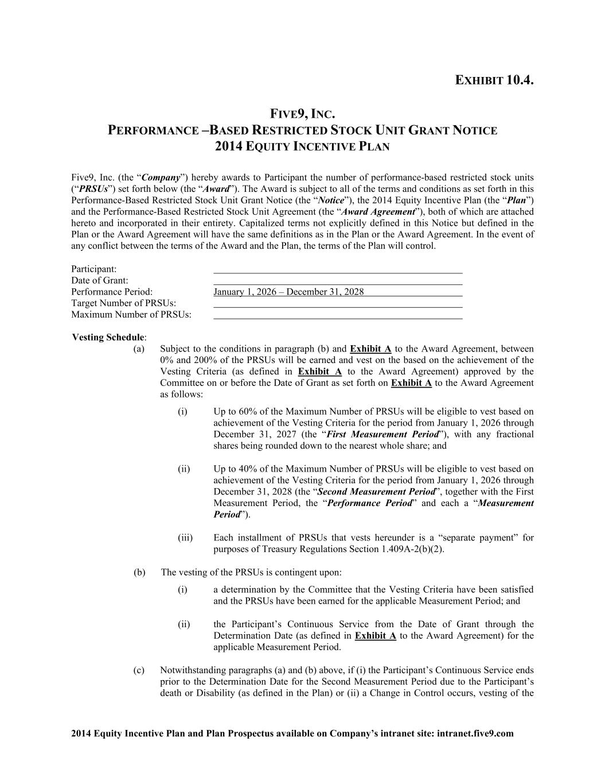
46
2014 Equity Incentive Plan and Plan Prospectus available on Company’s intranet site: intranet.five9.com EXHIBIT 10.4. FIVE9, INC. PERFORMANCE –BASED RESTRICTED STOCK UNIT GRANT NOTICE 2014 EQUITY INCENTIVE PLAN Five9, Inc. (the “Company”) hereby awards to Participant the number of performance-based restricted stock units (“PRSUs”) set forth below (the “Award”). The Award is subject to all of the terms and conditions as set forth in this Performance-Based Restricted Stock Unit Grant Notice (the “Notice”), the 2014 Equity Incentive Plan (the “Plan”) and the Performance-Based Restricted Stock Unit Agreement (the “Award Agreement”), both of which are attached hereto and incorporated in their entirety. Capitalized terms not explicitly defined in this Notice but defined in the Plan or the Award Agreement will have the same definitions as in the Plan or the Award Agreement. In the event of any conflict between the terms of the Award and the Plan, the terms of the Plan will control. Participant: Date of Grant: Performance Period: January 1, 2026 – December 31, 2028 Target Number of PRSUs: Maximum Number of PRSUs: Vesting Schedule: (a) Subject to the conditions in paragraph (b) and Exhibit A to the Award Agreement, between 0% and 200% of the PRSUs will be earned and vest on the based on the achievement of the Vesting Criteria (as defined in Exhibit A to the Award Agreement) approved by the Committee on or before the Date of Grant as set forth on Exhibit A to the Award Agreement as follows: (i) Up to 60% of the Maximum Number of PRSUs will be eligible to vest based on achievement of the Vesting Criteria for the period from January 1, 2026 through December 31, 2027 (the “First Measurement Period”), with any fractional shares being rounded down to the nearest whole share; and (ii) Up to 40% of the Maximum Number of PRSUs will be eligible to vest based on achievement of the Vesting Criteria for the period from January 1, 2026 through December 31, 2028 (the “Second Measurement Period”, together with the First Measurement Period, the “Performance Period” and each a “Measurement Period”). (iii) Each installment of PRSUs that vests hereunder is a “separate payment” for purposes of Treasury Regulations Section 1.409A-2(b)(2). (b) The vesting of the PRSUs is contingent upon: (i) a determination by the Committee that the Vesting Criteria have been satisfied and the PRSUs have been earned for the applicable Measurement Period; and (ii) the Participant’s Continuous Service from the Date of Grant through the Determination Date (as defined in Exhibit A to the Award Agreement) for the applicable Measurement Period. (c) Notwithstanding paragraphs (a) and (b) above, if (i) the Participant’s Continuous Service ends prior to the Determination Date for the Second Measurement Period due to the Participant’s death or Disability (as defined in the Plan) or (ii) a Change in Control occurs, vesting of the

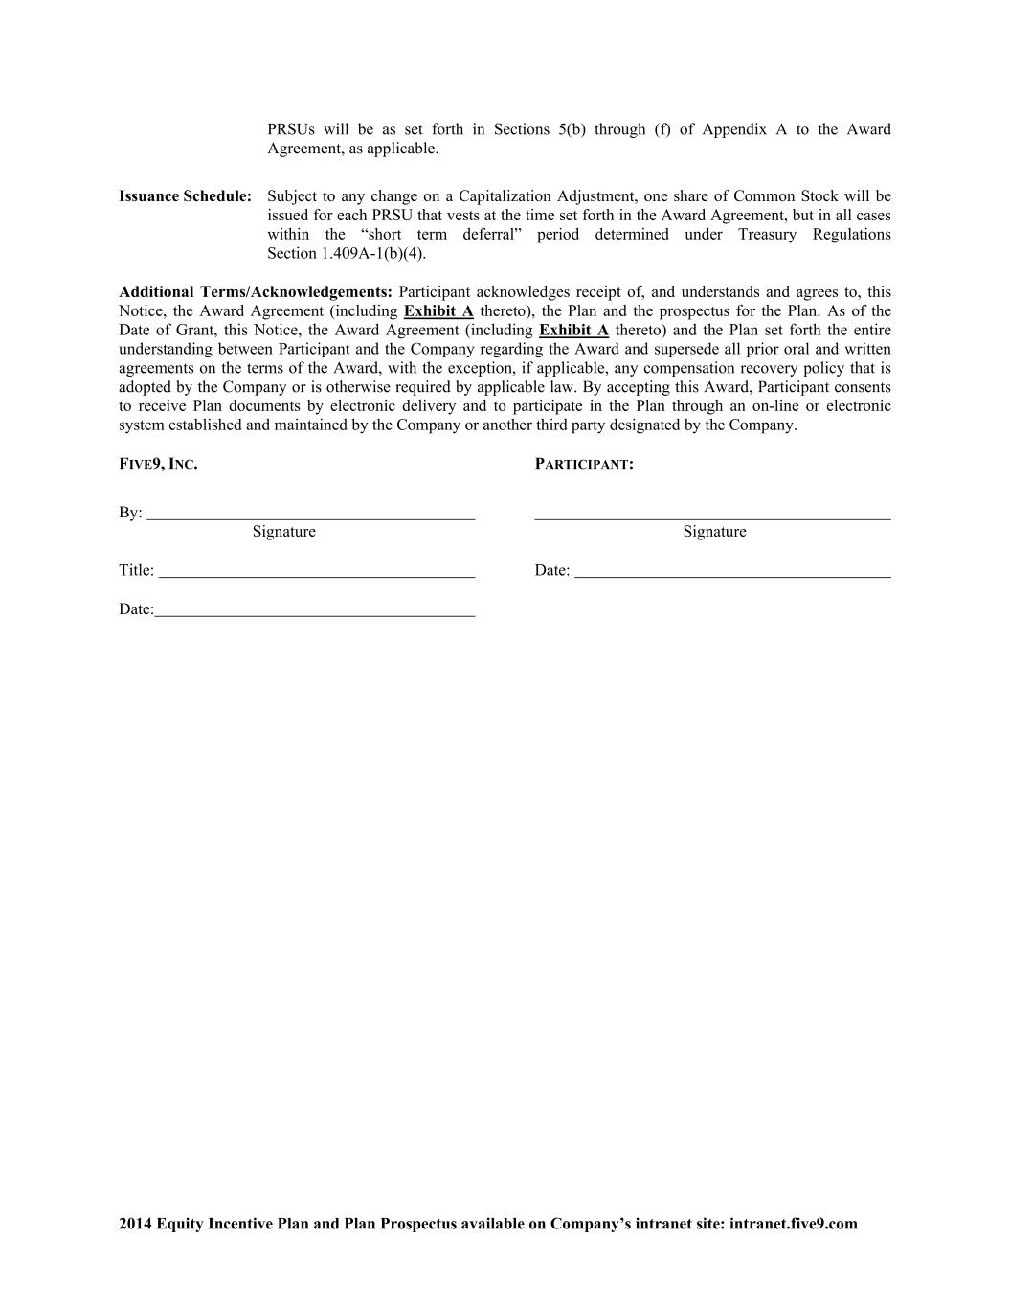
2014 Equity Incentive Plan and Plan Prospectus available on Company’s intranet site: intranet.five9.com PRSUs will be as set forth in Sections 5(b) through (f) of Appendix A to the Award Agreement, as applicable. Issuance Schedule: Subject to any change on a Capitalization Adjustment, one share of Common Stock will be issued for each PRSU that vests at the time set forth in the Award Agreement, but in all cases within the “short term deferral” period determined under Treasury Regulations Section 1.409A-1(b)(4). Additional Terms/Acknowledgements: Participant acknowledges receipt of, and understands and agrees to, this Notice, the Award Agreement (including Exhibit A thereto), the Plan and the prospectus for the Plan. As of the Date of Grant, this Notice, the Award Agreement (including Exhibit A thereto) and the Plan set forth the entire understanding between Participant and the Company regarding the Award and supersede all prior oral and written agreements on the terms of the Award, with the exception, if applicable, any compensation recovery policy that is adopted by the Company or is otherwise required by applicable law. By accepting this Award, Participant consents to receive Plan documents by electronic delivery and to participate in the Plan through an on-line or electronic system established and maintained by the Company or another third party designated by the Company. FIVE9, INC. PARTICIPANT: By: Signature Signature Title: Date: Date:

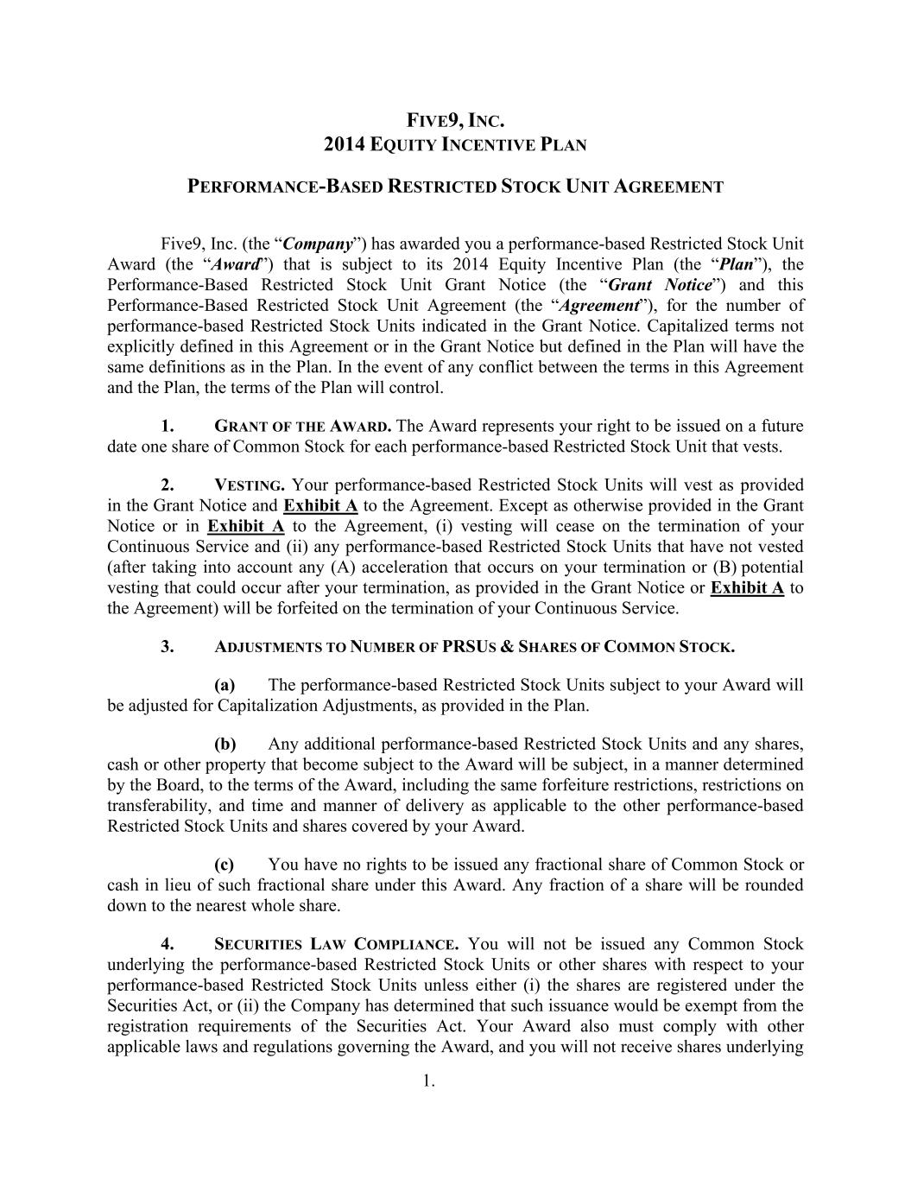
1. FIVE9, INC. 2014 EQUITY INCENTIVE PLAN PERFORMANCE-BASED RESTRICTED STOCK UNIT AGREEMENT Five9, Inc. (the “Company”) has awarded you a performance-based Restricted Stock Unit Award (the “Award”) that is subject to its 2014 Equity Incentive Plan (the “Plan”), the Performance-Based Restricted Stock Unit Grant Notice (the “Grant Notice”) and this Performance-Based Restricted Stock Unit Agreement (the “Agreement”), for the number of performance-based Restricted Stock Units indicated in the Grant Notice. Capitalized terms not explicitly defined in this Agreement or in the Grant Notice but defined in the Plan will have the same definitions as in the Plan. In the event of any conflict between the terms in this Agreement and the Plan, the terms of the Plan will control. 1. GRANT OF THE AWARD. The Award represents your right to be issued on a future date one share of Common Stock for each performance-based Restricted Stock Unit that vests. 2. VESTING. Your performance-based Restricted Stock Units will vest as provided in the Grant Notice and Exhibit A to the Agreement. Except as otherwise provided in the Grant Notice or in Exhibit A to the Agreement, (i) vesting will cease on the termination of your Continuous Service and (ii) any performance-based Restricted Stock Units that have not vested (after taking into account any (A) acceleration that occurs on your termination or (B) potential vesting that could occur after your termination, as provided in the Grant Notice or Exhibit A to the Agreement) will be forfeited on the termination of your Continuous Service. 3. ADJUSTMENTS TO NUMBER OF PRSUS & SHARES OF COMMON STOCK. (a) The performance-based Restricted Stock Units subject to your Award will be adjusted for Capitalization Adjustments, as provided in the Plan. (b) Any additional performance-based Restricted Stock Units and any shares, cash or other property that become subject to the Award will be subject, in a manner determined by the Board, to the terms of the Award, including the same forfeiture restrictions, restrictions on transferability, and time and manner of delivery as applicable to the other performance-based Restricted Stock Units and shares covered by your Award. (c) You have no rights to be issued any fractional share of Common Stock or cash in lieu of such fractional share under this Award. Any fraction of a share will be rounded down to the nearest whole share. 4. SECURITIES LAW COMPLIANCE. You will not be issued any Common Stock underlying the performance-based Restricted Stock Units or other shares with respect to your performance-based Restricted Stock Units unless either (i) the shares are registered under the Securities Act, or (ii) the Company has determined that such issuance would be exempt from the registration requirements of the Securities Act. Your Award also must comply with other applicable laws and regulations governing the Award, and you will not receive shares underlying

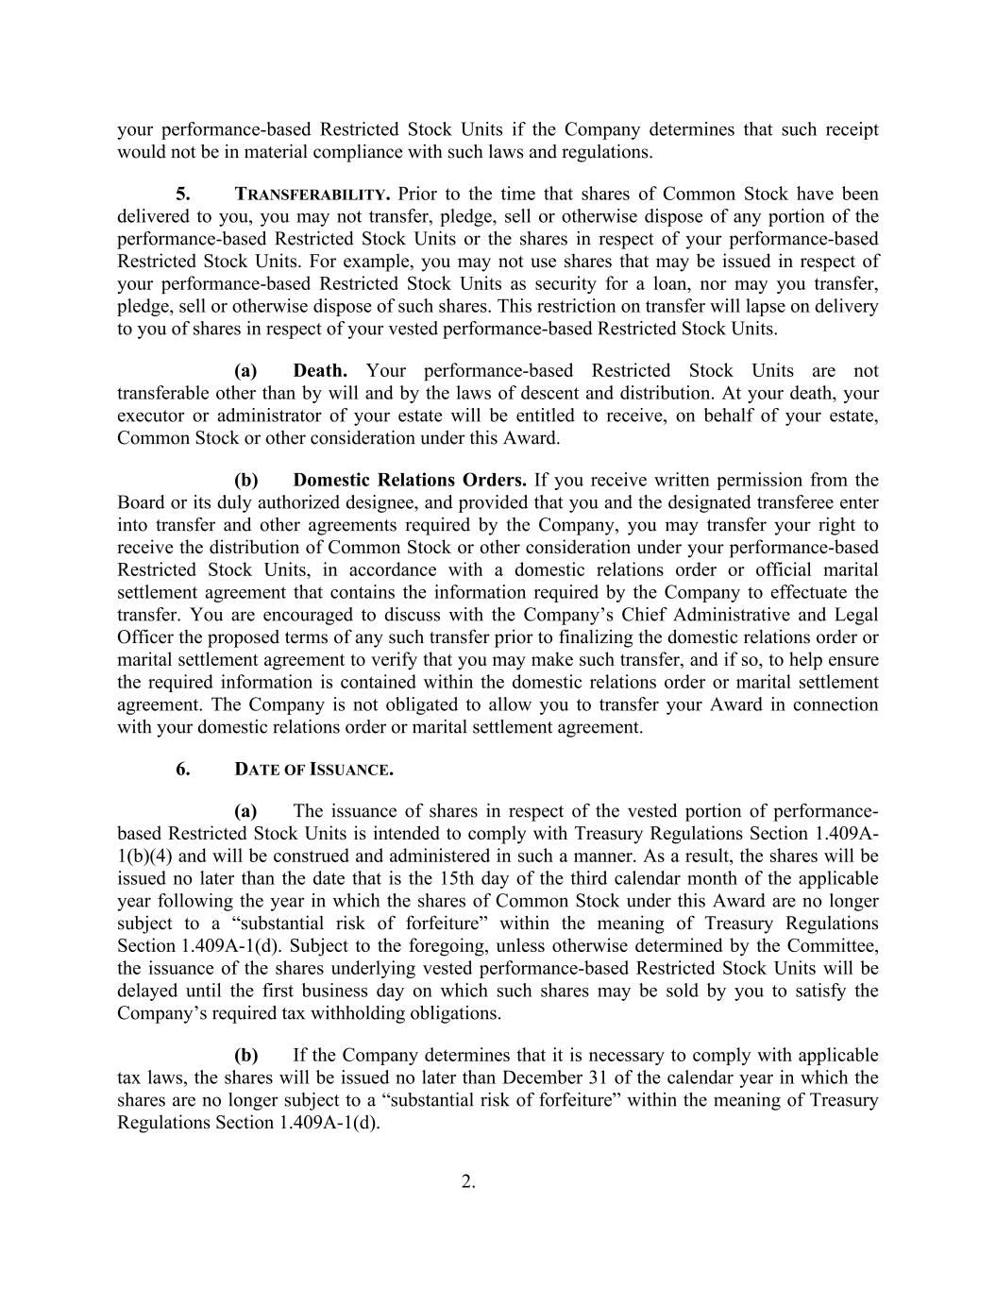
2. your performance-based Restricted Stock Units if the Company determines that such receipt would not be in material compliance with such laws and regulations. 5. TRANSFERABILITY. Prior to the time that shares of Common Stock have been delivered to you, you may not transfer, pledge, sell or otherwise dispose of any portion of the performance-based Restricted Stock Units or the shares in respect of your performance-based Restricted Stock Units. For example, you may not use shares that may be issued in respect of your performance-based Restricted Stock Units as security for a loan, nor may you transfer, pledge, sell or otherwise dispose of such shares. This restriction on transfer will lapse on delivery to you of shares in respect of your vested performance-based Restricted Stock Units. (a) Death. Your performance-based Restricted Stock Units are not transferable other than by will and by the laws of descent and distribution. At your death, your executor or administrator of your estate will be entitled to receive, on behalf of your estate, Common Stock or other consideration under this Award. (b) Domestic Relations Orders. If you receive written permission from the Board or its duly authorized designee, and provided that you and the designated transferee enter into transfer and other agreements required by the Company, you may transfer your right to receive the distribution of Common Stock or other consideration under your performance-based Restricted Stock Units, in accordance with a domestic relations order or official marital settlement agreement that contains the information required by the Company to effectuate the transfer. You are encouraged to discuss with the Company’s Chief Administrative and Legal Officer the proposed terms of any such transfer prior to finalizing the domestic relations order or marital settlement agreement to verify that you may make such transfer, and if so, to help ensure the required information is contained within the domestic relations order or marital settlement agreement. The Company is not obligated to allow you to transfer your Award in connection with your domestic relations order or marital settlement agreement. 6. DATE OF ISSUANCE. (a) The issuance of shares in respect of the vested portion of performance- based Restricted Stock Units is intended to comply with Treasury Regulations Section 1.409A- 1(b)(4) and will be construed and administered in such a manner. As a result, the shares will be issued no later than the date that is the 15th day of the third calendar month of the applicable year following the year in which the shares of Common Stock under this Award are no longer subject to a “substantial risk of forfeiture” within the meaning of Treasury Regulations Section 1.409A-1(d). Subject to the foregoing, unless otherwise determined by the Committee, the issuance of the shares underlying vested performance-based Restricted Stock Units will be delayed until the first business day on which such shares may be sold by you to satisfy the Company’s required tax withholding obligations. (b) If the Company determines that it is necessary to comply with applicable tax laws, the shares will be issued no later than December 31 of the calendar year in which the shares are no longer subject to a “substantial risk of forfeiture” within the meaning of Treasury Regulations Section 1.409A-1(d).

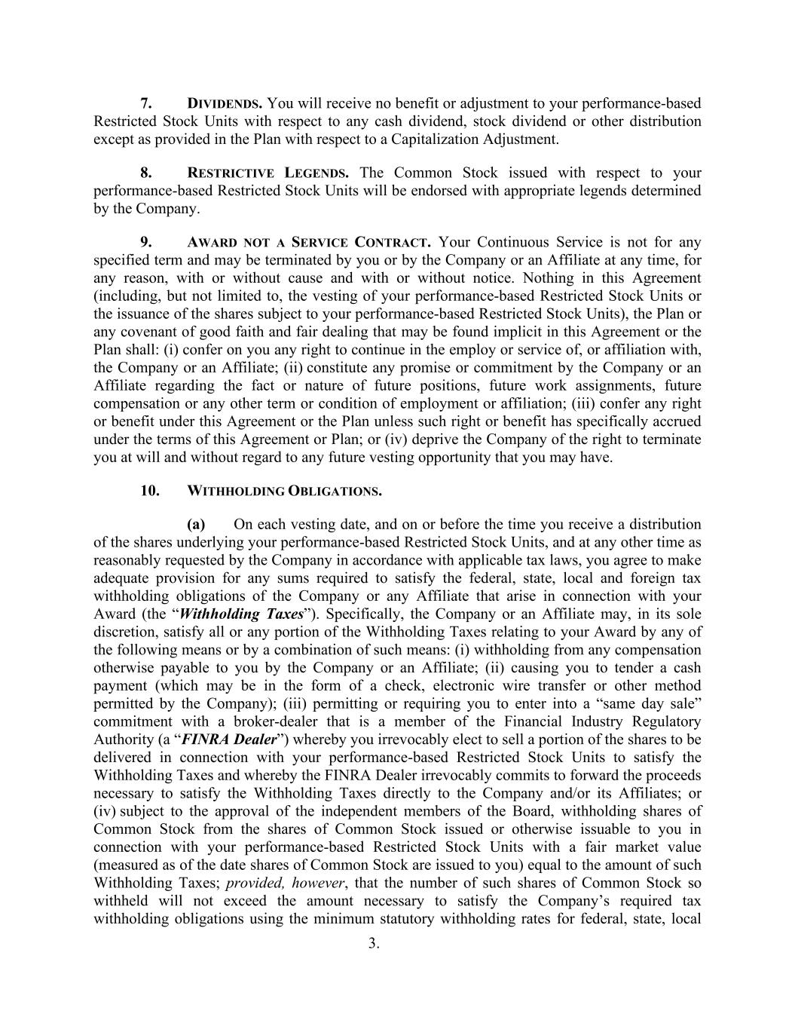
3. 7. DIVIDENDS. You will receive no benefit or adjustment to your performance-based Restricted Stock Units with respect to any cash dividend, stock dividend or other distribution except as provided in the Plan with respect to a Capitalization Adjustment. 8. RESTRICTIVE LEGENDS. The Common Stock issued with respect to your performance-based Restricted Stock Units will be endorsed with appropriate legends determined by the Company. 9. AWARD NOT A SERVICE CONTRACT. Your Continuous Service is not for any specified term and may be terminated by you or by the Company or an Affiliate at any time, for any reason, with or without cause and with or without notice. Nothing in this Agreement (including, but not limited to, the vesting of your performance-based Restricted Stock Units or the issuance of the shares subject to your performance-based Restricted Stock Units), the Plan or any covenant of good faith and fair dealing that may be found implicit in this Agreement or the Plan shall: (i) confer on you any right to continue in the employ or service of, or affiliation with, the Company or an Affiliate; (ii) constitute any promise or commitment by the Company or an Affiliate regarding the fact or nature of future positions, future work assignments, future compensation or any other term or condition of employment or affiliation; (iii) confer any right or benefit under this Agreement or the Plan unless such right or benefit has specifically accrued under the terms of this Agreement or Plan; or (iv) deprive the Company of the right to terminate you at will and without regard to any future vesting opportunity that you may have. 10. WITHHOLDING OBLIGATIONS. (a) On each vesting date, and on or before the time you receive a distribution of the shares underlying your performance-based Restricted Stock Units, and at any other time as reasonably requested by the Company in accordance with applicable tax laws, you agree to make adequate provision for any sums required to satisfy the federal, state, local and foreign tax withholding obligations of the Company or any Affiliate that arise in connection with your Award (the “Withholding Taxes”). Specifically, the Company or an Affiliate may, in its sole discretion, satisfy all or any portion of the Withholding Taxes relating to your Award by any of the following means or by a combination of such means: (i) withholding from any compensation otherwise payable to you by the Company or an Affiliate; (ii) causing you to tender a cash payment (which may be in the form of a check, electronic wire transfer or other method permitted by the Company); (iii) permitting or requiring you to enter into a “same day sale” commitment with a broker-dealer that is a member of the Financial Industry Regulatory Authority (a “FINRA Dealer”) whereby you irrevocably elect to sell a portion of the shares to be delivered in connection with your performance-based Restricted Stock Units to satisfy the Withholding Taxes and whereby the FINRA Dealer irrevocably commits to forward the proceeds necessary to satisfy the Withholding Taxes directly to the Company and/or its Affiliates; or (iv) subject to the approval of the independent members of the Board, withholding shares of Common Stock from the shares of Common Stock issued or otherwise issuable to you in connection with your performance-based Restricted Stock Units with a fair market value (measured as of the date shares of Common Stock are issued to you) equal to the amount of such Withholding Taxes; provided, however, that the number of such shares of Common Stock so withheld will not exceed the amount necessary to satisfy the Company’s required tax withholding obligations using the minimum statutory withholding rates for federal, state, local


4. and foreign tax purposes, including payroll taxes, that are applicable to supplemental taxable income. (b) Unless the Withholding Taxes of the Company and/or any Affiliate are satisfied, the Company will have no obligation to deliver to you any Common Stock. (c) If the Company’s obligation to withhold arises prior to the delivery to you of Common Stock or it is determined after the delivery of Common Stock to you that the amount of the Company’s withholding obligation was greater than the amount withheld by the Company, you agree to indemnify and hold the Company harmless from any failure by the Company to withhold the proper amount. 11. UNSECURED OBLIGATION. Your Award is unfunded, and as a holder of vested performance-based Restricted Stock Units, you will be considered an unsecured creditor of the Company with respect to the Company’s obligation, if any, to issue shares or other property pursuant to this Agreement. You will not have voting or any other rights as a stockholder of the Company with respect to the shares to be issued pursuant to this Agreement until such shares are issued to you. On such issuance, you will obtain full voting and other rights as a stockholder of the Company. Nothing contained in this Agreement, and no action taken pursuant to its provisions, will create or be construed to create a trust of any kind or a fiduciary relationship between you and the Company or any other person. 12. NOTICES. Any notices provided for in this Agreement or the Plan will be given in writing (including electronically) and will be deemed effectively given on receipt or, in the case of notices delivered by the Company to you, five days after deposit in the U.S. mail, postage prepaid, addressed to you at the last address you provided to the Company. The Company may, in its sole discretion, decide to deliver any documents related to participation in the Plan and this Award by electronic means or to request your consent to participate in the Plan by electronic means. By accepting this Award, you consent to receive such documents by electronic delivery and to participate in the Plan through an on-line or electronic system established and maintained by the Company or another third party designated by the Company. 13. MISCELLANEOUS. (a) The rights and obligations of the Company under your Award will be transferable to any one or more persons or entities, and all covenants and agreements hereunder will inure to the benefit of, and be enforceable by the Company’s successors and assigns. (b) You agree on request to execute any further documents or instruments necessary or desirable in the sole determination of the Company to carry out the purposes or intent of your Award. (c) You acknowledge and agree that you have reviewed your Award in its entirety, have had an opportunity to obtain the advice of counsel prior to executing and accepting your Award, and fully understand all provisions of your Award.

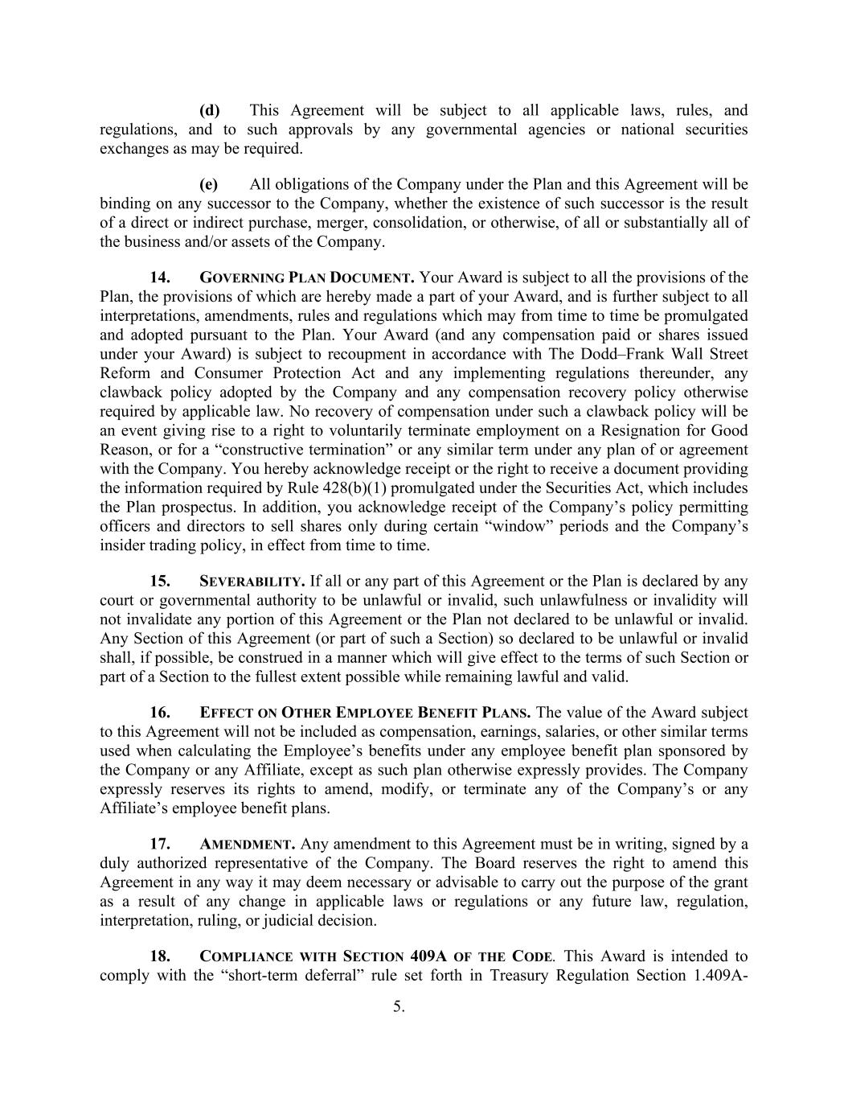
5. (d) This Agreement will be subject to all applicable laws, rules, and regulations, and to such approvals by any governmental agencies or national securities exchanges as may be required. (e) All obligations of the Company under the Plan and this Agreement will be binding on any successor to the Company, whether the existence of such successor is the result of a direct or indirect purchase, merger, consolidation, or otherwise, of all or substantially all of the business and/or assets of the Company. 14. GOVERNING PLAN DOCUMENT. Your Award is subject to all the provisions of the Plan, the provisions of which are hereby made a part of your Award, and is further subject to all interpretations, amendments, rules and regulations which may from time to time be promulgated and adopted pursuant to the Plan. Your Award (and any compensation paid or shares issued under your Award) is subject to recoupment in accordance with The Dodd–Frank Wall Street Reform and Consumer Protection Act and any implementing regulations thereunder, any clawback policy adopted by the Company and any compensation recovery policy otherwise required by applicable law. No recovery of compensation under such a clawback policy will be an event giving rise to a right to voluntarily terminate employment on a Resignation for Good Reason, or for a “constructive termination” or any similar term under any plan of or agreement with the Company. You hereby acknowledge receipt or the right to receive a document providing the information required by Rule 428(b)(1) promulgated under the Securities Act, which includes the Plan prospectus. In addition, you acknowledge receipt of the Company’s policy permitting officers and directors to sell shares only during certain “window” periods and the Company’s insider trading policy, in effect from time to time. 15. SEVERABILITY. If all or any part of this Agreement or the Plan is declared by any court or governmental authority to be unlawful or invalid, such unlawfulness or invalidity will not invalidate any portion of this Agreement or the Plan not declared to be unlawful or invalid. Any Section of this Agreement (or part of such a Section) so declared to be unlawful or invalid shall, if possible, be construed in a manner which will give effect to the terms of such Section or part of a Section to the fullest extent possible while remaining lawful and valid. 16. EFFECT ON OTHER EMPLOYEE BENEFIT PLANS. The value of the Award subject to this Agreement will not be included as compensation, earnings, salaries, or other similar terms used when calculating the Employee’s benefits under any employee benefit plan sponsored by the Company or any Affiliate, except as such plan otherwise expressly provides. The Company expressly reserves its rights to amend, modify, or terminate any of the Company’s or any Affiliate’s employee benefit plans. 17. AMENDMENT. Any amendment to this Agreement must be in writing, signed by a duly authorized representative of the Company. The Board reserves the right to amend this Agreement in any way it may deem necessary or advisable to carry out the purpose of the grant as a result of any change in applicable laws or regulations or any future law, regulation, interpretation, ruling, or judicial decision. 18. COMPLIANCE WITH SECTION 409A OF THE CODE. This Award is intended to comply with the “short-term deferral” rule set forth in Treasury Regulation Section 1.409A-

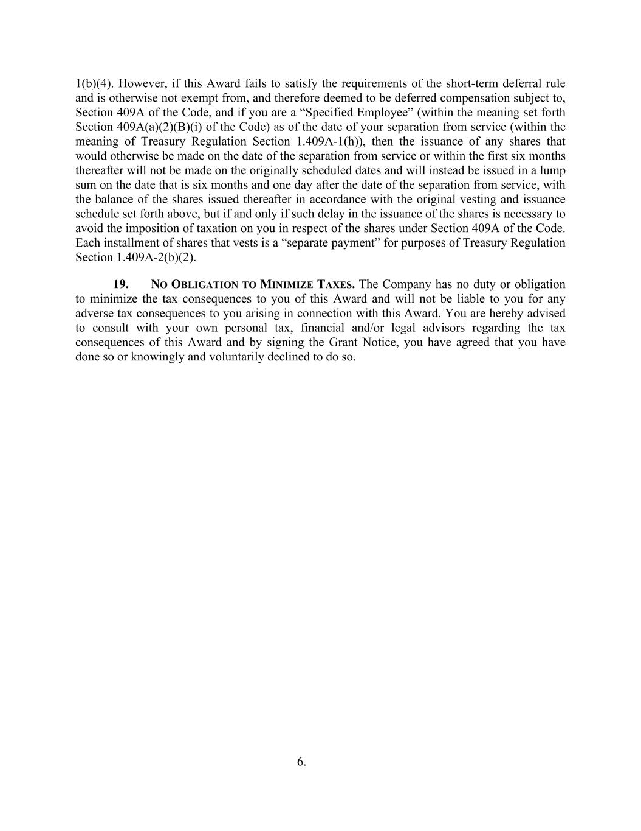
6. 1(b)(4). However, if this Award fails to satisfy the requirements of the short-term deferral rule and is otherwise not exempt from, and therefore deemed to be deferred compensation subject to, Section 409A of the Code, and if you are a “Specified Employee” (within the meaning set forth Section 409A(a)(2)(B)(i) of the Code) as of the date of your separation from service (within the meaning of Treasury Regulation Section 1.409A-1(h)), then the issuance of any shares that would otherwise be made on the date of the separation from service or within the first six months thereafter will not be made on the originally scheduled dates and will instead be issued in a lump sum on the date that is six months and one day after the date of the separation from service, with the balance of the shares issued thereafter in accordance with the original vesting and issuance schedule set forth above, but if and only if such delay in the issuance of the shares is necessary to avoid the imposition of taxation on you in respect of the shares under Section 409A of the Code. Each installment of shares that vests is a “separate payment” for purposes of Treasury Regulation Section 1.409A-2(b)(2). 19. NO OBLIGATION TO MINIMIZE TAXES. The Company has no duty or obligation to minimize the tax consequences to you of this Award and will not be liable to you for any adverse tax consequences to you arising in connection with this Award. You are hereby advised to consult with your own personal tax, financial and/or legal advisors regarding the tax consequences of this Award and by signing the Grant Notice, you have agreed that you have done so or knowingly and voluntarily declined to do so.

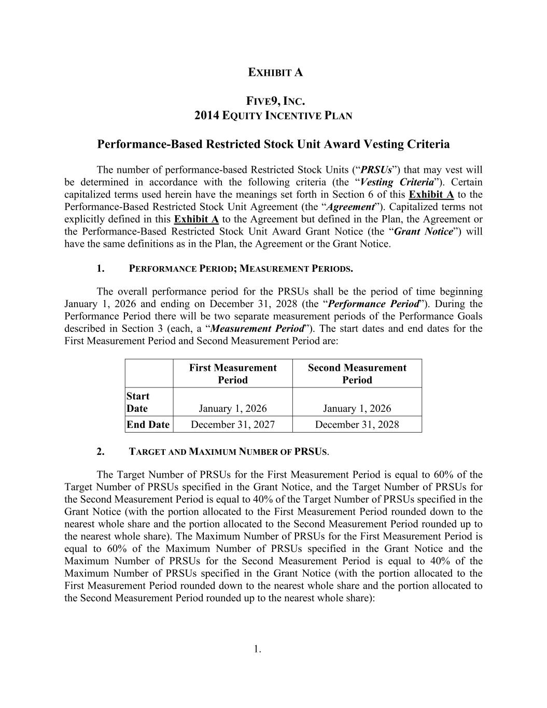
1. EXHIBIT A FIVE9, INC. 2014 EQUITY INCENTIVE PLAN Performance-Based Restricted Stock Unit Award Vesting Criteria The number of performance-based Restricted Stock Units (“PRSUs”) that may vest will be determined in accordance with the following criteria (the “Vesting Criteria”). Certain capitalized terms used herein have the meanings set forth in Section 6 of this Exhibit A to the Performance-Based Restricted Stock Unit Agreement (the “Agreement”). Capitalized terms not explicitly defined in this Exhibit A to the Agreement but defined in the Plan, the Agreement or the Performance-Based Restricted Stock Unit Award Grant Notice (the “Grant Notice”) will have the same definitions as in the Plan, the Agreement or the Grant Notice. 1. PERFORMANCE PERIOD; MEASUREMENT PERIODS. The overall performance period for the PRSUs shall be the period of time beginning January 1, 2026 and ending on December 31, 2028 (the “Performance Period”). During the Performance Period there will be two separate measurement periods of the Performance Goals described in Section 3 (each, a “Measurement Period”). The start dates and end dates for the First Measurement Period and Second Measurement Period are: First Measurement Period Second Measurement Period Start Date January 1, 2026 January 1, 2026 End Date December 31, 2027 December 31, 2028 2. TARGET AND MAXIMUM NUMBER OF PRSUS. The Target Number of PRSUs for the First Measurement Period is equal to 60% of the Target Number of PRSUs specified in the Grant Notice, and the Target Number of PRSUs for the Second Measurement Period is equal to 40% of the Target Number of PRSUs specified in the Grant Notice (with the portion allocated to the First Measurement Period rounded down to the nearest whole share and the portion allocated to the Second Measurement Period rounded up to the nearest whole share). The Maximum Number of PRSUs for the First Measurement Period is equal to 60% of the Maximum Number of PRSUs specified in the Grant Notice and the Maximum Number of PRSUs for the Second Measurement Period is equal to 40% of the Maximum Number of PRSUs specified in the Grant Notice (with the portion allocated to the First Measurement Period rounded down to the nearest whole share and the portion allocated to the Second Measurement Period rounded up to the nearest whole share):

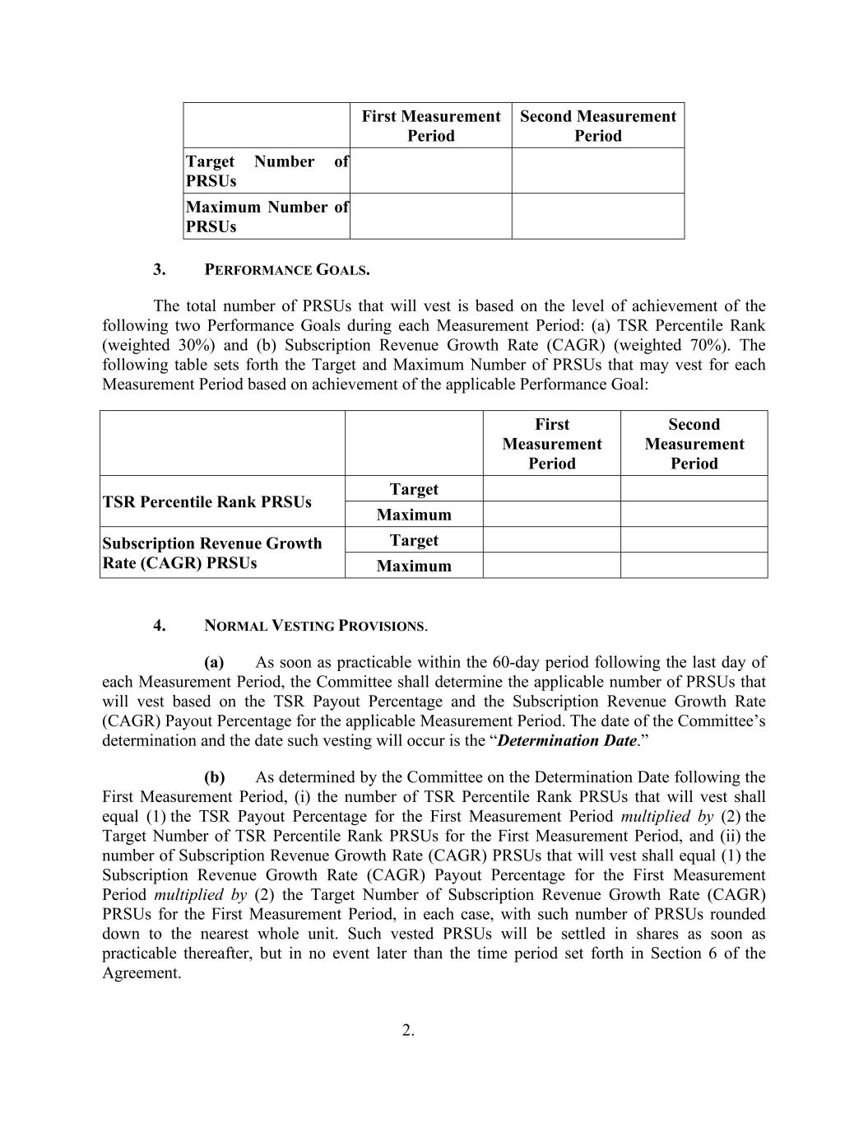
2. First Measurement Period Second Measurement Period Target Number of PRSUs Maximum Number of PRSUs 3. PERFORMANCE GOALS. The total number of PRSUs that will vest is based on the level of achievement of the following two Performance Goals during each Measurement Period: (a) TSR Percentile Rank (weighted 30%) and (b) Subscription Revenue Growth Rate (CAGR) (weighted 70%). The following table sets forth the Target and Maximum Number of PRSUs that may vest for each Measurement Period based on achievement of the applicable Performance Goal: First Measurement Period Second Measurement Period TSR Percentile Rank PRSUs Target Maximum Subscription Revenue Growth Rate (CAGR) PRSUs Target Maximum 4. NORMAL VESTING PROVISIONS. (a) As soon as practicable within the 60-day period following the last day of each Measurement Period, the Committee shall determine the applicable number of PRSUs that will vest based on the TSR Payout Percentage and the Subscription Revenue Growth Rate (CAGR) Payout Percentage for the applicable Measurement Period. The date of the Committee’s determination and the date such vesting will occur is the “Determination Date.” (b) As determined by the Committee on the Determination Date following the First Measurement Period, (i) the number of TSR Percentile Rank PRSUs that will vest shall equal (1) the TSR Payout Percentage for the First Measurement Period multiplied by (2) the Target Number of TSR Percentile Rank PRSUs for the First Measurement Period, and (ii) the number of Subscription Revenue Growth Rate (CAGR) PRSUs that will vest shall equal (1) the Subscription Revenue Growth Rate (CAGR) Payout Percentage for the First Measurement Period multiplied by (2) the Target Number of Subscription Revenue Growth Rate (CAGR) PRSUs for the First Measurement Period, in each case, with such number of PRSUs rounded down to the nearest whole unit. Such vested PRSUs will be settled in shares as soon as practicable thereafter, but in no event later than the time period set forth in Section 6 of the Agreement.

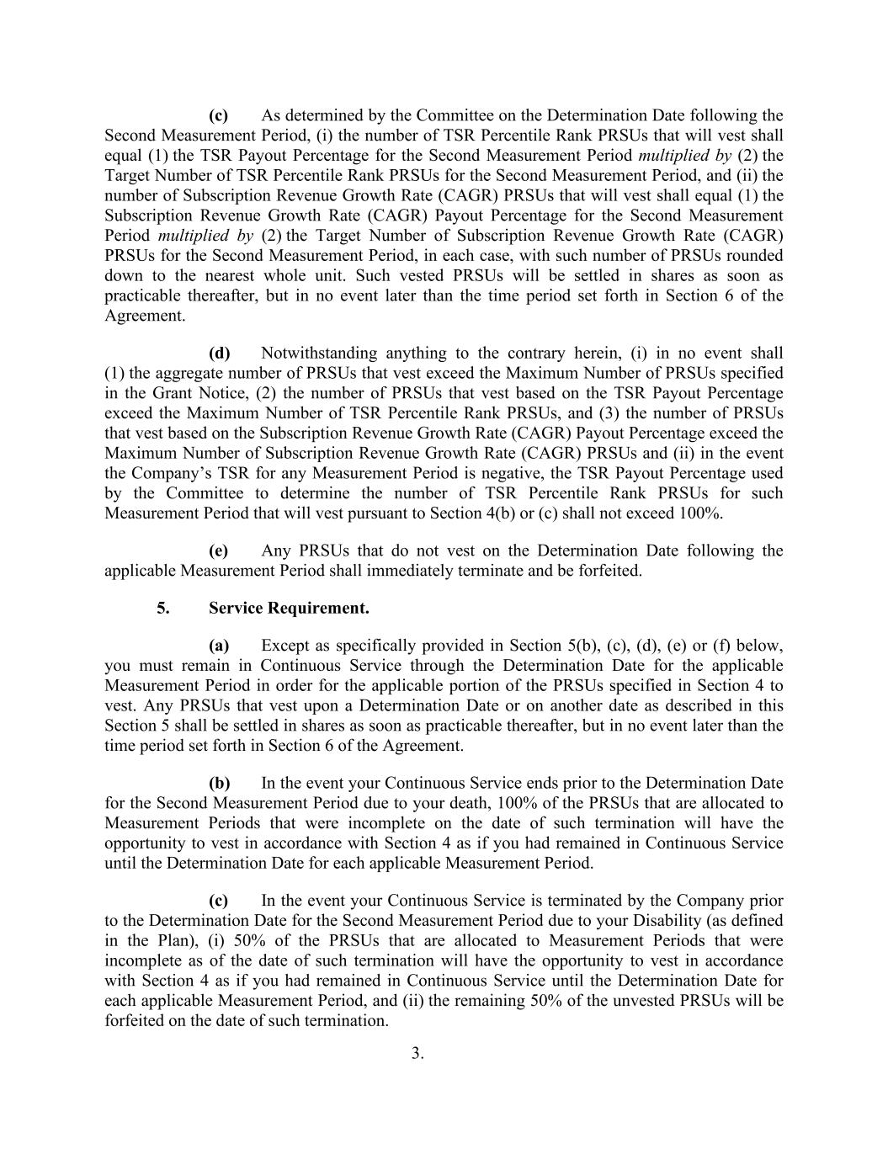
3. (c) As determined by the Committee on the Determination Date following the Second Measurement Period, (i) the number of TSR Percentile Rank PRSUs that will vest shall equal (1) the TSR Payout Percentage for the Second Measurement Period multiplied by (2) the Target Number of TSR Percentile Rank PRSUs for the Second Measurement Period, and (ii) the number of Subscription Revenue Growth Rate (CAGR) PRSUs that will vest shall equal (1) the Subscription Revenue Growth Rate (CAGR) Payout Percentage for the Second Measurement Period multiplied by (2) the Target Number of Subscription Revenue Growth Rate (CAGR) PRSUs for the Second Measurement Period, in each case, with such number of PRSUs rounded down to the nearest whole unit. Such vested PRSUs will be settled in shares as soon as practicable thereafter, but in no event later than the time period set forth in Section 6 of the Agreement. (d) Notwithstanding anything to the contrary herein, (i) in no event shall (1) the aggregate number of PRSUs that vest exceed the Maximum Number of PRSUs specified in the Grant Notice, (2) the number of PRSUs that vest based on the TSR Payout Percentage exceed the Maximum Number of TSR Percentile Rank PRSUs, and (3) the number of PRSUs that vest based on the Subscription Revenue Growth Rate (CAGR) Payout Percentage exceed the Maximum Number of Subscription Revenue Growth Rate (CAGR) PRSUs and (ii) in the event the Company’s TSR for any Measurement Period is negative, the TSR Payout Percentage used by the Committee to determine the number of TSR Percentile Rank PRSUs for such Measurement Period that will vest pursuant to Section 4(b) or (c) shall not exceed 100%. (e) Any PRSUs that do not vest on the Determination Date following the applicable Measurement Period shall immediately terminate and be forfeited. 5. Service Requirement. (a) Except as specifically provided in Section 5(b), (c), (d), (e) or (f) below, you must remain in Continuous Service through the Determination Date for the applicable Measurement Period in order for the applicable portion of the PRSUs specified in Section 4 to vest. Any PRSUs that vest upon a Determination Date or on another date as described in this Section 5 shall be settled in shares as soon as practicable thereafter, but in no event later than the time period set forth in Section 6 of the Agreement. (b) In the event your Continuous Service ends prior to the Determination Date for the Second Measurement Period due to your death, 100% of the PRSUs that are allocated to Measurement Periods that were incomplete on the date of such termination will have the opportunity to vest in accordance with Section 4 as if you had remained in Continuous Service until the Determination Date for each applicable Measurement Period. (c) In the event your Continuous Service is terminated by the Company prior to the Determination Date for the Second Measurement Period due to your Disability (as defined in the Plan), (i) 50% of the PRSUs that are allocated to Measurement Periods that were incomplete as of the date of such termination will have the opportunity to vest in accordance with Section 4 as if you had remained in Continuous Service until the Determination Date for each applicable Measurement Period, and (ii) the remaining 50% of the unvested PRSUs will be forfeited on the date of such termination.

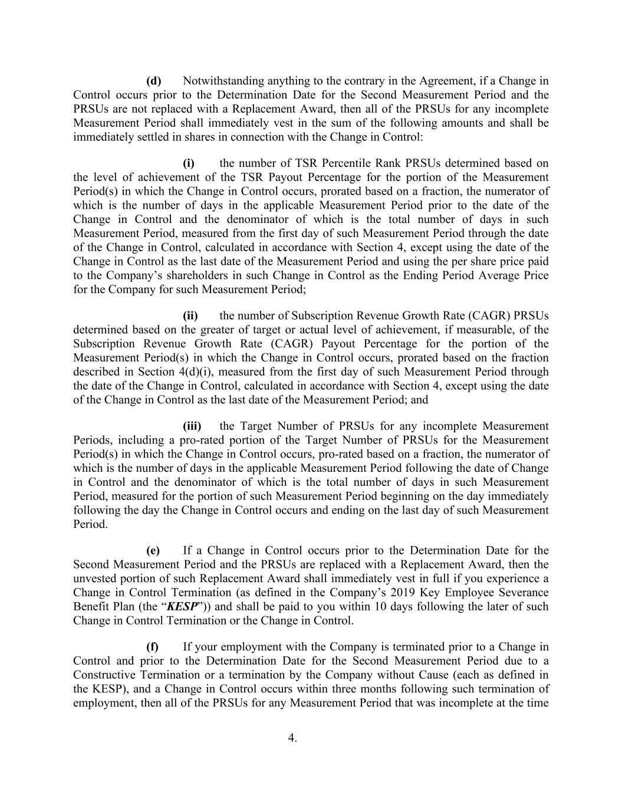
4. (d) Notwithstanding anything to the contrary in the Agreement, if a Change in Control occurs prior to the Determination Date for the Second Measurement Period and the PRSUs are not replaced with a Replacement Award, then all of the PRSUs for any incomplete Measurement Period shall immediately vest in the sum of the following amounts and shall be immediately settled in shares in connection with the Change in Control: (i) the number of TSR Percentile Rank PRSUs determined based on the level of achievement of the TSR Payout Percentage for the portion of the Measurement Period(s) in which the Change in Control occurs, prorated based on a fraction, the numerator of which is the number of days in the applicable Measurement Period prior to the date of the Change in Control and the denominator of which is the total number of days in such Measurement Period, measured from the first day of such Measurement Period through the date of the Change in Control, calculated in accordance with Section 4, except using the date of the Change in Control as the last date of the Measurement Period and using the per share price paid to the Company’s shareholders in such Change in Control as the Ending Period Average Price for the Company for such Measurement Period; (ii) the number of Subscription Revenue Growth Rate (CAGR) PRSUs determined based on the greater of target or actual level of achievement, if measurable, of the Subscription Revenue Growth Rate (CAGR) Payout Percentage for the portion of the Measurement Period(s) in which the Change in Control occurs, prorated based on the fraction described in Section 4(d)(i), measured from the first day of such Measurement Period through the date of the Change in Control, calculated in accordance with Section 4, except using the date of the Change in Control as the last date of the Measurement Period; and (iii) the Target Number of PRSUs for any incomplete Measurement Periods, including a pro-rated portion of the Target Number of PRSUs for the Measurement Period(s) in which the Change in Control occurs, pro-rated based on a fraction, the numerator of which is the number of days in the applicable Measurement Period following the date of Change in Control and the denominator of which is the total number of days in such Measurement Period, measured for the portion of such Measurement Period beginning on the day immediately following the day the Change in Control occurs and ending on the last day of such Measurement Period. (e) If a Change in Control occurs prior to the Determination Date for the Second Measurement Period and the PRSUs are replaced with a Replacement Award, then the unvested portion of such Replacement Award shall immediately vest in full if you experience a Change in Control Termination (as defined in the Company’s 2019 Key Employee Severance Benefit Plan (the “KESP”)) and shall be paid to you within 10 days following the later of such Change in Control Termination or the Change in Control. (f) If your employment with the Company is terminated prior to a Change in Control and prior to the Determination Date for the Second Measurement Period due to a Constructive Termination or a termination by the Company without Cause (each as defined in the KESP), and a Change in Control occurs within three months following such termination of employment, then all of the PRSUs for any Measurement Period that was incomplete at the time

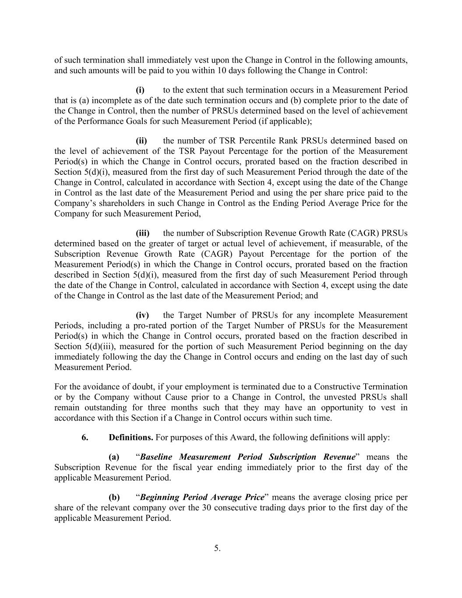
5. of such termination shall immediately vest upon the Change in Control in the following amounts, and such amounts will be paid to you within 10 days following the Change in Control: (i) to the extent that such termination occurs in a Measurement Period that is (a) incomplete as of the date such termination occurs and (b) complete prior to the date of the Change in Control, then the number of PRSUs determined based on the level of achievement of the Performance Goals for such Measurement Period (if applicable); (ii) the number of TSR Percentile Rank PRSUs determined based on the level of achievement of the TSR Payout Percentage for the portion of the Measurement Period(s) in which the Change in Control occurs, prorated based on the fraction described in Section 5(d)(i), measured from the first day of such Measurement Period through the date of the Change in Control, calculated in accordance with Section 4, except using the date of the Change in Control as the last date of the Measurement Period and using the per share price paid to the Company’s shareholders in such Change in Control as the Ending Period Average Price for the Company for such Measurement Period, (iii) the number of Subscription Revenue Growth Rate (CAGR) PRSUs determined based on the greater of target or actual level of achievement, if measurable, of the Subscription Revenue Growth Rate (CAGR) Payout Percentage for the portion of the Measurement Period(s) in which the Change in Control occurs, prorated based on the fraction described in Section 5(d)(i), measured from the first day of such Measurement Period through the date of the Change in Control, calculated in accordance with Section 4, except using the date of the Change in Control as the last date of the Measurement Period; and (iv) the Target Number of PRSUs for any incomplete Measurement Periods, including a pro-rated portion of the Target Number of PRSUs for the Measurement Period(s) in which the Change in Control occurs, prorated based on the fraction described in Section 5(d)(iii), measured for the portion of such Measurement Period beginning on the day immediately following the day the Change in Control occurs and ending on the last day of such Measurement Period. For the avoidance of doubt, if your employment is terminated due to a Constructive Termination or by the Company without Cause prior to a Change in Control, the unvested PRSUs shall remain outstanding for three months such that they may have an opportunity to vest in accordance with this Section if a Change in Control occurs within such time. 6. Definitions. For purposes of this Award, the following definitions will apply: (a) “Baseline Measurement Period Subscription Revenue” means the Subscription Revenue for the fiscal year ending immediately prior to the first day of the applicable Measurement Period. (b) “Beginning Period Average Price” means the average closing price per share of the relevant company over the 30 consecutive trading days prior to the first day of the applicable Measurement Period.

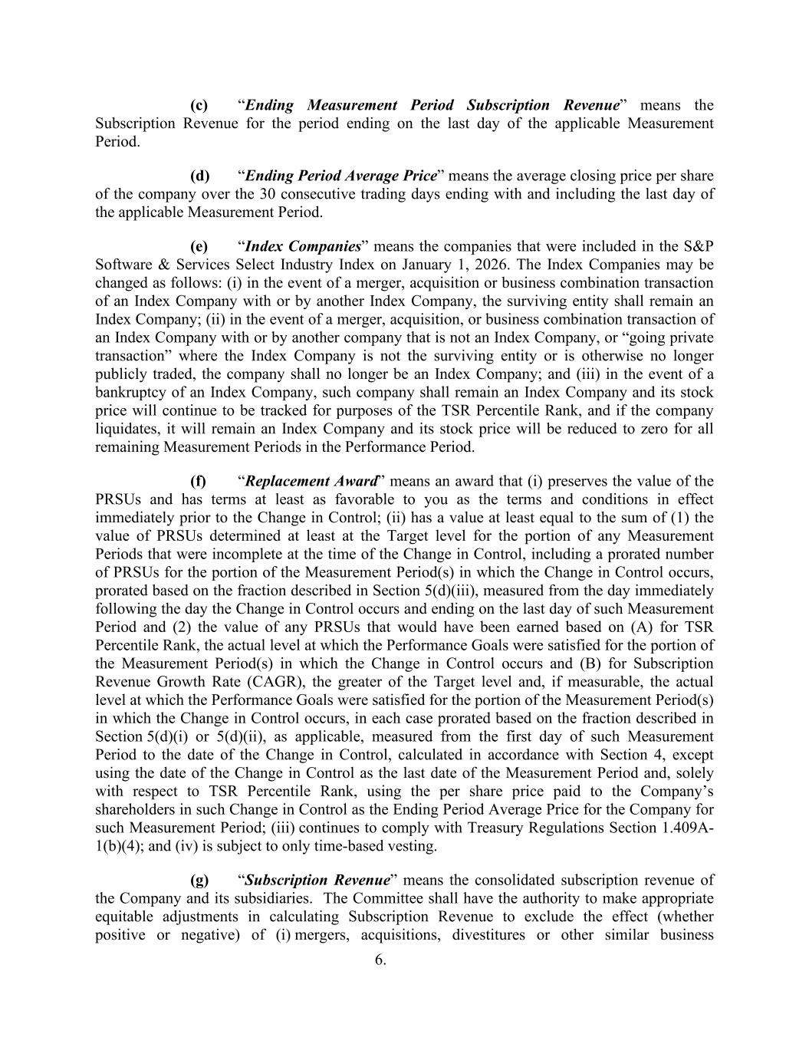
6. (c) “Ending Measurement Period Subscription Revenue” means the Subscription Revenue for the period ending on the last day of the applicable Measurement Period. (d) “Ending Period Average Price” means the average closing price per share of the company over the 30 consecutive trading days ending with and including the last day of the applicable Measurement Period. (e) “Index Companies” means the companies that were included in the S&P Software & Services Select Industry Index on January 1, 2026. The Index Companies may be changed as follows: (i) in the event of a merger, acquisition or business combination transaction of an Index Company with or by another Index Company, the surviving entity shall remain an Index Company; (ii) in the event of a merger, acquisition, or business combination transaction of an Index Company with or by another company that is not an Index Company, or “going private transaction” where the Index Company is not the surviving entity or is otherwise no longer publicly traded, the company shall no longer be an Index Company; and (iii) in the event of a bankruptcy of an Index Company, such company shall remain an Index Company and its stock price will continue to be tracked for purposes of the TSR Percentile Rank, and if the company liquidates, it will remain an Index Company and its stock price will be reduced to zero for all remaining Measurement Periods in the Performance Period. (f) “Replacement Award” means an award that (i) preserves the value of the PRSUs and has terms at least as favorable to you as the terms and conditions in effect immediately prior to the Change in Control; (ii) has a value at least equal to the sum of (1) the value of PRSUs determined at least at the Target level for the portion of any Measurement Periods that were incomplete at the time of the Change in Control, including a prorated number of PRSUs for the portion of the Measurement Period(s) in which the Change in Control occurs, prorated based on the fraction described in Section 5(d)(iii), measured from the day immediately following the day the Change in Control occurs and ending on the last day of such Measurement Period and (2) the value of any PRSUs that would have been earned based on (A) for TSR Percentile Rank, the actual level at which the Performance Goals were satisfied for the portion of the Measurement Period(s) in which the Change in Control occurs and (B) for Subscription Revenue Growth Rate (CAGR), the greater of the Target level and, if measurable, the actual level at which the Performance Goals were satisfied for the portion of the Measurement Period(s) in which the Change in Control occurs, in each case prorated based on the fraction described in Section 5(d)(i) or 5(d)(ii), as applicable, measured from the first day of such Measurement Period to the date of the Change in Control, calculated in accordance with Section 4, except using the date of the Change in Control as the last date of the Measurement Period and, solely with respect to TSR Percentile Rank, using the per share price paid to the Company’s shareholders in such Change in Control as the Ending Period Average Price for the Company for such Measurement Period; (iii) continues to comply with Treasury Regulations Section 1.409A- 1(b)(4); and (iv) is subject to only time-based vesting. (g) “Subscription Revenue” means the consolidated subscription revenue of the Company and its subsidiaries. The Committee shall have the authority to make appropriate equitable adjustments in calculating Subscription Revenue to exclude the effect (whether positive or negative) of (i) mergers, acquisitions, divestitures or other similar business

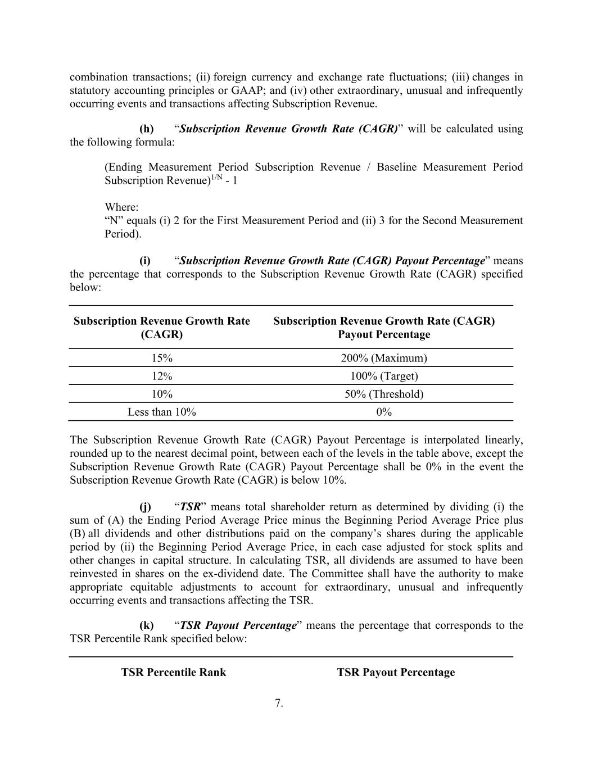
7. combination transactions; (ii) foreign currency and exchange rate fluctuations; (iii) changes in statutory accounting principles or GAAP; and (iv) other extraordinary, unusual and infrequently occurring events and transactions affecting Subscription Revenue. (h) “Subscription Revenue Growth Rate (CAGR)” will be calculated using the following formula: (Ending Measurement Period Subscription Revenue / Baseline Measurement Period Subscription Revenue)1/N - 1 Where: “N” equals (i) 2 for the First Measurement Period and (ii) 3 for the Second Measurement Period). (i) “Subscription Revenue Growth Rate (CAGR) Payout Percentage” means the percentage that corresponds to the Subscription Revenue Growth Rate (CAGR) specified below: Subscription Revenue Growth Rate (CAGR) Subscription Revenue Growth Rate (CAGR) Payout Percentage 15% 200% (Maximum) 12% 100% (Target) 10% 50% (Threshold) Less than 10% 0% The Subscription Revenue Growth Rate (CAGR) Payout Percentage is interpolated linearly, rounded up to the nearest decimal point, between each of the levels in the table above, except the Subscription Revenue Growth Rate (CAGR) Payout Percentage shall be 0% in the event the Subscription Revenue Growth Rate (CAGR) is below 10%. (j) “TSR” means total shareholder return as determined by dividing (i) the sum of (A) the Ending Period Average Price minus the Beginning Period Average Price plus (B) all dividends and other distributions paid on the company’s shares during the applicable period by (ii) the Beginning Period Average Price, in each case adjusted for stock splits and other changes in capital structure. In calculating TSR, all dividends are assumed to have been reinvested in shares on the ex-dividend date. The Committee shall have the authority to make appropriate equitable adjustments to account for extraordinary, unusual and infrequently occurring events and transactions affecting the TSR. (k) “TSR Payout Percentage” means the percentage that corresponds to the TSR Percentile Rank specified below: TSR Percentile Rank TSR Payout Percentage

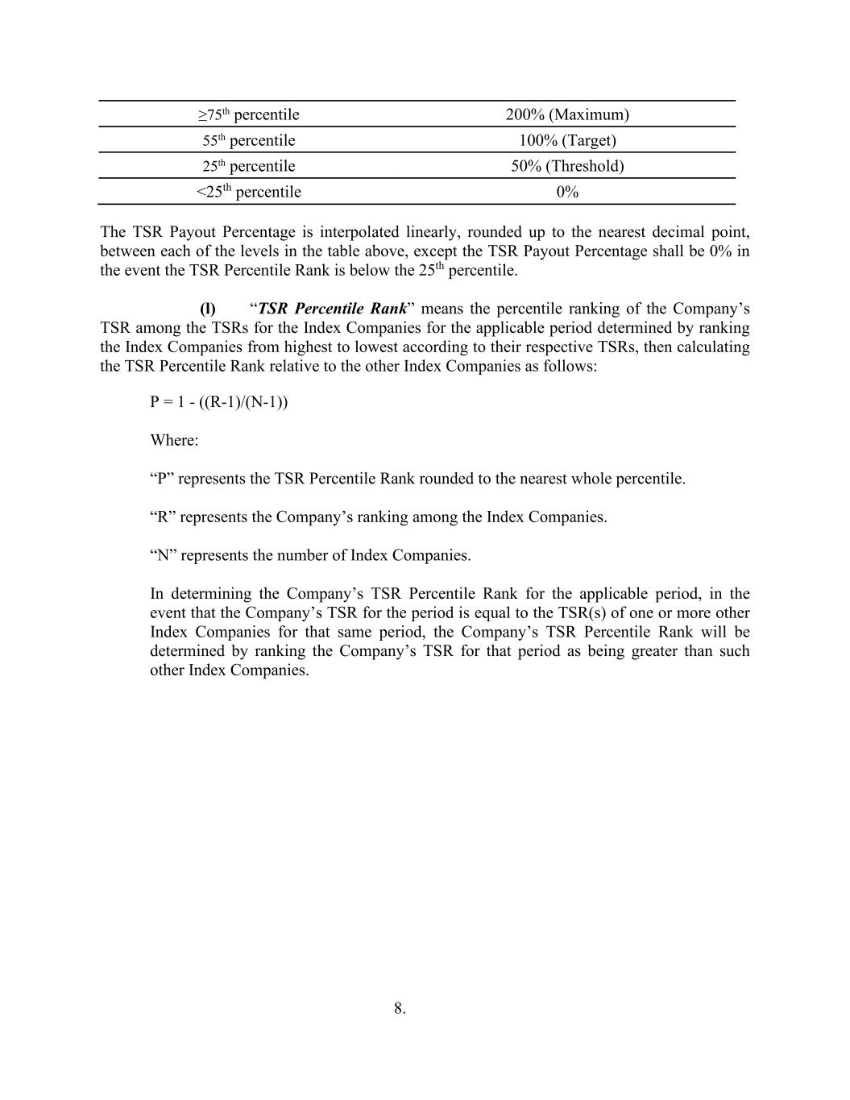
8. ≥75th percentile 200% (Maximum) 55th percentile 100% (Target) 25th percentile 50% (Threshold) <25th percentile 0% The TSR Payout Percentage is interpolated linearly, rounded up to the nearest decimal point, between each of the levels in the table above, except the TSR Payout Percentage shall be 0% in the event the TSR Percentile Rank is below the 25th percentile. (l) “TSR Percentile Rank” means the percentile ranking of the Company’s TSR among the TSRs for the Index Companies for the applicable period determined by ranking the Index Companies from highest to lowest according to their respective TSRs, then calculating the TSR Percentile Rank relative to the other Index Companies as follows: P = 1 - ((R-1)/(N-1)) Where: “P” represents the TSR Percentile Rank rounded to the nearest whole percentile. “R” represents the Company’s ranking among the Index Companies. “N” represents the number of Index Companies. In determining the Company’s TSR Percentile Rank for the applicable period, in the event that the Company’s TSR for the period is equal to the TSR(s) of one or more other Index Companies for that same period, the Company’s TSR Percentile Rank will be determined by ranking the Company’s TSR for that period as being greater than such other Index Companies.

Exhibit 31.1
CERTIFICATION OF CHIEF EXECUTIVE OFFICER
PURSUANT TO SECTION 302 OF
THE SARBANES-OXLEY ACT OF 2002
I, Amit Mathradas, certify that:

1.I have reviewed this quarterly report on Form 10-Q of Five9, Inc. for the quarter ended March 31, 2026;
2.Based on my knowledge, this report does not contain any untrue statement of a material fact or omit to state a material fact necessary to make the statements made, in light of the circumstances under which such statements were made, not misleading with respect to the period covered by this report;
3.Based on my knowledge, the financial statements, and other financial information included in this report, fairly present in all material respects the financial condition, results of operations and cash flows of the registrant as of, and for, the periods presented in this report;
4.The registrant’s other certifying officer and I are responsible for establishing and maintaining disclosure controls and procedures (as defined in Exchange Act Rules 13a-15(e) and 15d-15(e)) and internal control over financial reporting (as defined in Exchange Act Rules 13a-15(f) and 15d-15(f)) for the registrant and have:
(a)Designed such disclosure controls and procedures, or caused such disclosure controls and procedures to be designed under our supervision, to ensure that material information relating to the registrant, including its consolidated subsidiaries, is made known to us by others within those entities, particularly during the period in which this report is being prepared;
(b)Designed such internal control over financial reporting, or caused such internal control over financial reporting to be designed under our supervision, to provide reasonable assurance regarding the reliability of financial reporting and the preparation of financial statements for external purposes in accordance with generally accepted accounting principles;
(c)Evaluated the effectiveness of the registrant’s disclosure controls and procedures and presented in this report our conclusions about the effectiveness of the disclosure controls and procedures, as of the end of the period covered by this report based on such evaluation; and
(d)Disclosed in this report any change in the registrant’s internal control over financial reporting that occurred during the registrant’s most recent fiscal quarter (the registrant’s fourth fiscal quarter in the case of an annual report) that has materially affected, or is reasonably likely to materially affect, the registrant’s internal control over financial reporting; and
5.The registrant’s other certifying officer and I have disclosed, based on our most recent evaluation of internal control over financial reporting, to the registrant’s auditors and the audit committee of the registrant’s board of directors (or persons performing the equivalent functions):
(a)All significant deficiencies and material weaknesses in the design or operation of internal control over financial reporting which are reasonably likely to adversely affect the registrant’s ability to record, process, summarize and report financial information; and
(b)Any fraud, whether or not material, that involves management or other employees who have a significant role in the registrant’s internal control over financial reporting.

Date: |  |  | April 30, 2026 |  |  | By: |  |  | /s/ Amit Mathradas
 |  |  |  |  |  |  |  |  | Amit Mathradas
 |  |  |  |  |  |  |  |  | Chief Executive Officer
 |  |  |  |  |  |  |  |  | (Principal Executive Officer)

Exhibit 31.2
CERTIFICATION OF CHIEF FINANCIAL OFFICER
PURSUANT TO SECTION 302 OF
THE SARBANES-OXLEY ACT OF 2002
I, Bryan Lee, certify that:

1.I have reviewed this quarterly report on Form 10-Q of Five9, Inc. for the quarter ended March 31, 2026;
2.Based on my knowledge, this report does not contain any untrue statement of a material fact or omit to state a material fact necessary to make the statements made, in light of the circumstances under which such statements were made, not misleading with respect to the period covered by this report;
3.Based on my knowledge, the financial statements, and other financial information included in this report, fairly present in all material respects the financial condition, results of operations and cash flows of the registrant as of, and for, the periods presented in this report;
4.The registrant’s other certifying officer and I are responsible for establishing and maintaining disclosure controls and procedures (as defined in Exchange Act Rules 13a-15(e) and 15d-15(e)) and internal control over financial reporting (as defined in Exchange Act Rules 13a-15(f) and 15d-15(f)) for the registrant and have:
(a)Designed such disclosure controls and procedures, or caused such disclosure controls and procedures to be designed under our supervision, to ensure that material information relating to the registrant, including its consolidated subsidiaries, is made known to us by others within those entities, particularly during the period in which this report is being prepared;
(b)Designed such internal control over financial reporting, or caused such internal control over financial reporting to be designed under our supervision, to provide reasonable assurance regarding the reliability of financial reporting and the preparation of financial statements for external purposes in accordance with generally accepted accounting principles;
(c)Evaluated the effectiveness of the registrant’s disclosure controls and procedures and presented in this report our conclusions about the effectiveness of the disclosure controls and procedures, as of the end of the period covered by this report based on such evaluation; and
(d)Disclosed in this report any change in the registrant’s internal control over financial reporting that occurred during the registrant’s most recent fiscal quarter (the registrant’s fourth fiscal quarter in the case of an annual report) that has materially affected, or is reasonably likely to materially affect, the registrant’s internal control over financial reporting; and
5.The registrant’s other certifying officer and I have disclosed, based on our most recent evaluation of internal control over financial reporting, to the registrant’s auditors and the audit committee of the registrant’s board of directors (or persons performing the equivalent functions):
(a)All significant deficiencies and material weaknesses in the design or operation of internal control over financial reporting which are reasonably likely to adversely affect the registrant’s ability to record, process, summarize and report financial information; and
(b)Any fraud, whether or not material, that involves management or other employees who have a significant role in the registrant’s internal control over financial reporting.

Date: |  |  | April 30, 2026 |  |  | By: |  |  | /s/ Bryan Lee
 |  |  |  |  |  |  |  |  | Bryan Lee
 |  |  |  |  |  |  |  |  | Interim Chief Financial Officer
 |  |  |  |  |  |  |  |  | (Principal Financial Officer)

Exhibit 32.1
CERTIFICATION OF CHIEF EXECUTIVE OFFICER AND CHIEF FINANCIAL OFFICER
PURSUANT TO 18 U.S.C. SECTION 1350,
AS ADOPTED PURSUANT TO
SECTION 906 OF THE SARBANES-OXLEY ACT OF 2002
I, Amit Mathradas, certify, pursuant to 18 U.S.C. Section 1350, as adopted pursuant to Section 906 of the Sarbanes-Oxley Act of 2002, that the Quarterly Report of Five9, Inc. (the “Company”) on Form 10-Q for the fiscal quarter ended March 31, 2026 fully complies with the requirements of Section 13(a) or 15(d) of the Securities Exchange Act of 1934 and that information contained in such Quarterly Report on Form 10-Q fairly presents in all material respects the financial condition and results of operations of the Company.

Date: |  |  | April 30, 2026 |  |  | By: |  |  | /s/ Amit Mathradas
 |  |  |  |  |  |  |  |  | Amit Mathradas
 |  |  |  |  |  |  |  |  | Chief Executive Officer

I, Bryan Lee, certify, pursuant to 18 U.S.C. Section 1350, as adopted pursuant to Section 906 of the Sarbanes-Oxley Act of 2002, that the Quarterly Report of Five9, Inc. (the “Company”) on Form 10-Q for the fiscal quarter ended March 31, 2026 fully complies with the requirements of Section 13(a) or 15(d) of the Securities Exchange Act of 1934 and that information contained in such Quarterly Report on Form 10-Q fairly presents in all material respects the financial condition and results of operations of the Company.

Date: |  |  | April 30, 2026 |  |  | By: |  |  | /s/ Bryan Lee
 |  |  |  |  |  |  |  |  | Bryan Lee
 |  |  |  |  |  |  |  |  | Interim Chief Financial Officer

This certification accompanies the Form 10-Q to which it relates, is not deemed filed with the Securities and Exchange Commission and is not to be incorporated by reference into any filing of Five9, Inc. under the Securities Act of 1933, as amended, or the Securities Exchange Act of 1934, as amended (whether made before or after the date of the Form 10-Q), irrespective of any general incorporation language contained in such filing.

